Youth Newsletter
July 2001
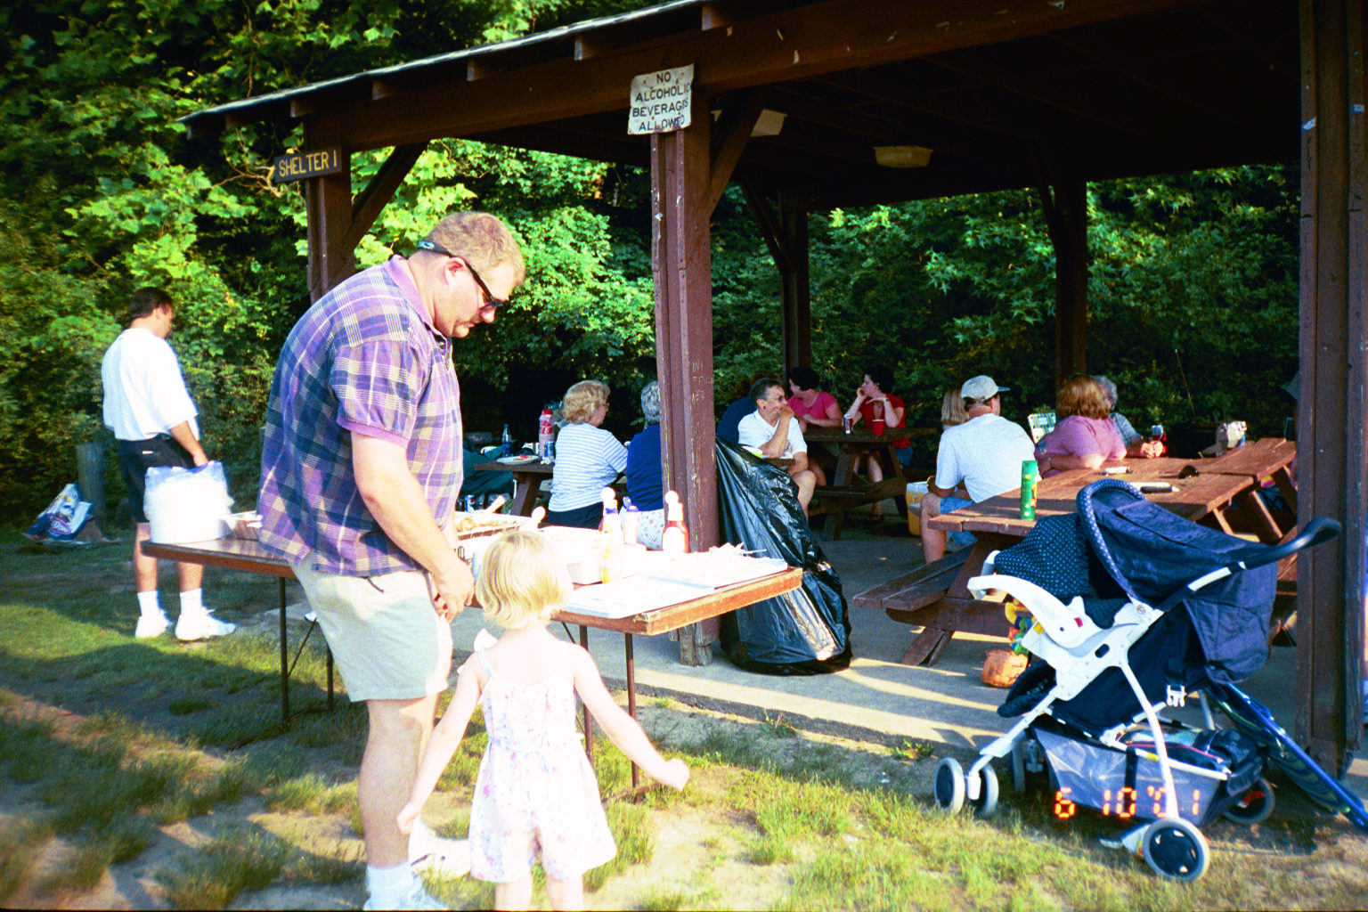
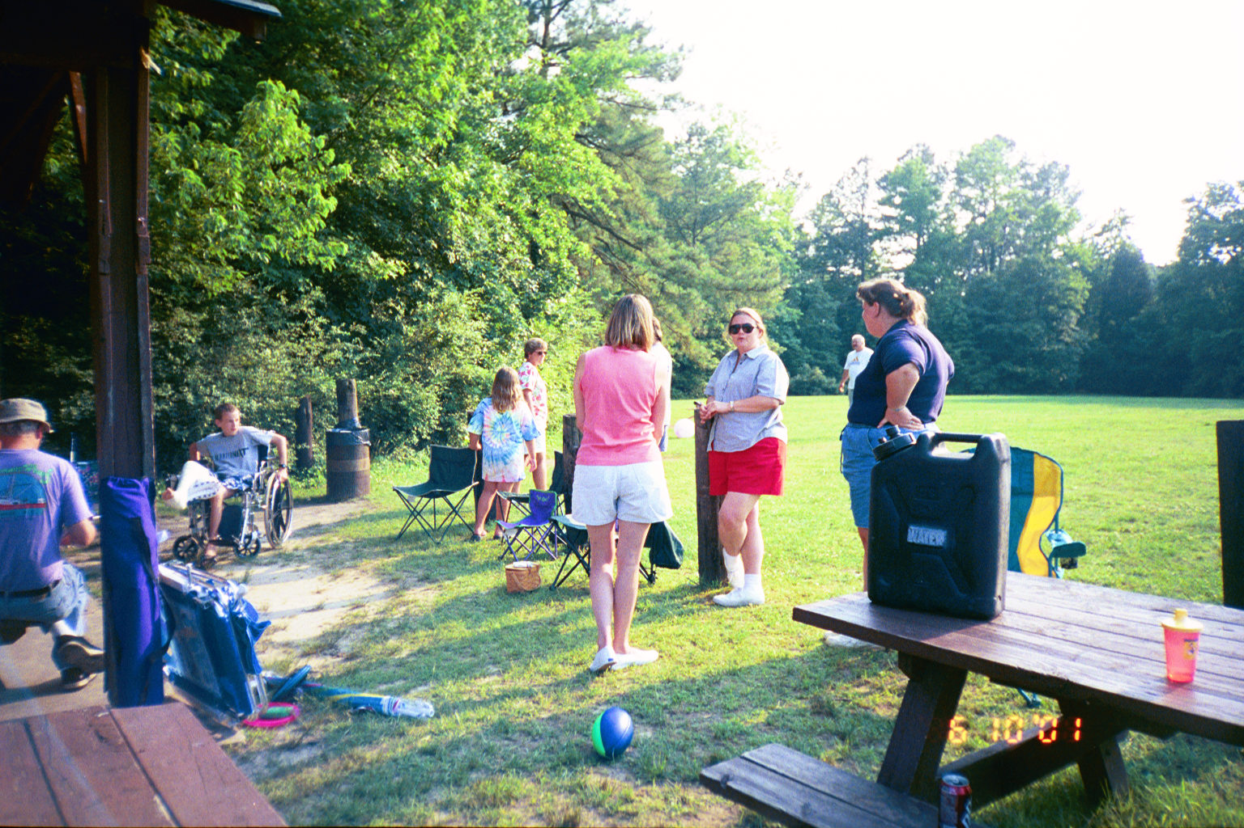
After dinner, the group continued to enjoy the activities at the park. Several young people once again hit the nature trail, the playground, and the tennis courts. William Powell taught several young people how to play horseshoes. And a number of young people and adults played an interesting game of volleyball--with a huge ball nearly three feet around!

The cook-out ended at 7:00pm with a brief and informal certificate ceremony.

Thanks to all who helped make the cook-out a wonderful time. Special thanks to Bill and Delores Duplissey, Bert and Robin Morris, Brian and Bonnie Maki, and Lisa and Steve Tarkington for their hard work preparing and serving an excellent meal!

As we close out this youth group season, special thanks go out to all the young people who participated in youth groups this year and to their parents who encouraged and supported their participation. And thanks to all our hard-working, dedicated youth leaders for making a difference in the lives of our young people.

Youth, Leaders Enjoy Youth Group Cook-Out

Over forty young people and leaders showed up at Bennetts Creek Park on Sunday, June 10, for the first annual Youth Group Cook-Out.

The cook-out started at 3:00pm with games and other activities. Several young people played tennis on the park’s two tennis courts, while the younger ones especially enjoyed the park’s modern playground equipment. Many young people also enjoyed walking along the nature trail. Rev. Palmer even tried out his angling skills on the park’s fishing pier!

Meanwhile, a number of young people and adults took to the field for a game of softball. The young people teamed up against the adults, but the pitching of Whitney Holland gave the youth a distinct advantage. The adults could barely manage a hit!

Around 5:00pm, the group stopped for a delicious dinner of hamburgers and hot dogs with all the fixings, chips, baked beans, and drinks. Brownies and watermelon were served to top off the meal.
Youth and leaders enjoy a delicious meal!

Leaders converse while the young people play!
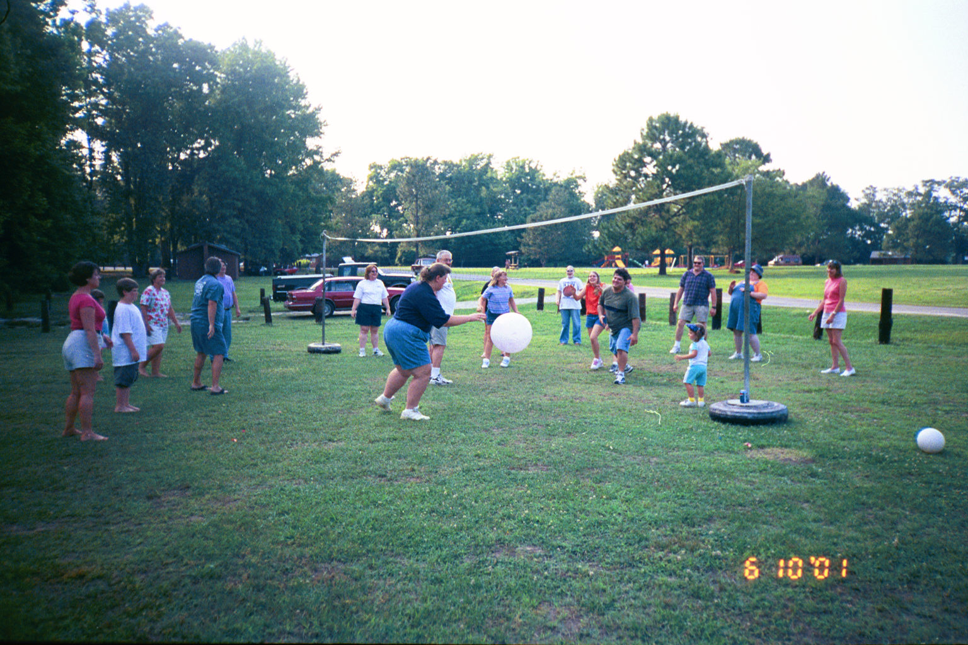
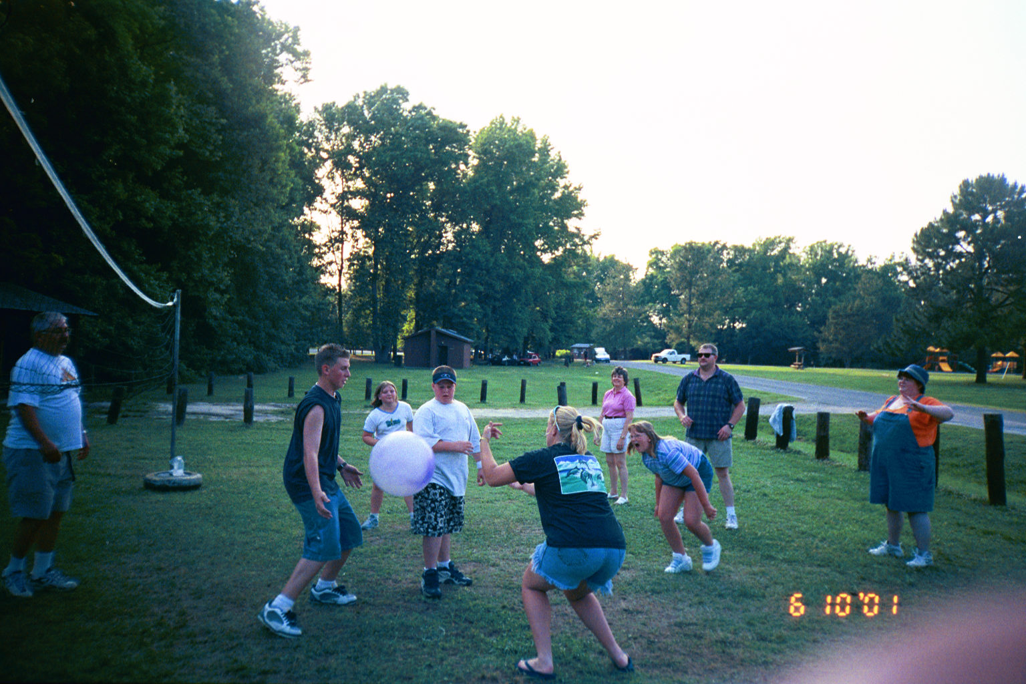
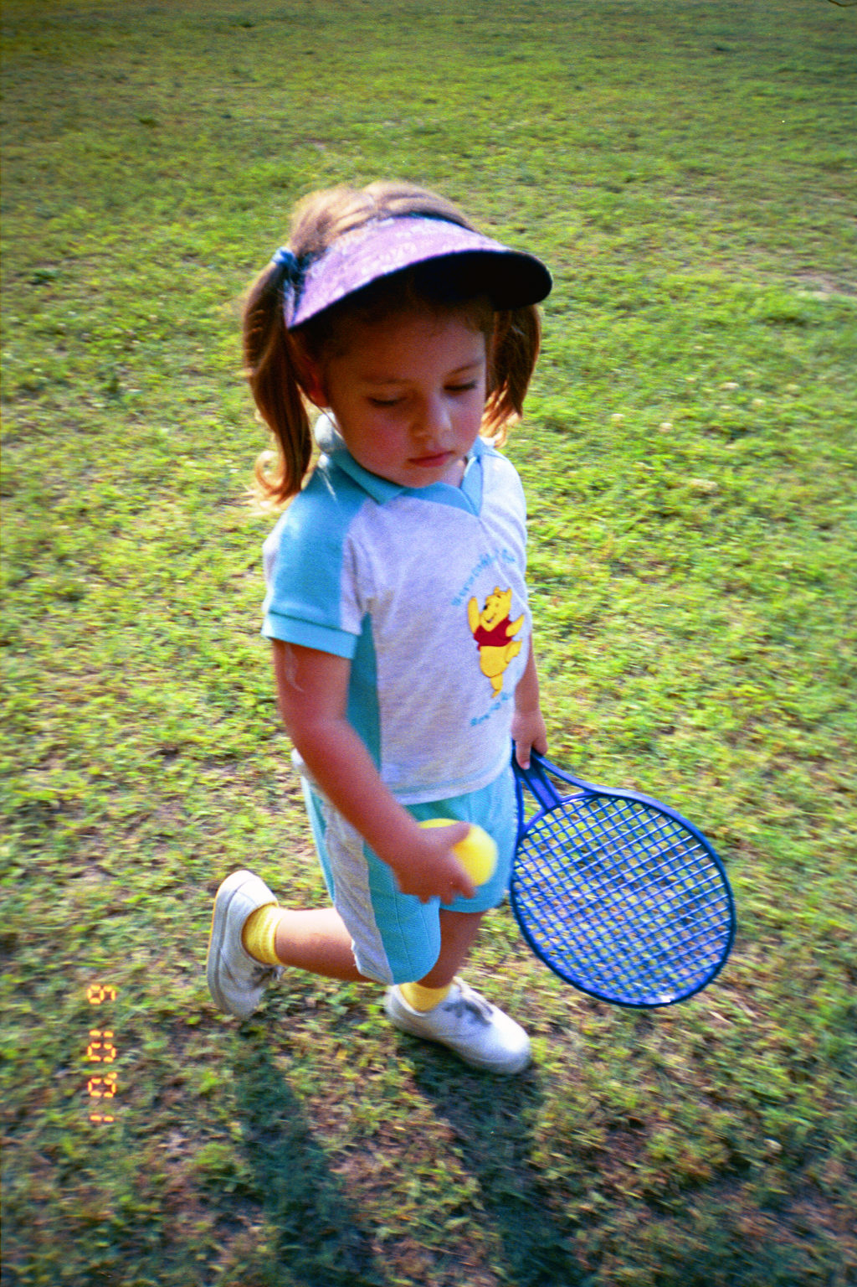
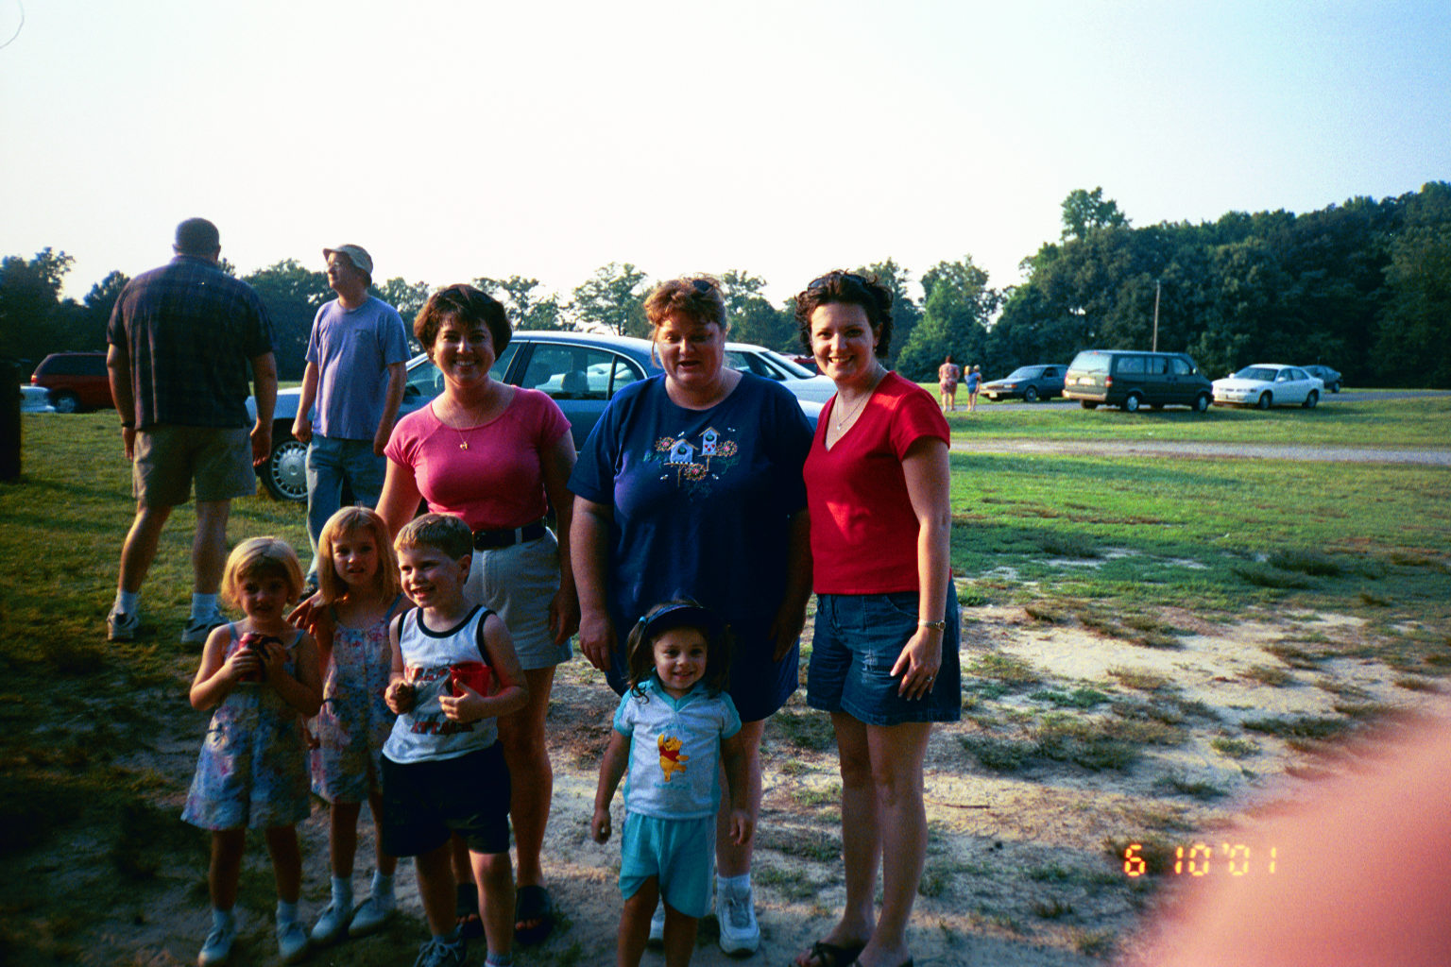
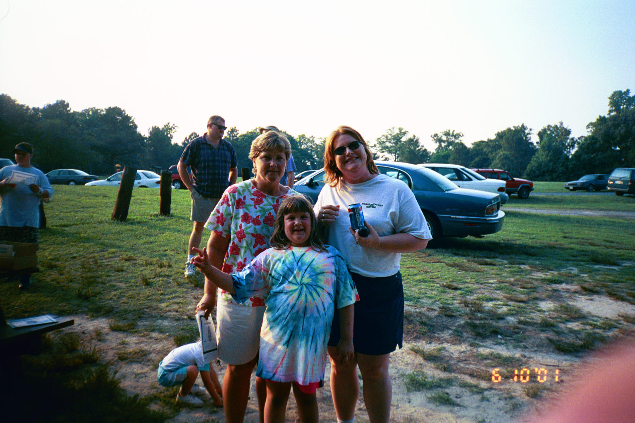
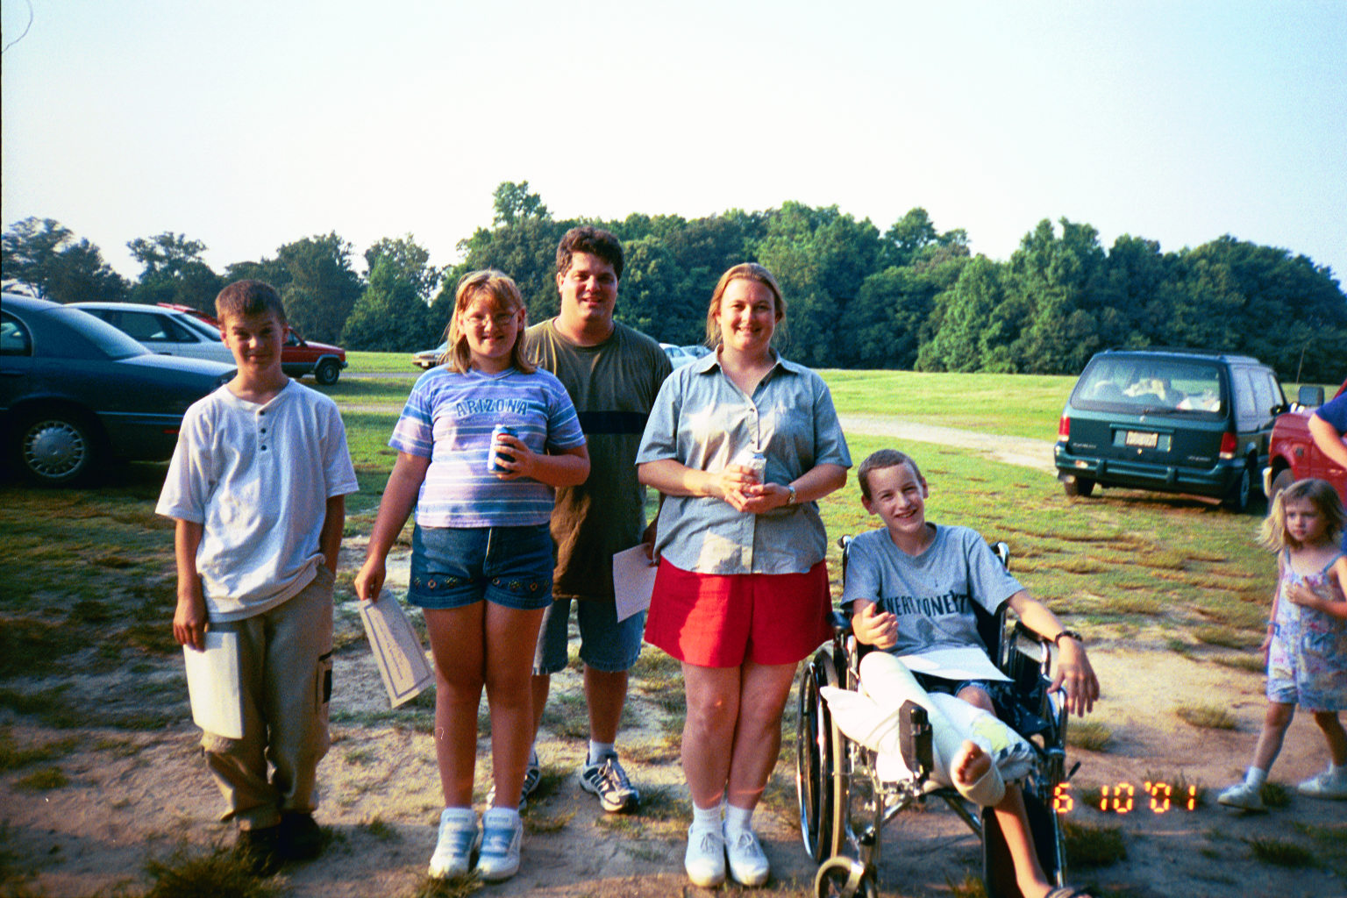
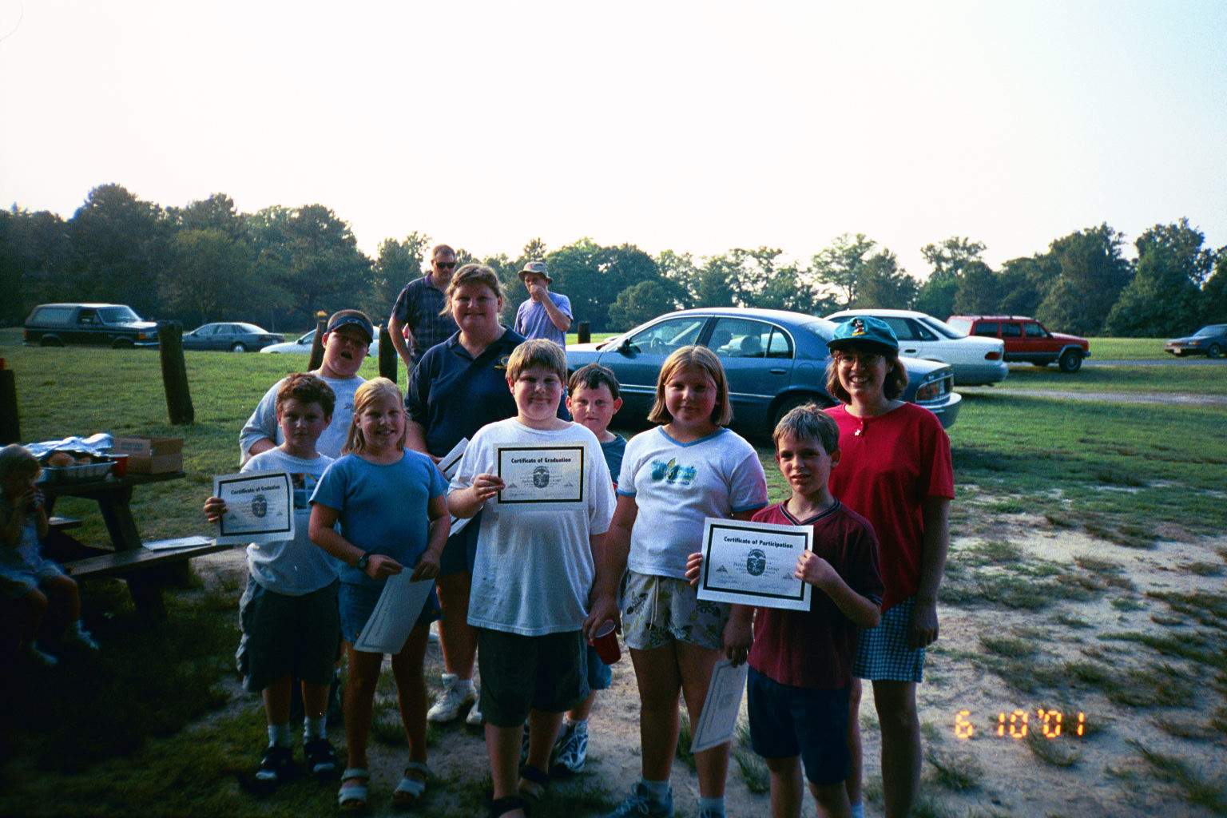
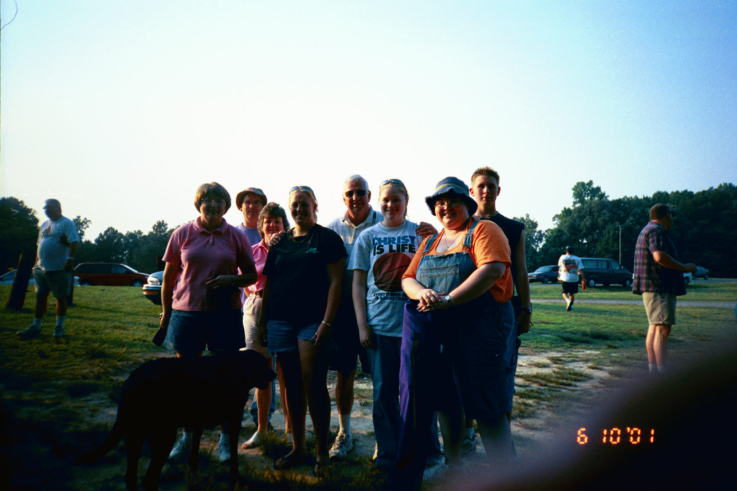

Youth Group Cook-Out Photo Gallery
A wacky game of volleyball!
I got it!
Tennis, anyone?
Scooters (with David’s finger!)
Alphas
The Youth Groups of Bethlehem
Omegas (yep, you guessed it!)
Pathfinders (with no finger)
Voyagers (with that pesky finger again!)

