
Youth Newsletter
February 2004
Alphas, Omegas Enjoy Wintry Trip, Although Skiing Gets “Snowed Out”

On Saturday, January 24, 29 junior and senior high youth, leaders, and parent volunteers left for the mountains near Harrisonburg, Virginia, for more than two days of fun and fellowship.

The group’s original plan included snowtubing and skiing or snowboarding at Massanutten. However, about 6 inches of snow caused an abrupt change in plans after the group arrived in Harrisonburg.

The adventure started on Saturday at about 12:00noon, as youth and parents arrived at Graham Hall and began to pack the vehicles for the trip. Although snow was in the forecast, it was not anticipated that the snow would affect the group’s plans at Massanutten on Sunday evening and Monday.

The group left the church on schedule at approximately 12:45pm. At about 5:00pm, the group arrived at the Days Inn in Harrisonburg, checked in, and unpacked their vehicles. The group then went to a nearby Cracker Barrel restaurant for dinner, and returned to the hotel to enjoy the indoor heated pool and hot tub for the rest of the evening.

On Sunday at 10:00am, the group attended the morning worship service at Grace Covenant Church in Harrisonburg. To begin the service, a praise and worship band complete with keyboard, guitar, bass, drums, percussion, and over a dozen singers led the congregation in almost 45 minutes of both energetic and worshipful singing. Dual video projectors flashed the song lyrics on the church walls in front of the congregation. One member of the praise and worship team waved large beautiful __
gold and white flags in rhythm to the music during several songs, while another member—a young physically-challenged woman—used sign language instead of singing the praise and worship songs. After announcements, prayer, and an offering, guest speaker Dawn Sweigart delivered an insightful, funny, and passionate message.

Although the church service was very different, and somewhat longer, than our own, several youth found some of the things that made it different quite interesting. And most understood that, although different denominations worship in different ways, what really matters is that we’re all worshipping the same God with all of our hearts.

(cont’d on page 4, Ski Retreat)

Pathfinders’

Trail Hike

Sunday, February 1, 2004

12:30pm-2:00pm

immediately after lunch
during the Regular Meeting time

children participating will be working to earn their Trail Hikes activity badge
ALPHAS
February 1 Regular Meeting, 12:15pm-2:00pm
Souper Bowl Sunday • please bring a non-perishable food item for the Food Pantry
February 8 Regular Meeting, 5:45pm-7:30pm
February 15 Regular Meeting, 5:45pm-7:30pm
February 22 Youth Group Family Skating Party, 5:15pm-7:15pm • Smithfield Skate
February 27- Alphas/Omegas World Vision 30
February 28 Hour Famine, time & details TBA
February 29 Youth Concert, 5:30pm-8:00pm

OMEGAS
February 1 Regular Meeting, 12:15pm-2:00pm
Souper Bowl Sunday • please bring a non-perishable food item for the Food Pantry
February 8 Regular Meeting, 5:45pm-7:30pm
February 15 Regular Meeting, 5:45pm-7:30pm
February 22 Youth Group Family Skating Party, 5:15pm-7:15pm • Smithfield Skate
February 27- Alphas/Omegas World Vision 30
February 28 Hour Famine, time & details TBA
February 29 Youth Concert, 5:30pm-8:00pm

For more detailed information about your group's schedule, please contact your group's leaders.

SCOOTERS
February 1 Regular Meeting, 12:15pm-2:00pm
Souper Bowl Sunday • please bring a non-perishable food item for the Food Pantry
February 8 Regular Meeting, 5:45pm-7:30pm
February 15 Regular Meeting, 5:45pm-7:30pm
February 22 Youth Group Family Skating Party, 5:15pm-7:15pm • Smithfield Skate
February 29 Regular Meeting, 5:45pm-7:30pm

VOYAGERS
February 1 Regular Meeting, 12:15pm-2:00pm
Souper Bowl Sunday • please bring a non-perishable food item for the Food Pantry
February 8 Nursing Home Trip, 12:00noon-3:30pm • see article this page for info
February 15 Regular Meeting, 5:45pm-7:30pm
February 22 Youth Group Family Skating Party, 5:15pm-7:15pm • Smithfield Skate
February 29 Regular Meeting, 5:45pm-7:30pm

PATHFINDERS
February 1 Regular Meeting, 12:15pm-2:00pm
Souper Bowl Sunday • please bring a non-perishable food item for the Food Pantry
February 8 Regular Meeting, 5:45pm-7:30pm
February 15 Regular Meeting, 5:45pm-7:30pm
February 22 Youth Group Family Skating Party, 5:15pm-7:15pm • Smithfield Skate
February 29 Regular Meeting, 5:45pm-7:30pm

YOUTH GROUP SCHEDULES
Voyagers, Children’s Choir to Visit Nursing Home

On Sunday, February 8, the Voyagers club and other members of the Children’s Choir are planning to visit the nursing home residents at either Nansemond Pointe or Lake Prince, and to perform a number of songs for the residents during their visit.

The group will leave church at 12:00noon, immediately following the Morning Worship service, and will return to church at approximately 3:30pm. The Voyagers club will not meet that evening during the Regular Meeting time.

Children are asked to bring $3.00 each for lunch at McDonald’s.

The group plans to return to church by 3:30pm. The Voyagers club will not have their Regular Meeting that nught.


Sunday, February 1 is

Souper Bowl Sunday!

Special Regular Meeting time
12:15pm-2:00pm
(following Morning Worship)
lunch provided

please bring a non-perishable food item to help restock Bethlehem's Food Pantry for the needy in our community

Youth Coordinator's Corner
by David Salerno
The Youth Coordinator’s Corner will take a short break this month in order to make room to report the many things that are going on in the Youth Groups at Bethlehem. But there's one thing I just have to share with you that occurred during the Alphas/Omegas Youth Ski Retreat this past weekend.

It's very encouraging and makes me feel great to receive compliments on our youth program here at Bethlehem from members of the congregation and the community. It lets me know that the efforts of the leaders, the volunteers, and everyone else involved are recognized and appreciated.

However, when I received spontaneous, unsolicited compliments on the behavior of our youth on two different occasions while dining after church at the Applebee's restaurant in Harrisonburg, well, that made me feel especially proud. These compliments—from complete strangers, in a town where we knew no one and no one knew us—struck me from out of the blue, like lightning from above. They reaffirmed what I have always known, that we have an outstanding group of young people led by an incredible group of leaders and volunteers.

Let there be no doubt. Every member of Bethlehem Christian Church should be proud of their young people and the way in which they represent the church and Christ to others. I couldn't be prouder myself.
Alphas, Omegas to Participate in World Vision 30 Hour Famine

On Friday, February 27 and Saturday, February 28, Bethlehem’s junior and senior high youth will go without food for 30 hours so that others less fortunate children may eat.

Over 29,000 children die every day due to hunger and hunger-related diseases.

World Vision’s 30 Hour Famine is an international youth movement to fight hunger and change the lives of the famine participants and hungry children all over the world.

This year, thousands of youth groups in more than 21 countries—over 1 million youth worldwide—will unite with one goal in mind: to help children living in some of the most deplorable conditions on earth.

Youth will be seeking donors and sponsors in the congregation and our local community. It takes only $30 per month—just $1 a day—to feed and care for a child through World Vision, even in the most remote of locations.

Then, beginning after lunch on Friday, the youth will not have any solid food to eat until they break their famine at dinner on Saturday.

While participating in the Famine, the group will get a real taste of what hunger is like, and will participate in various activities that will unite the youth and make a lasting impact on their lives.

World Vision is a non-profit Christian relief organization that is dedicated to meeting the needs of children, families, and communities all over the world. World Vision has been helping people in need for over 50 years. Each year, more than 80 million people in almost 100 countries receive the hope of a brighter future through thousands of World Vision projects worldwide.

When a junior or senior high youth asks you to sponsor them for the World Vision 30 Hour Famine, please consider helping to fight hunger all over the world and to spread the love of Christ to a world in need. Thank you in advance for your support and prayers.

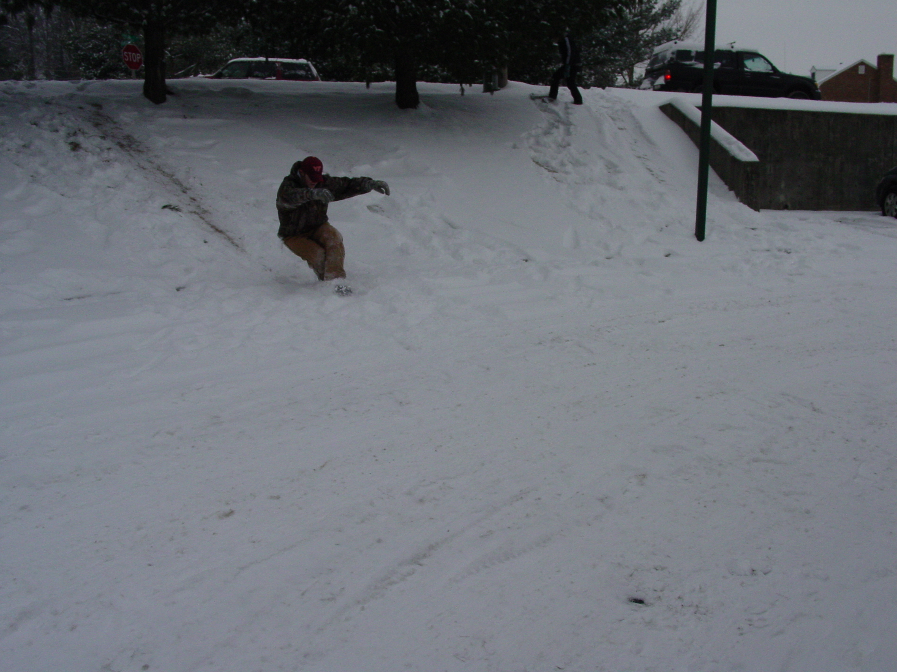
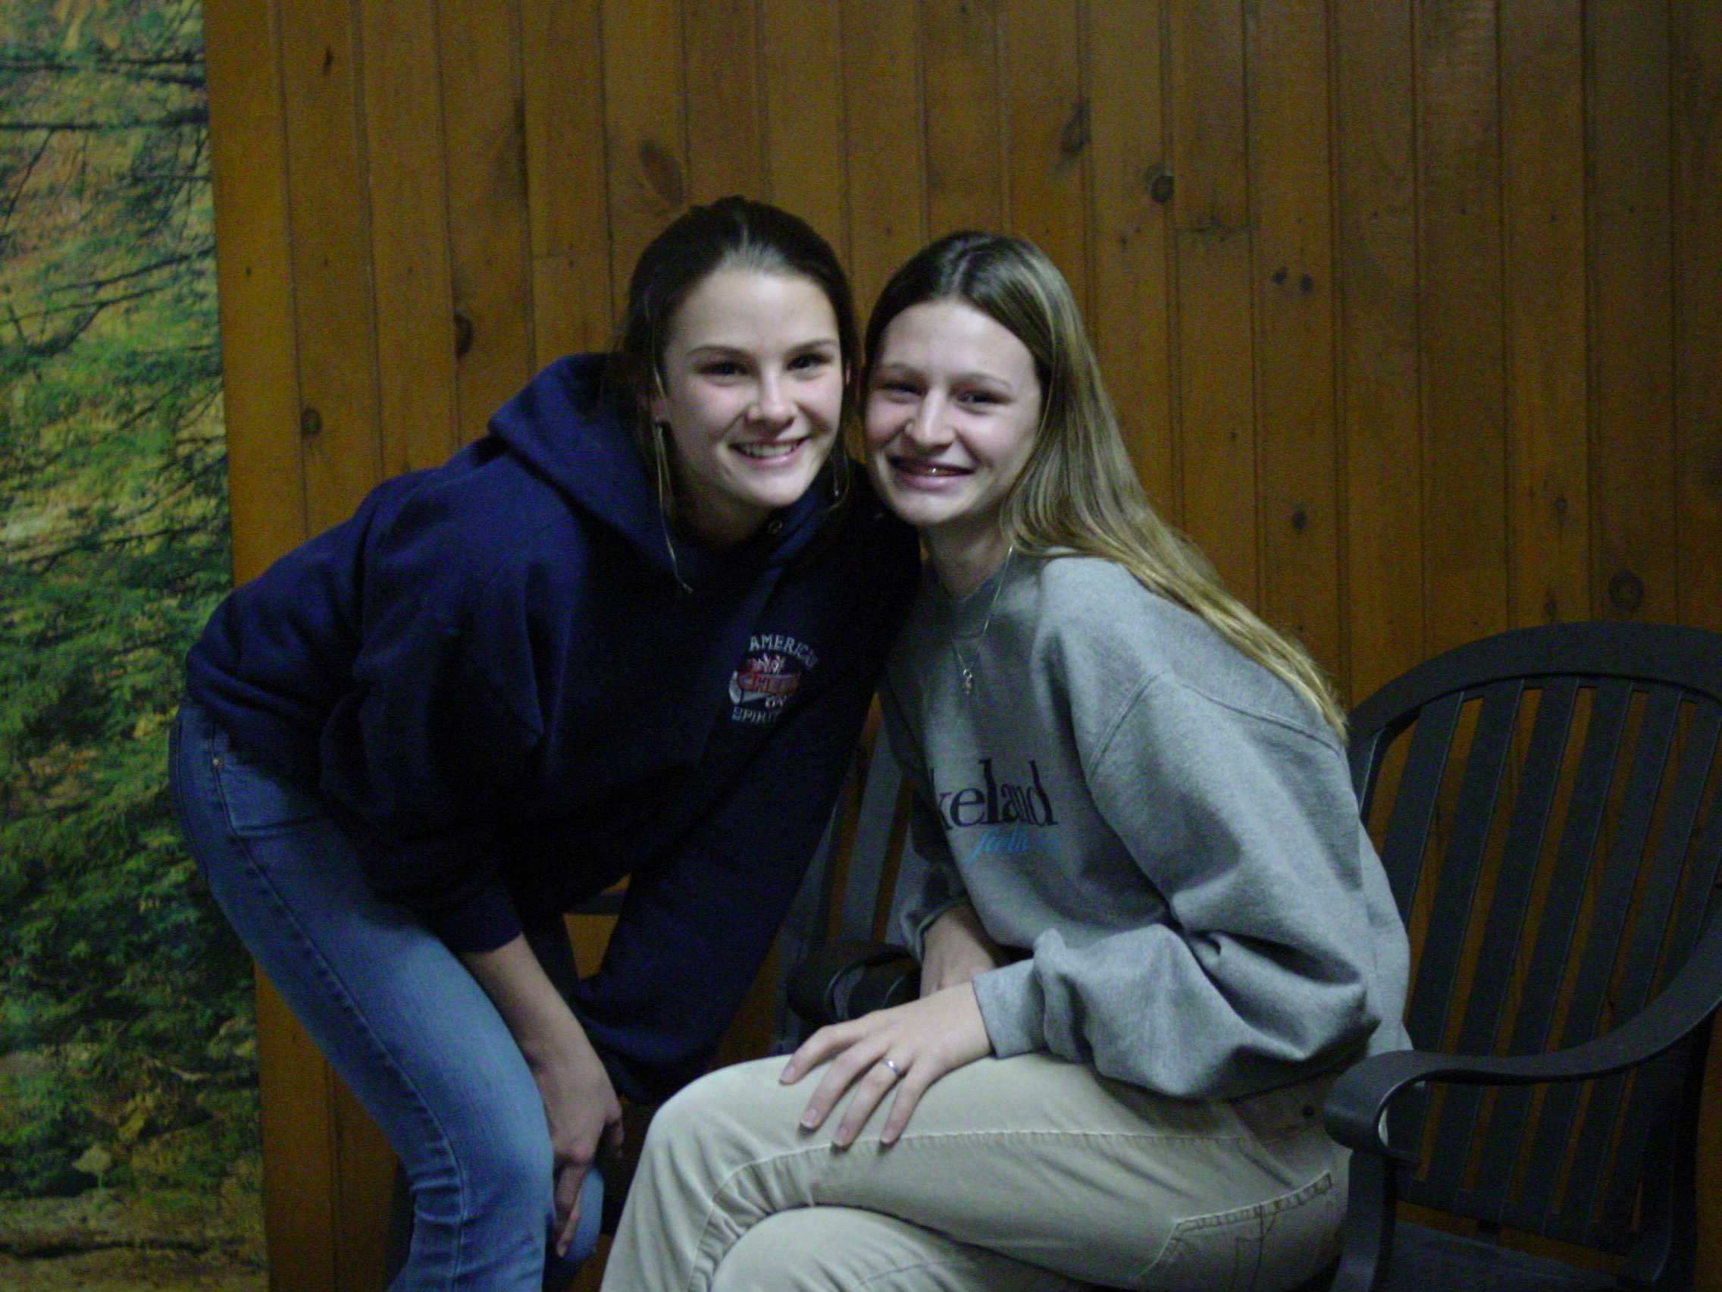

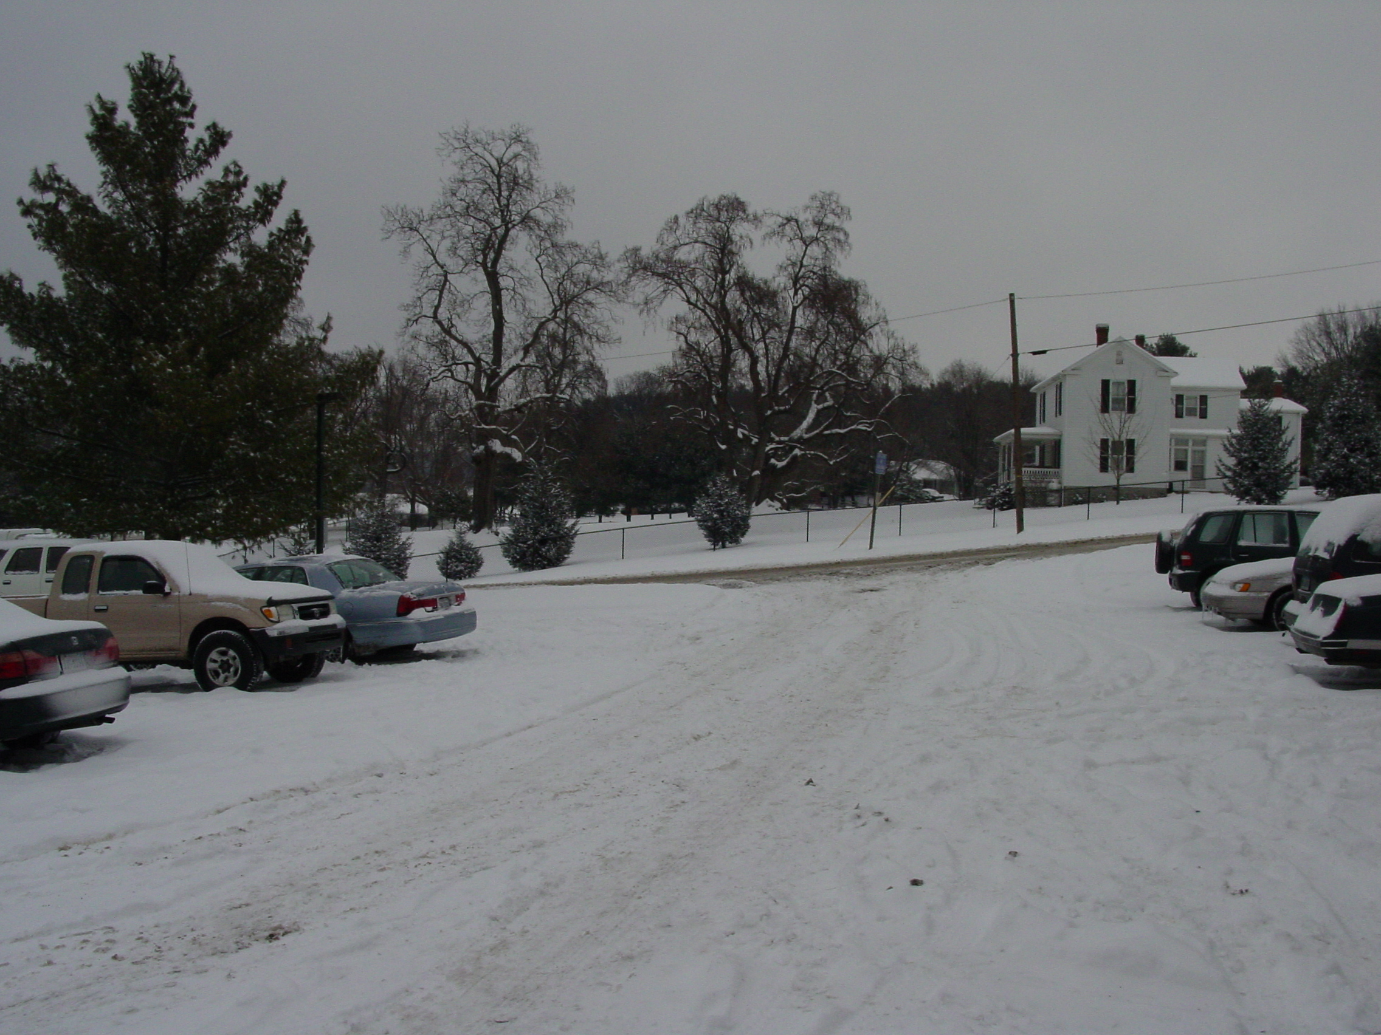
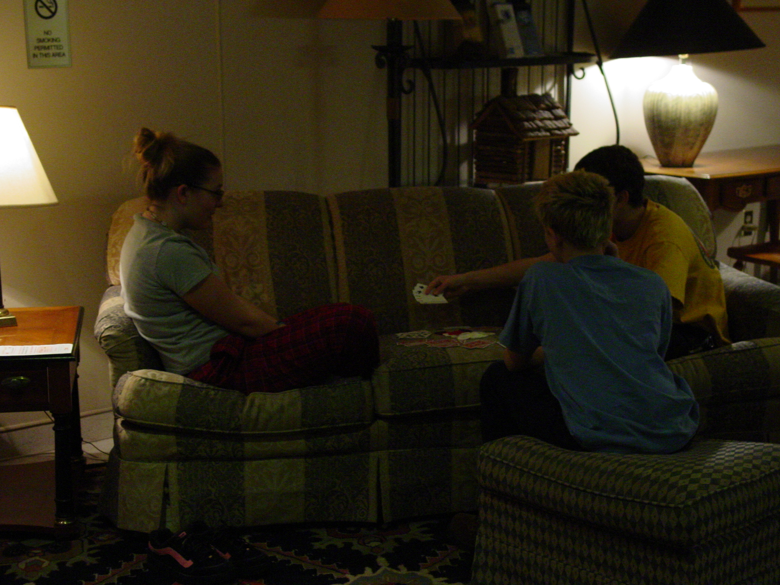
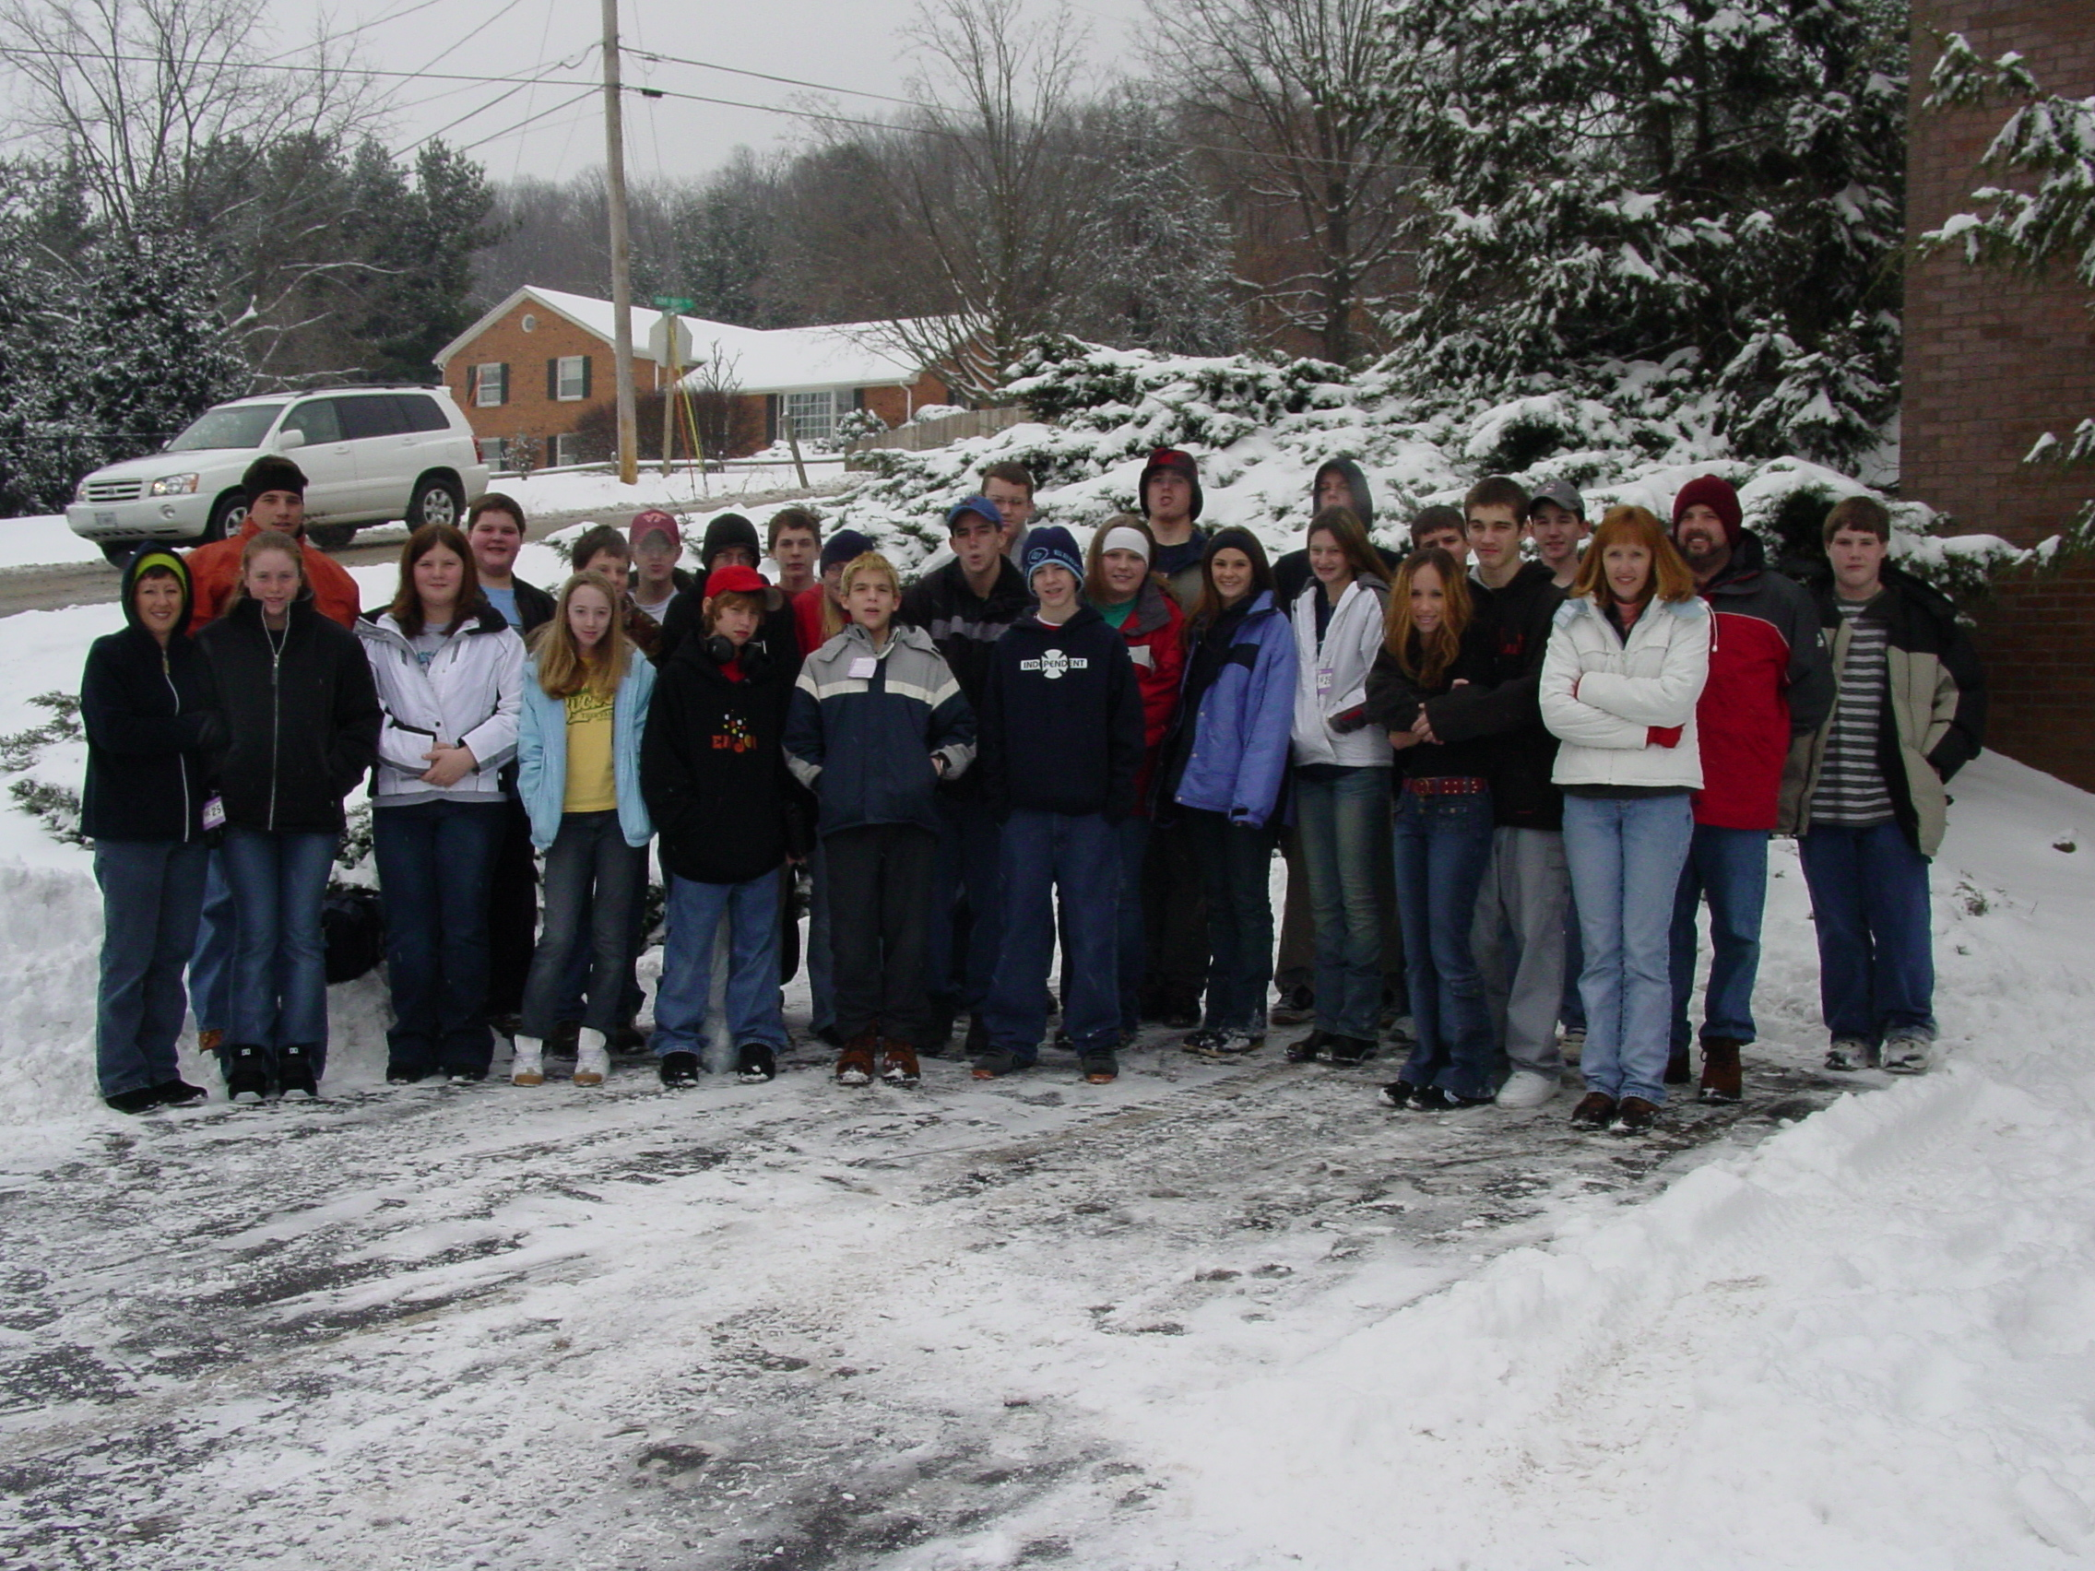
(Ski Retreat, cont’d from page 1)

Following the worship service, the group went to lunch at a nearby Applebee’s restaurant. Shortly after their arrival there, the snow began to fall.

After lunch, the group returned to the hotel to rest and relax for a few hours before their scheduled snowtubing session at 7:00pm.

Although there was much concern about the worsening conditions, the leaders called Massanutten and were assured that the roads leading up to the snowtubing park were passable. However, on their way to Massanutten, the group found much snow and ice on the road, and was forced to make its way very slowly to avoid skidding.

The group arrived at Massanutten at 7:00pm, just in time for the snowtubing session. Although the snowtubing session continued until 9:00pm, the group decided to leave early due to concerns about the worsening weather conditions.

On their way back from Massanutten, the group found even more snow and ice on the road, and continued to make its way very slowly. However, despite all of the group’s efforts, one of the vehicles did slide off the road surface into a shallow ditch and had to be pulled out by another vehicle.

The group finally arrived back at the hotel safe and sound, although just a little shaken, at about 10:00pm. The group then ordered pizza delivery to the hotel, while the leaders discussed their plans for the next day. After much discussion, due to the road and weather conditions, the leaders decided to _
cancel their plans for skiing or snowboarding at Massanutten the next morning.

The group awoke Monday morning to a beautiful snow-covered landscape. Some took a final dip in the hotel’s pool and hot tub, while others played outside in the snow. Several enterprising youth found a small hill just outside the hotel and used cardboard pizza boxes as makeshift sleds.

After packing the vehicles and having a time of devotion, the group left for home at about 11:00am. The group returned using the interstate highways, and found them to be in generally good condition. The group stopped for lunch at a Western Sizzlin’ restaurant just beyond Staunton, and returned to Graham Hall around 6:00pm, five hours earlier than the scheduled return time of 11:00pm.

Although some were disappointed at not getting the chance to ski or snowboard, the safety of the youth was of the utmost concern to the leaders. The group nonetheless enjoyed a great time of fun and fellowship, making memories and learning lessons that will last a lifetime.

The day of skiing or snowboarding that was canceled will be rescheduled and announced at the Regular Meeting on Sunday, February 1. Youth who went on this trip will be given the choice of going on the rescheduled trip, or having their lift ticket, rental, and lesson costs refunded. And youth who could not go on this trip will be given the opportunity to sign up for the rescheduled trip.

Special thanks to all who made this trip possible, but especially to the parents of the youth for entrusting us with the care of your children.

