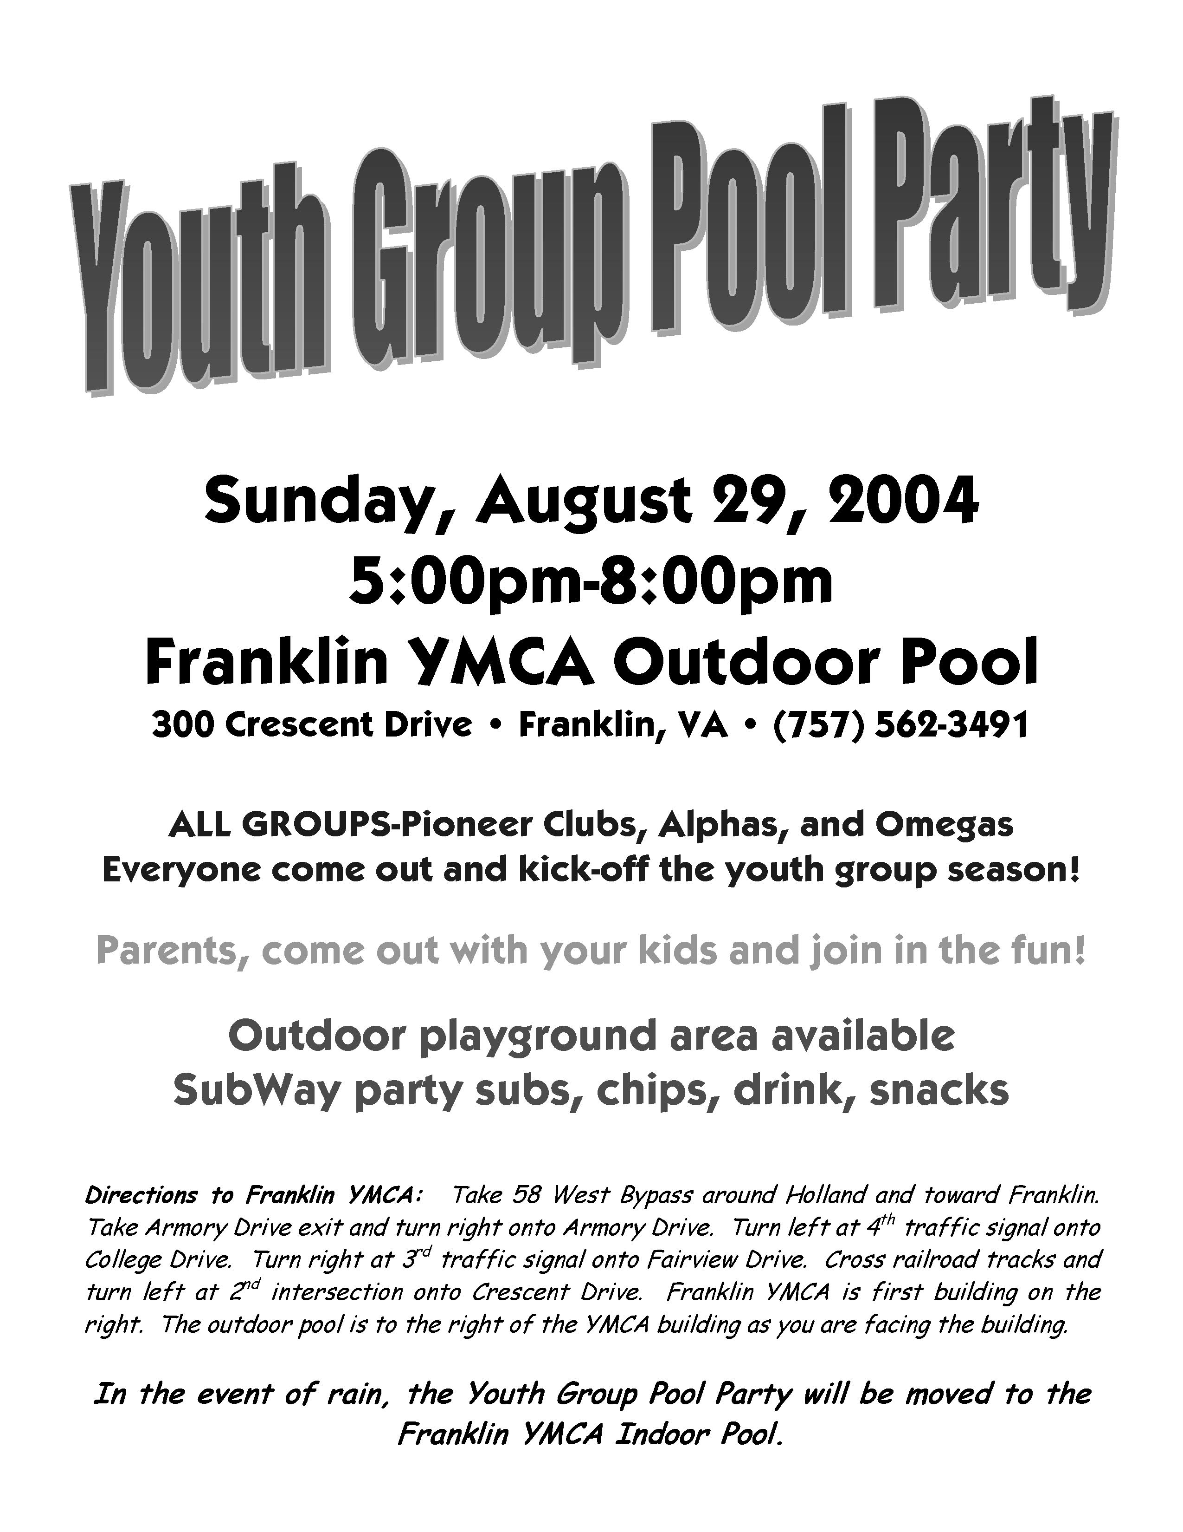
Youth Newsletter

The Youth Groups at Bethlehem Christian Church

July 2004
Over 50 Youth, Parents, Leaders Enjoy Cook-Out

The Youth Groups at Bethlehem closed out the 2003-2004 season on Sunday, June 6, with a cook-out at Bennett’s Creek Park.

“As the clouds rolled in, I began to get a bit worried that the weather might ruin our afternoon," said David Salerno, Bethlehem’s Youth Coordinator. “Fortunately, the rain held off, and the clouds actually helped keep the temperature a bit cooler and the day a little more comfortable.”

Most of the younger children enjoyed the playground, complete with slides, swings, and ladders, while many of the older youth and adults took to the diamond for a competitive game of softball.

Several in the group participated in the other activities available at the park, such as horseshoes, tennis, nature walking, and fishing.

After about two hours of fun and fellowship, the group enjoyed a delicious dinner of hamburgers, hot dogs, baked beans, and potato salad, prepared and delivered by Ricky and Roy’s Catering. Fresh slices of watermelon were served for dessert.

Following dinner, a brief closing ceremony was held, certificates were passed out, and group pictures were taken.

Thanks to all who came out to enjoy the picnic, and all who helped make this youth group season great!

ALL GROUPS
August 29 Youth Group Pool Party, 5:00pm-8:00pm
Franklin YMCA
September 5 Regular Meeting, 5:30pm-7:15pm
September 12 Regular Meeting, 5:30pm-7:15pm
September 19 Regular Meeting, 5:30pm-7:15pm
September 26 Regular Meeting, 5:30pm-7:15pm

For more detailed information about your group's schedule, please contact your group's leaders.

The complete Fall 2004 Youth Group Schedule will be available soon. Please visit the Youth Group Web Site at http://www.bccyouth.org for the latest schedule information!
YOUTH GROUP SCHEDULES

Check out the fresh, new look!
http://www.bccyouth.org

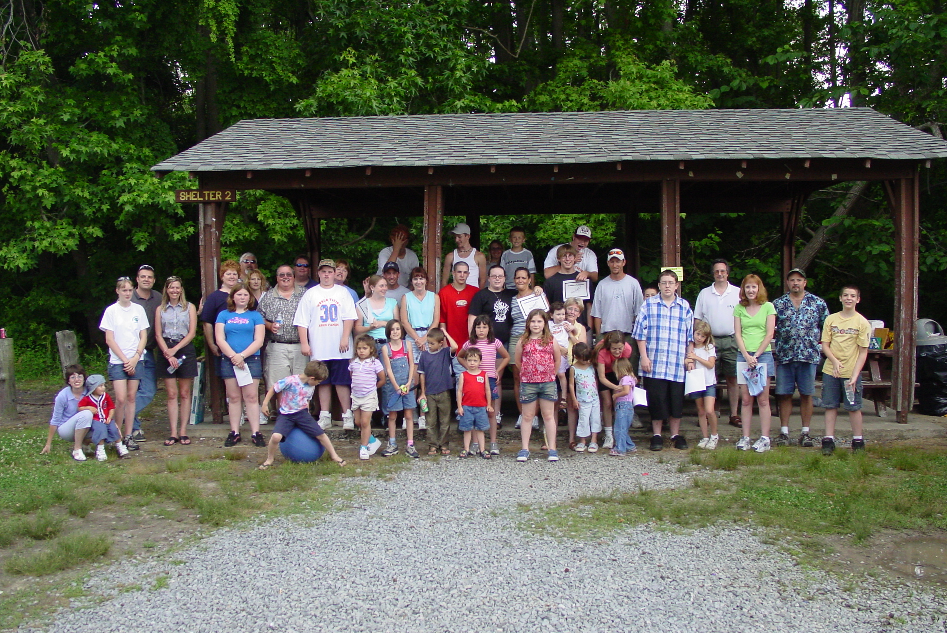
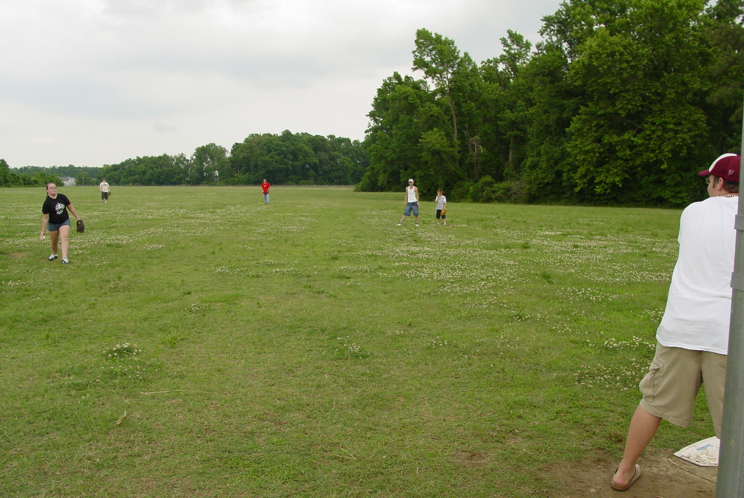
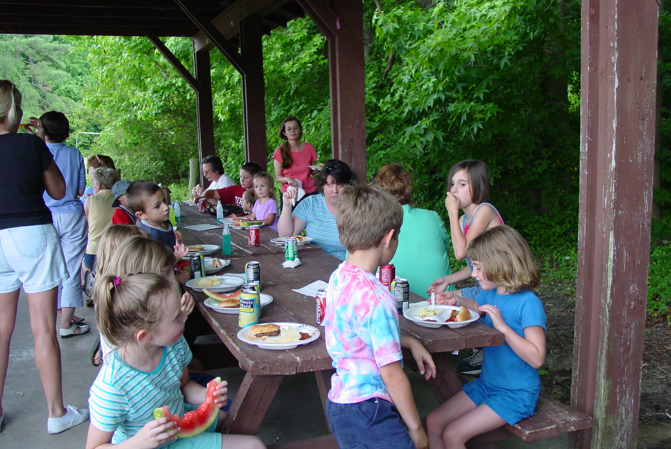
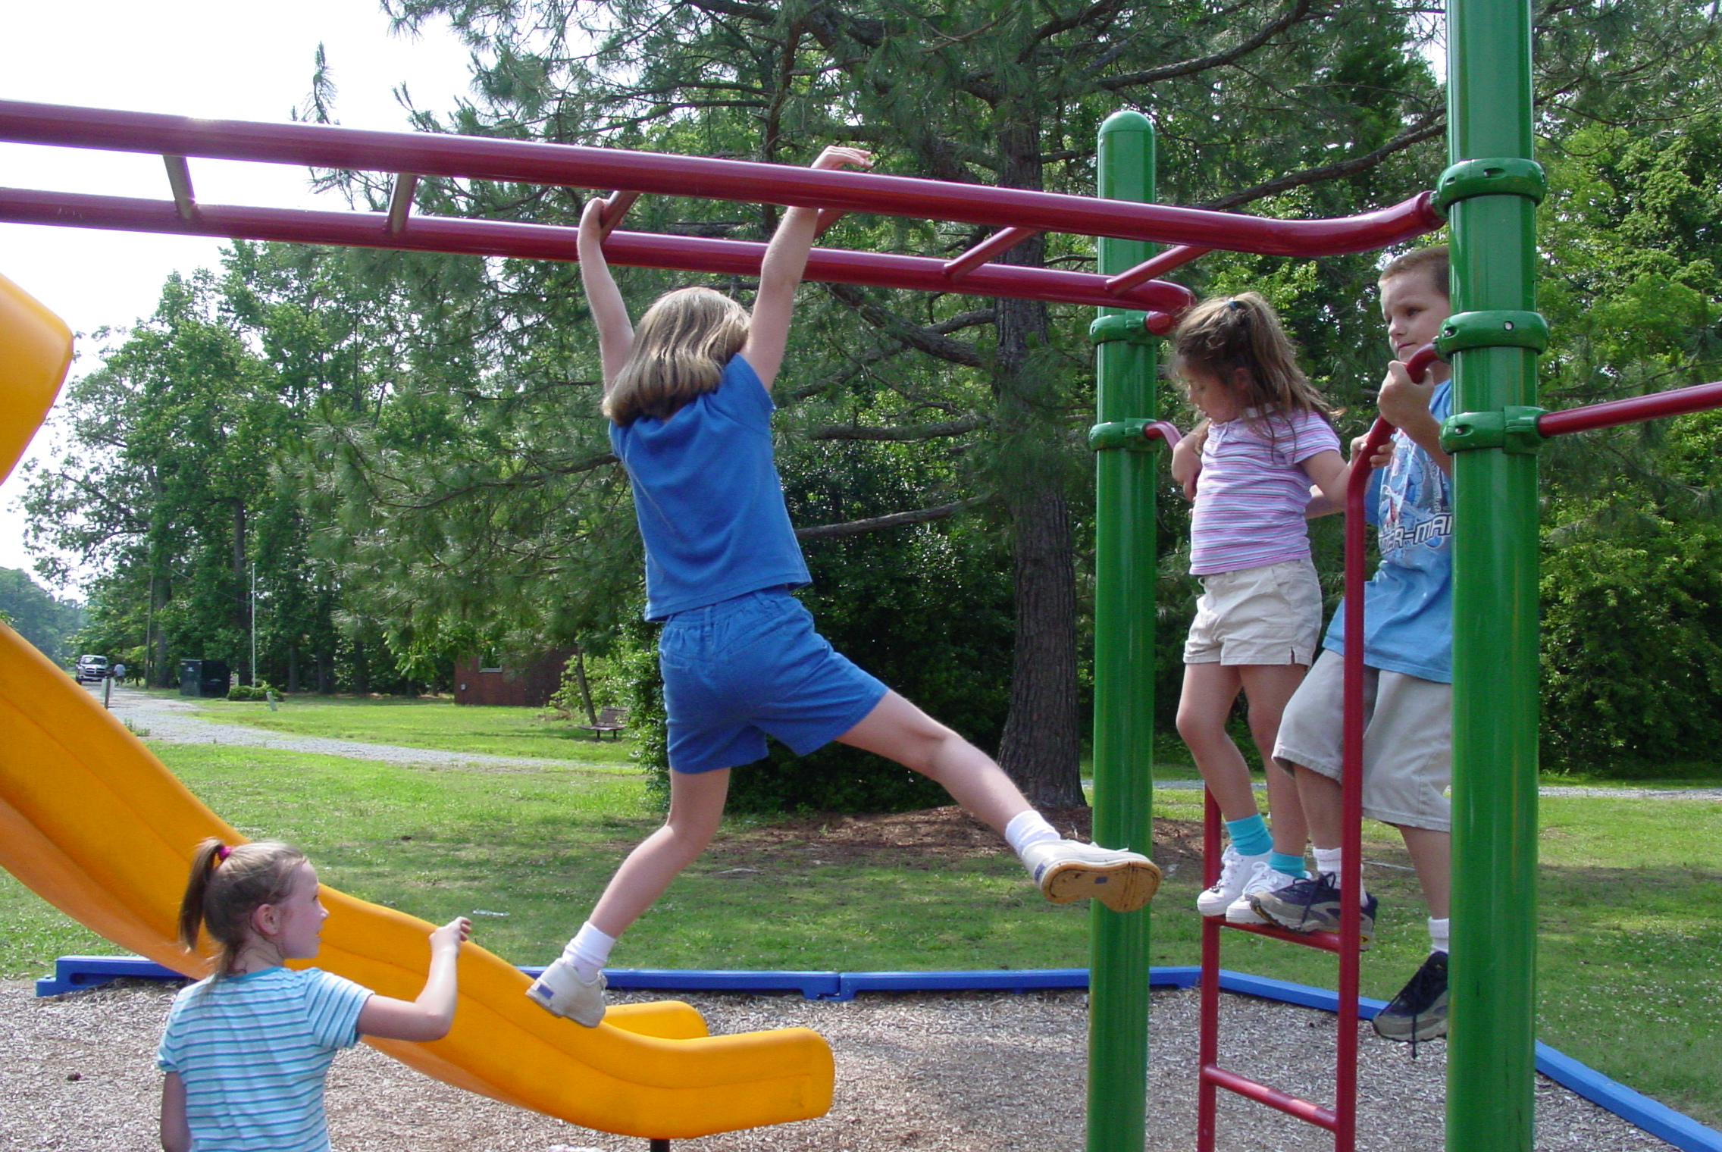

Youth Coordinator's Corner
by David Salerno
Over the past several months, I have talked in detail about the three elements I think are critical to a successful youth fellowship program—fun enjoyable activities, church and community projects, and practical Christian instruction.

While I feel it is important to include all three of these elements in Bethlehem’s youth fellowship program, I feel it is just as important to insure that they are included in the proper balance.

Balance is important in our diet for a number of reasons. A balanced diet helps to insure that we get vitamins and nutrients from a variety of sources, and that we develop healthy, interesting eating habits.

Balance in a youth fellowship program works in much the same way.

Balance helps to insure that children learn about Jesus and Christian living from a wide variety of sources—lessons, experiences, interactions, activities, and projects that help them to put their faith into action.

Balance and variety help to keep children interested and involved in a youth fellowship program, and to keep the program exciting and “fresh”.
Even teaching methods benefit from balance and variety.

By incorporating a variety of teaching methods into their lessons, teachers and leaders better reach all types of learners. Children learn in many different ways—some children are visual learners, while others learn better by experiential methods. By using a variety of teaching techniques, and incorporating a wide assortment of teaching tools, such as discussions, educational games, music, visual cues, etc., the needs of children of all learning styles are addressed.

It is important to remember that balance should be a “long-term” measure. There may be short periods where there appears to be a lack of balance and variety, such as a month in which no activities are planned, or several weeks in a row of nothing but activities and projects. The important thing is that, over a period of time, such as several months, children are given a variety of opportunities for participation and learning, and a fair balance of the three critical elements is maintained.

Balance and variety are essential to a successful, growing youth fellowship program. I am dedicated to insuring that Bethlehem has a healthy, balanced program that meets the needs of youth and families in both the church and the surrounding community.

Until next month, God bless,
Youth Group Cook-Out Photo Gallery
Visit http://www.bccyouth.org
and click on the Scrapbook button
for even more Cook-Out photos!

