Youth Newsletter

The Youth Groups at Bethlehem Christian Church

October 2004
Youth Groups Kick Off 2004-2005 Season With Pool Party

On Sunday, August 29, nearly 50 youth, leaders, and parents kicked off the youth group season with a pool party at the Franklin YMCA.

Youth and adults alike enjoyed swimming in the outdoor pool, while the younger children also had fun climbing and sliding on the outdoor playground. The group also enjoyed a dinner of Subway party subs, chips, drinks, and snacks.

"It was great to see everyone come out and have fun together as we start off the 2004-2005 youth group season," commented David Salerno, Bethlehem's Youth Coordinator. "That’s what youth group is all about—children and families having fun and growing together.”

The Youth Group Pool Party was the first of a number of special events planned for the youth this fall.

On October 16, the Alpha and Omega youth will be taking a trip to Kings Dominion for the theme park’s annual Christian Family Days. While at the park, youth can enjoy special music and performances by Christian youth groups and bands, all at a special discounted admission price. Trip details and a permission slip will be available at the Regular Meeting on October 3.

On October 17, all three Pioneer Club groups will take a trip to Whidbee Lane Farm, where they will experience the cornfield maze, the petting zoo, crop exhibitions, and other unique sights at the Holland tourist farm. The groups will leave after the Morning Worship service, and will not have a Regular Meeting that evening. Details and a permission slip will be available soon.

(continued on page 2)
(Kick Off, continued from page 1)

On October 31, the junior and senior high youth will be going door-to-door in the community for their annual Trick-or-Treat for UNICEF campaign. They will have information about the programs sponsored by the international children’s charity, and join young people all over the world soliciting donations to help children in need.

Also on October 31, Bethlehem will host its second annual Community Harvest Festival. Featuring games, crafts, prizes, popcorn, cotton candy, and more, this event is the perfect opportunity to invite your friends to join in the fun at Bethlehem!

On November 7, Youth Sunday, the youth of the church will take over the responsibility of teaching Sunday School and leading the Morning Worship service. This is wonderful learning experience for our young people, and a great opportunity to see our youth put their faith into action in the church.

On November 14, the Alphas and Omegas will be treated to a Youth Concert, featuring the modern “rock-rap” music of local Christian band Hemotheory. The youth of other area churches and the community will also be invited.

On December 12, the children and youth will present their annual Children’s Christmas Play. Practices will be held before each Regular Meeting for several weeks before the play. Following the play, the children will enjoy their annual Christmas Party, where they will receive a visit from a special visitor from the North Pole!

Individual clubs may have other special events planned throughout the year, so please be sure to stay in touch with your group leaders for the latest schedule information.

And plans are already being considered for special events in the winter and spring, including our annual Alpha/Omega Youth Ski Trip, participating in the World Vision 30-Hour Famine, and going on a summer mission trip.

We are looking forward to an active and fun-filled youth group season, and hope your young person will join us and participate in The Youth Groups at Bethlehem!
YOUTH GROUP SCHEDULES

SCOOTERS • VOYAGERS •

PATHFINDERS

October 3 Regular Meeting, 5:30pm-7:15pm
October 10 Regular Meeting, 5:30pm-7:15pm
October 17 Trip to Whidbee Lane Farm, time TBA
October 24 Regular Meeting, 5:30pm-7:15pm
October 31 Community Harvest Festival, time TBA
November 7 Youth Sunday, 9:30am-12:00noon
Regular Meeting, 5:30pm-7:15pm

ALPHAS • OMEGAS

October 3 Regular Meeting, 5:30pm-7:15pm
October 10 Regular Meeting, 5:30pm-7:15pm
October 16 Kings Dominion Trip, time TBA
October 17 Regular Meeting, 5:30pm-7:15pm
October 24 Regular Meeting, 5:30pm-7:15pm
October 31 Tick-or-Treat for UNICEF, 12:00noon-3:00pm
October 31 Community Harvest Festival, time TBA
November 7 Youth Sunday, 9:30am-12:00noon
Regular Meeting, 5:30pm-7:15pm

For more detailed information about your group's schedule, please contact your group's leaders.

Alphas Visit Nursing Home

On Sunday, September 26, the Alpha Youth Group visited the residents at Nansemond Pointe Nursing Home.

The group was sure to visit every resident listed in the bulletin, but had extra time and visited other residents as well.

While visiting, the children gave the residents brightly-colored suncatchers, which they had painted by hand over the previous two weeks, to decorate their rooms.

The residents enjoyed and were very appreciative of the children’s visit.

Nothing is impossible
for those who trust in the Lord!

Be sure to visit

http://www.bccyouth.org

for the latest information about The Youth Groups at Bethlehem!


Youth Coordinator's Corner
by David Salerno
On Saturday, September 18, we had the privilege of hosting a Pioneer Clubs Leader Training Workshop here at Bethlehem Christian Church.

Earlier in the summer, I was asked by a Pioneer Clubs representative if would be willing to host a seminar. “Certainly,” I said, and, after checking the availability of the church, I scheduled the seminar for the third Saturday in September.

As things progressed and details emerged, I realized that we were going to be the only church in Virginia to host a Pioneer Clubs seminar.

I also realized that, due to scheduling and traveling conflicts, Pioneer Clubs was not going to be able to send a workshop leader to Virginia, and that I would have to take on the responsibility of leading the workshop myself.

Pioneer Clubs did, however, send a detailed workshop presentation guide and overhead transparencies to help me lead the workshop.

In the days preceding the workshop, I set up the display tables, projector, and other needed equipment in Graham Hall, and practiced my presentation with a number of “dry runs”.

When the day approached, 20 people came to attend the seminar, some from as far away as Danville and Fredericksburg. Three new and returning leaders from Bethlehem attended the workshop as well.

The attendees were greeted by a refreshment table filled with pastries, fresh fruit, juice, and coffee. Display tables exhibited the Pioneer Clubs curriculum, as well as the variety of optional materials that can be used within the Pioneer Clubs program. A special “ideas table” demonstrated several of the unique and creative ideas we have implemented here at Bethlehem, including our activity award organizers, our award display options, our curriculum storage organizers, and our Pioneer Bucks program.

At 9:00am, I began the workshop presentation. Over the next two hours, we discussed how to set up a Pioneer Clubs program, how to use the Pioneer Clubs curriculum, how to prepare for a Pioneer Clubs meeting, the different parts of a typical meeting, club discipline, and many other topics of interest. The attendees were led in detailed demonstrations of an actual Activity Award and a Bible Exploration, complete with a Bible Memory Award exercise. Throughout the presentation, I added helpful hints and “lessons learned” from our experience with Pioneer Clubs here at Bethlehem.

Overall, the workshop was an incredible success. Most people who attended the workshop were new or relatively new to Pioneer Clubs, and learned much from the workshop presentation. But even those who had been working with Pioneer Clubs for years gained from the workshop, leaving with new ideas and a fresh perspective.

A number of people worked hard to help make this workshop a great success. Special thanks to Janis Greene and Wanda Crumpler for providing the refreshments and setting up the refreshment table, and to Paula Thornton for handling the welcome and registration table. Also, special thanks to our nursery worker, Tiffany Ehrenfried, for being available to keep the nursery if needed.

Hosting the Pioneer Clubs Leader Training Workshop was a great opportunity to join with others and discuss how to more effectively use the Pioneer Clubs curriculum to reach children for Christ. I think we all left the better for it.

Until next time, God bless,




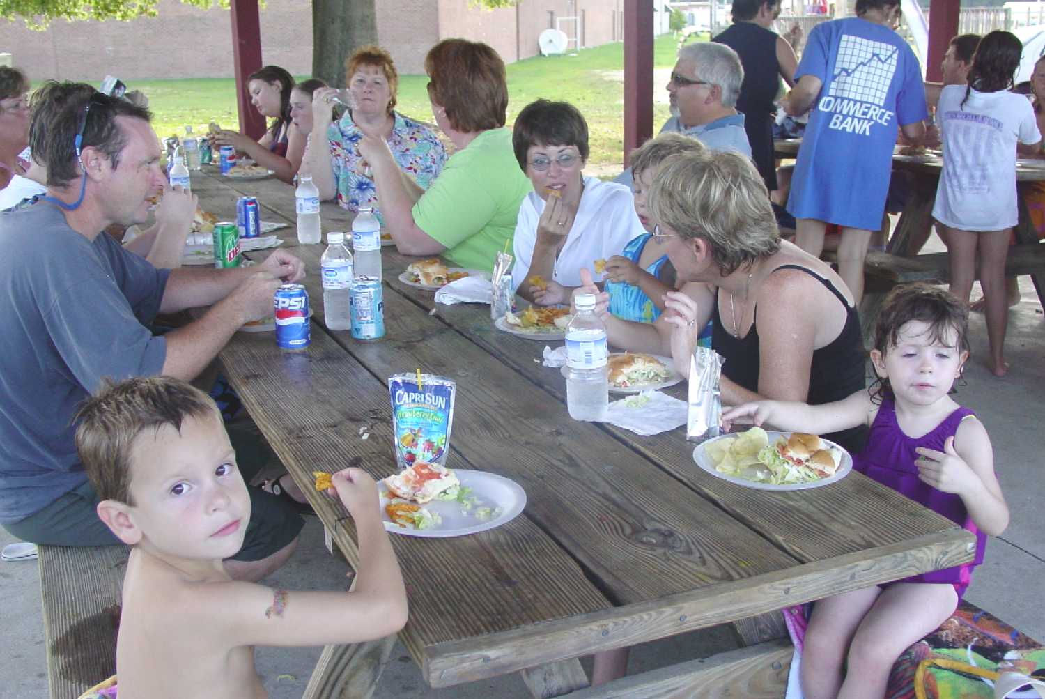

Kelly cruises around the pool with her noodle ➔

⬅ Ride ‘em, cowgirl!
⬅ Enjoying subs under the picnic shelter
Whitney and Victoria take a refreshing dip ➔
⬅ Susan helps Dixie do a back float
Hey, Kate! ➔

Youth Group Pool Party Photo Gallery

