Youth Newsletter
The Youth Groups at Bethlehem Christian Church

December 2005
YOUTH GROUP SCHEDULES

Third Annual Harvest Festival a Huge Success

On Sunday, October 30, Bethlehem Christian Church hosted its third annual Community Harvest Festival.

Beginning at 5:00pm, children from the church and the community gathered for food, games, and old-fashioned family fun.

In Graham Hall, the children could try their hand at various games of skill, such as the Pop-a-Verse Dart Throw, the Fishing Game, the Touchdown for Jesus Football Toss, the pumpkin-themed Bean Bag Toss, Bobbing for Apples, and the Candy Corn Relay. All who tried were rewarded with candy and prizes.

Also available in Graham Hall was a Cake Walk, where over twenty children and adults won prize cakes and pies, and Face Painting.

Outside, a Hay Ride took children on a thrilling trip around the church property in a trailer loaded with hay bales.

Many delicious treats were also served to the children, including hot dogs, drinks, popcorn, and cotton candy.

Throughout the evening, Christian clown Merry Heart made balloon animals and offered temporary tattoos. She also had a special presentation for the children, where she amazed them with an assortment of tricks and presented them with a Gospel message.

The festival ended with a costume contest for both the children and the adults. Medals were awarded for the top three costumes in each age division.

“This year’s Harvest Festival was a great success, with an estimated 150 children and adults coming out to enjoy the evening’s activities,” commented David Salerno, Bethlehem’s Youth Director. “Special thanks to Robert Lewis, chairman of the Harvest Festival Committee, for the tremendous effort he put into organizing the event.”

“But it was especially heart-warming to see so many people from the church volunteering in various capacities—it truly was a church-wide event. An extra-special ‘thank you’ to everyone who pitched in to make the festival a huge success.”



ALL CLUBS

December 4 Children’s Christmas Play
No Regular Meeting
December 11 Regular Meeting, 5:30pm-7:15pm
December 18 No Regular Meeting
Christmas Cantata
December 25 No Regular Meeting
Christmas Day
January 1 Regular Meeting, 5:30pm-7:15pm

For more information about your club's schedule, including any special events planned for your individual club, please contact your club's leaders.


Thanks to all who contributed to this year’s Trick-or-Treat for UNICEF fundraising campaign.

$185 was raised for children in need all over the world.

Thanks for your support!



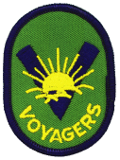
Pioneer Clubs
News & Notes

The Scooters club earned their “Growing Like Jesus” badge. During the past month, they also made “I Am Special” handprint banners, and recreated a village scene of Jesus at the temple.

The Voyagers club earned their “Special to God”, “Club Helper”, and “Bible Times” badges. As part of their badge requirements, they also reenacted scenes and activities from Biblical times.

The Pathfinders club earned their “God Made Us” Bible award, and their “Creative Fun” and “Exercise Fun” activity awards. The club also prepared 100 cards for Military Mail Call, and as part of their badge requirements, stamped some of the cards with creative Christmas designs.
Children, Youth Lead Congregation on Youth Sunday

Each year, on the first Sunday in November, Bethlehem’s youth accept the responsibility of teaching Sunday School and leading the Morning Worship service.

This year, on Sunday, November 6, Youth Sunday began with the junior and senior high school youth helping teach the children’s and adult Sunday School classes.

Following Sunday School, the youth led the Morning Worship service.

Junior ushers greeted worshippers as they arrived, tallied the number of people in the congregation, handed out visitor’s cards, and took up the morning offering.

The Youth Choir and Praise Team began the service by leading the congregation in a number of praise songs. During the service, this group also led the congregational hymns and sang the Anthem.

The Children’s Choir performed two songs during the service, and the Youth Chorus performed MercyMe’s popular hit, “I Can Only Imagine”. The Junior Handbell Choir also performed the Gathering Music.

Shane Culbertson was the Lay Reader, leading the Congregational Call to Worship and delivering the Offertory Prayer. Ashley Barber welcomed visitors and read the morning announcements, while Brooke Crumpler led the congregation in the Morning Prayer. Jacob Oliver and Kaleb Alexander taught the Children’s Sermon, while Brittany West and Claudia Graham helped with Children’s Church. Kelsey Greene read the Morning Scripture.

This year, Kristin Ranno and Nathan Neblett delivered the Morning Messages. Kristin discussed how God wants to use the problems we encounter for good in our lives, while Nathan encouraged us to trade our sorrows for God’s joy. Both of their sermons can still be heard online on the church web site at http://www.bccsuffolk.org.

We have much to be thankful for here at Bethlehem. Most importantly, we have an incredible group of young people who are ready, willing, and able to take on responsibility, as well as leadership roles, within the church.

Thanks to each young person who participated in Youth Sunday. Great job!

And special thanks to the Women’s Fellowship for serving lunch to the children, youth, and their families after the service.
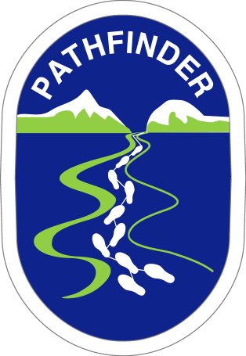
Omega Youth
Fudge Sale

• Chocolate
• Chocolate Pecan
• Peanut Butter

$5 per pound

Please place your order with any Omega Youth group member by December 7!

