Youth Newsletter
The Youth Groups at Bethlehem Christian Church

June 2006
YOUTH GROUP SCHEDULES

Youth Group Family Skating Party

Skye enjoys skating to the latest Christian music

Fran and Sarah stop for a picture

Good friends, good fellowship, great fun!
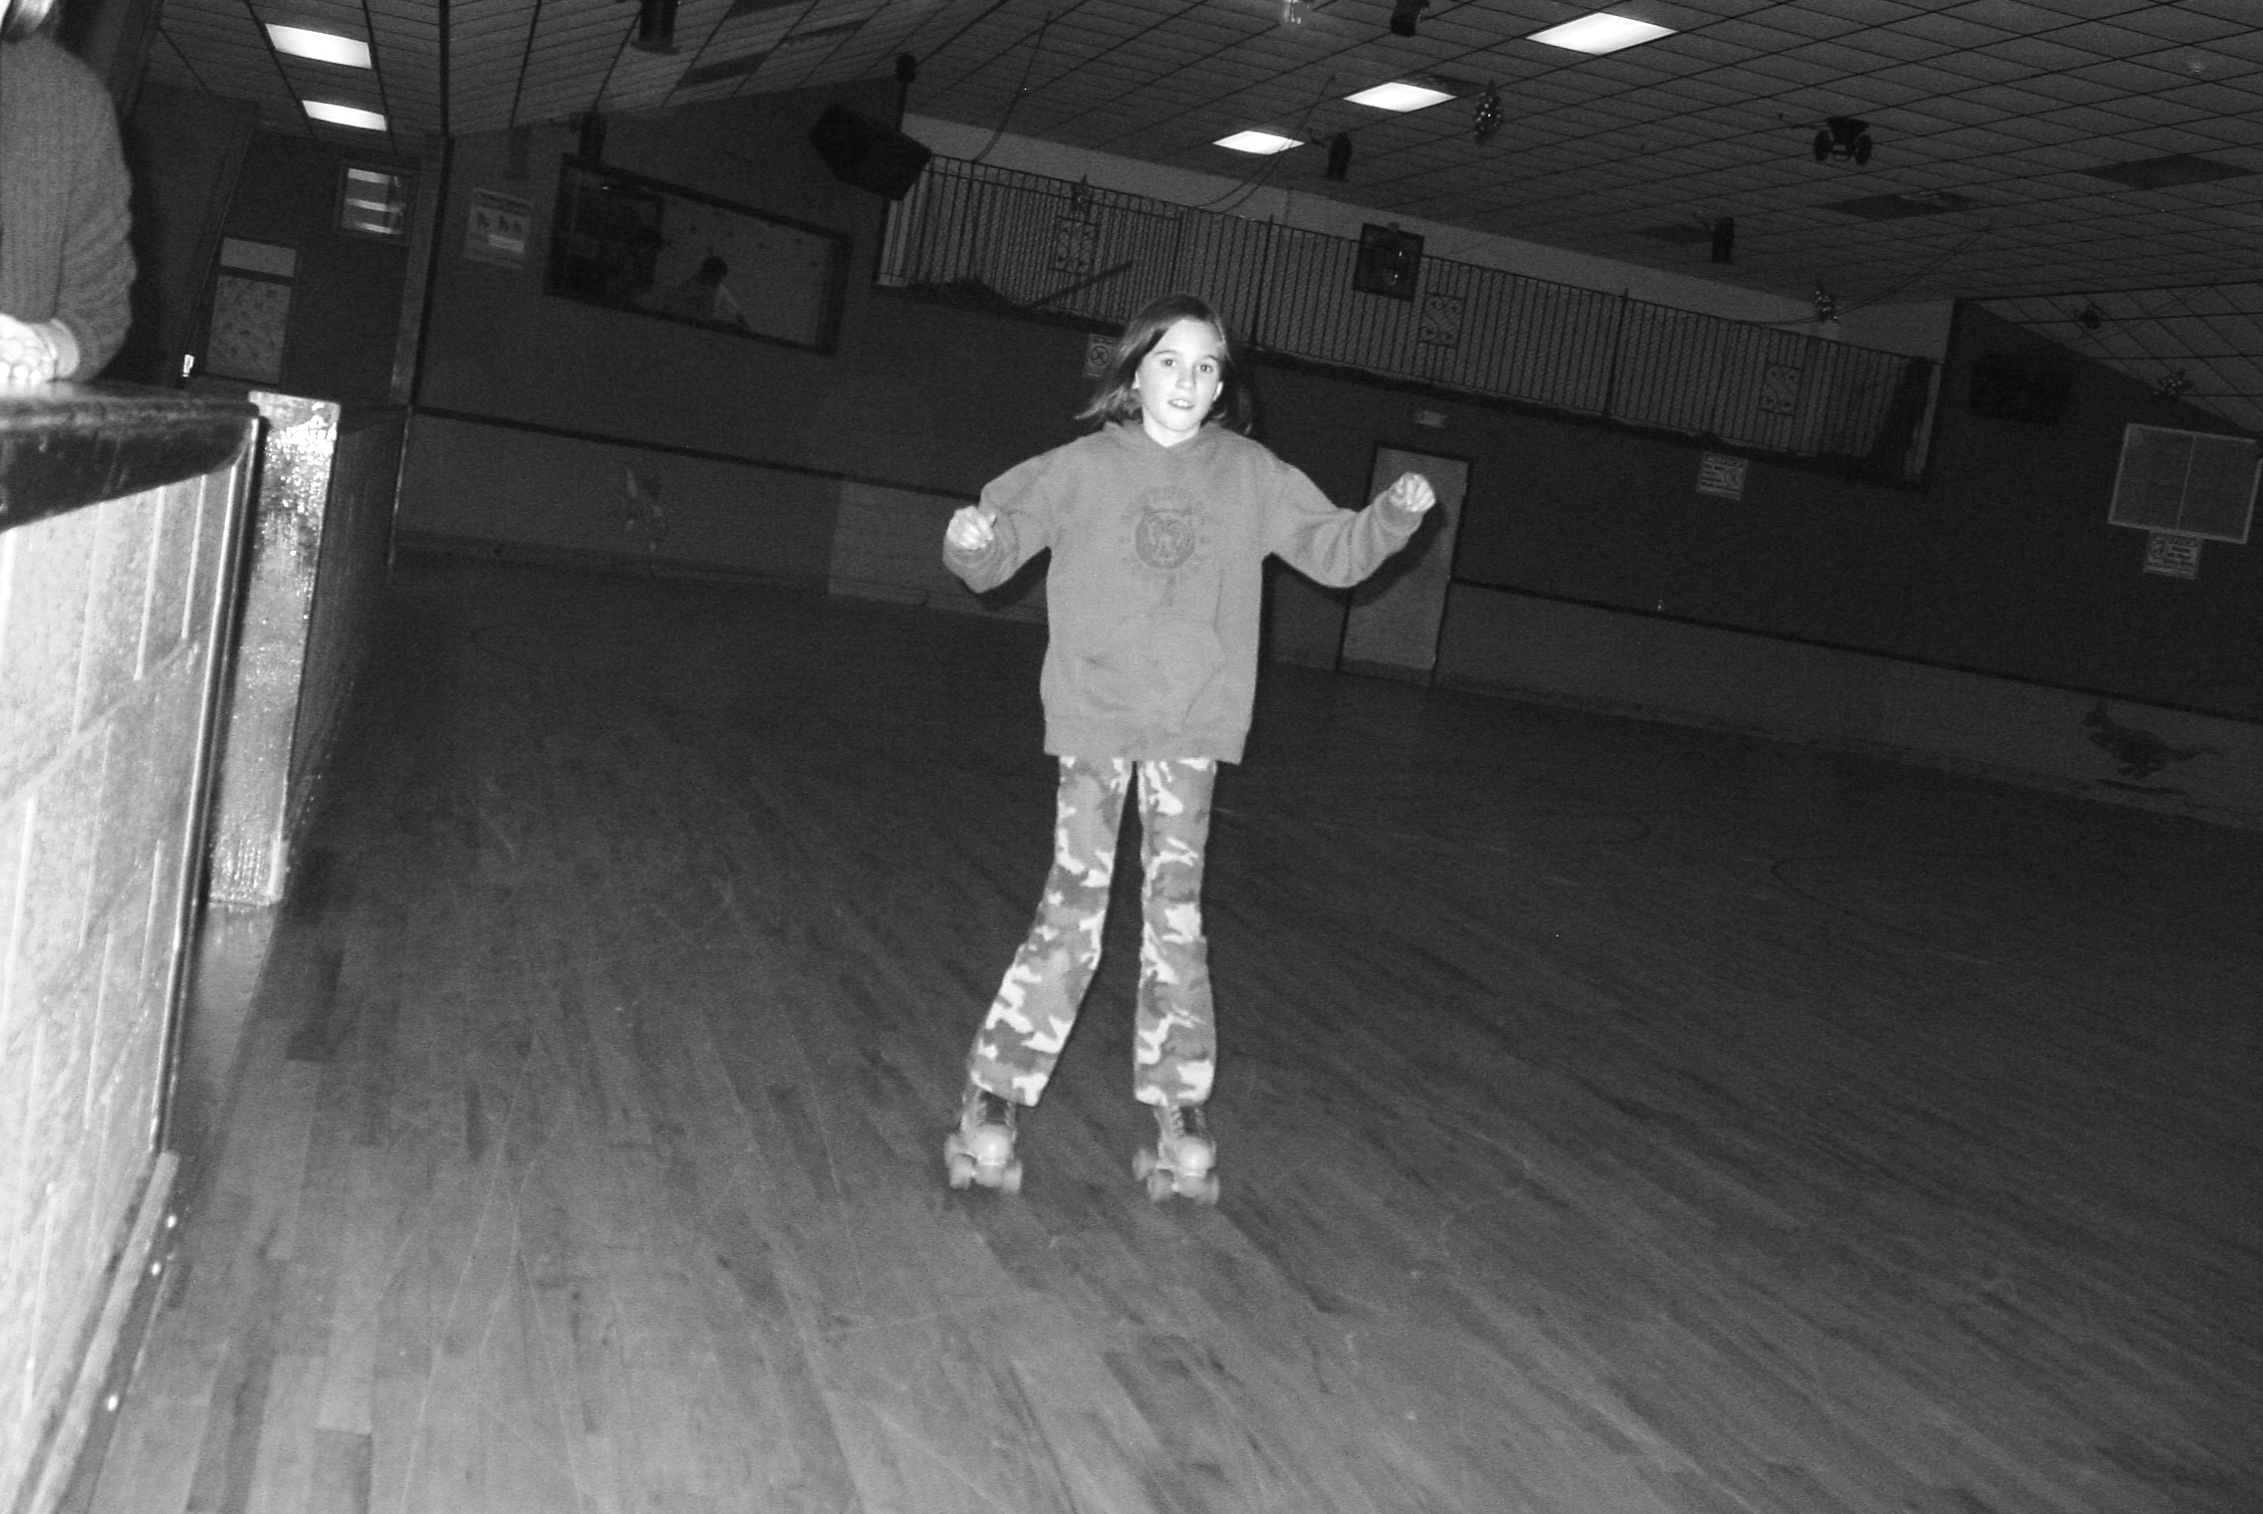
June 4 Youth Group Picnic, 3:00pm-7:30pm
Bennett’s Creek Park, Shelter #1
August 27 Youth Group Pool Party, time & details TBA

For more information about your club's schedule, including any special events planned for your individual club, please contact your club's leaders.

Nursing Home Visit

The Voyagers and Alphas look for residents to visit

The groups stops for treats at Sonic

Good friends, good fellowship, great fun!

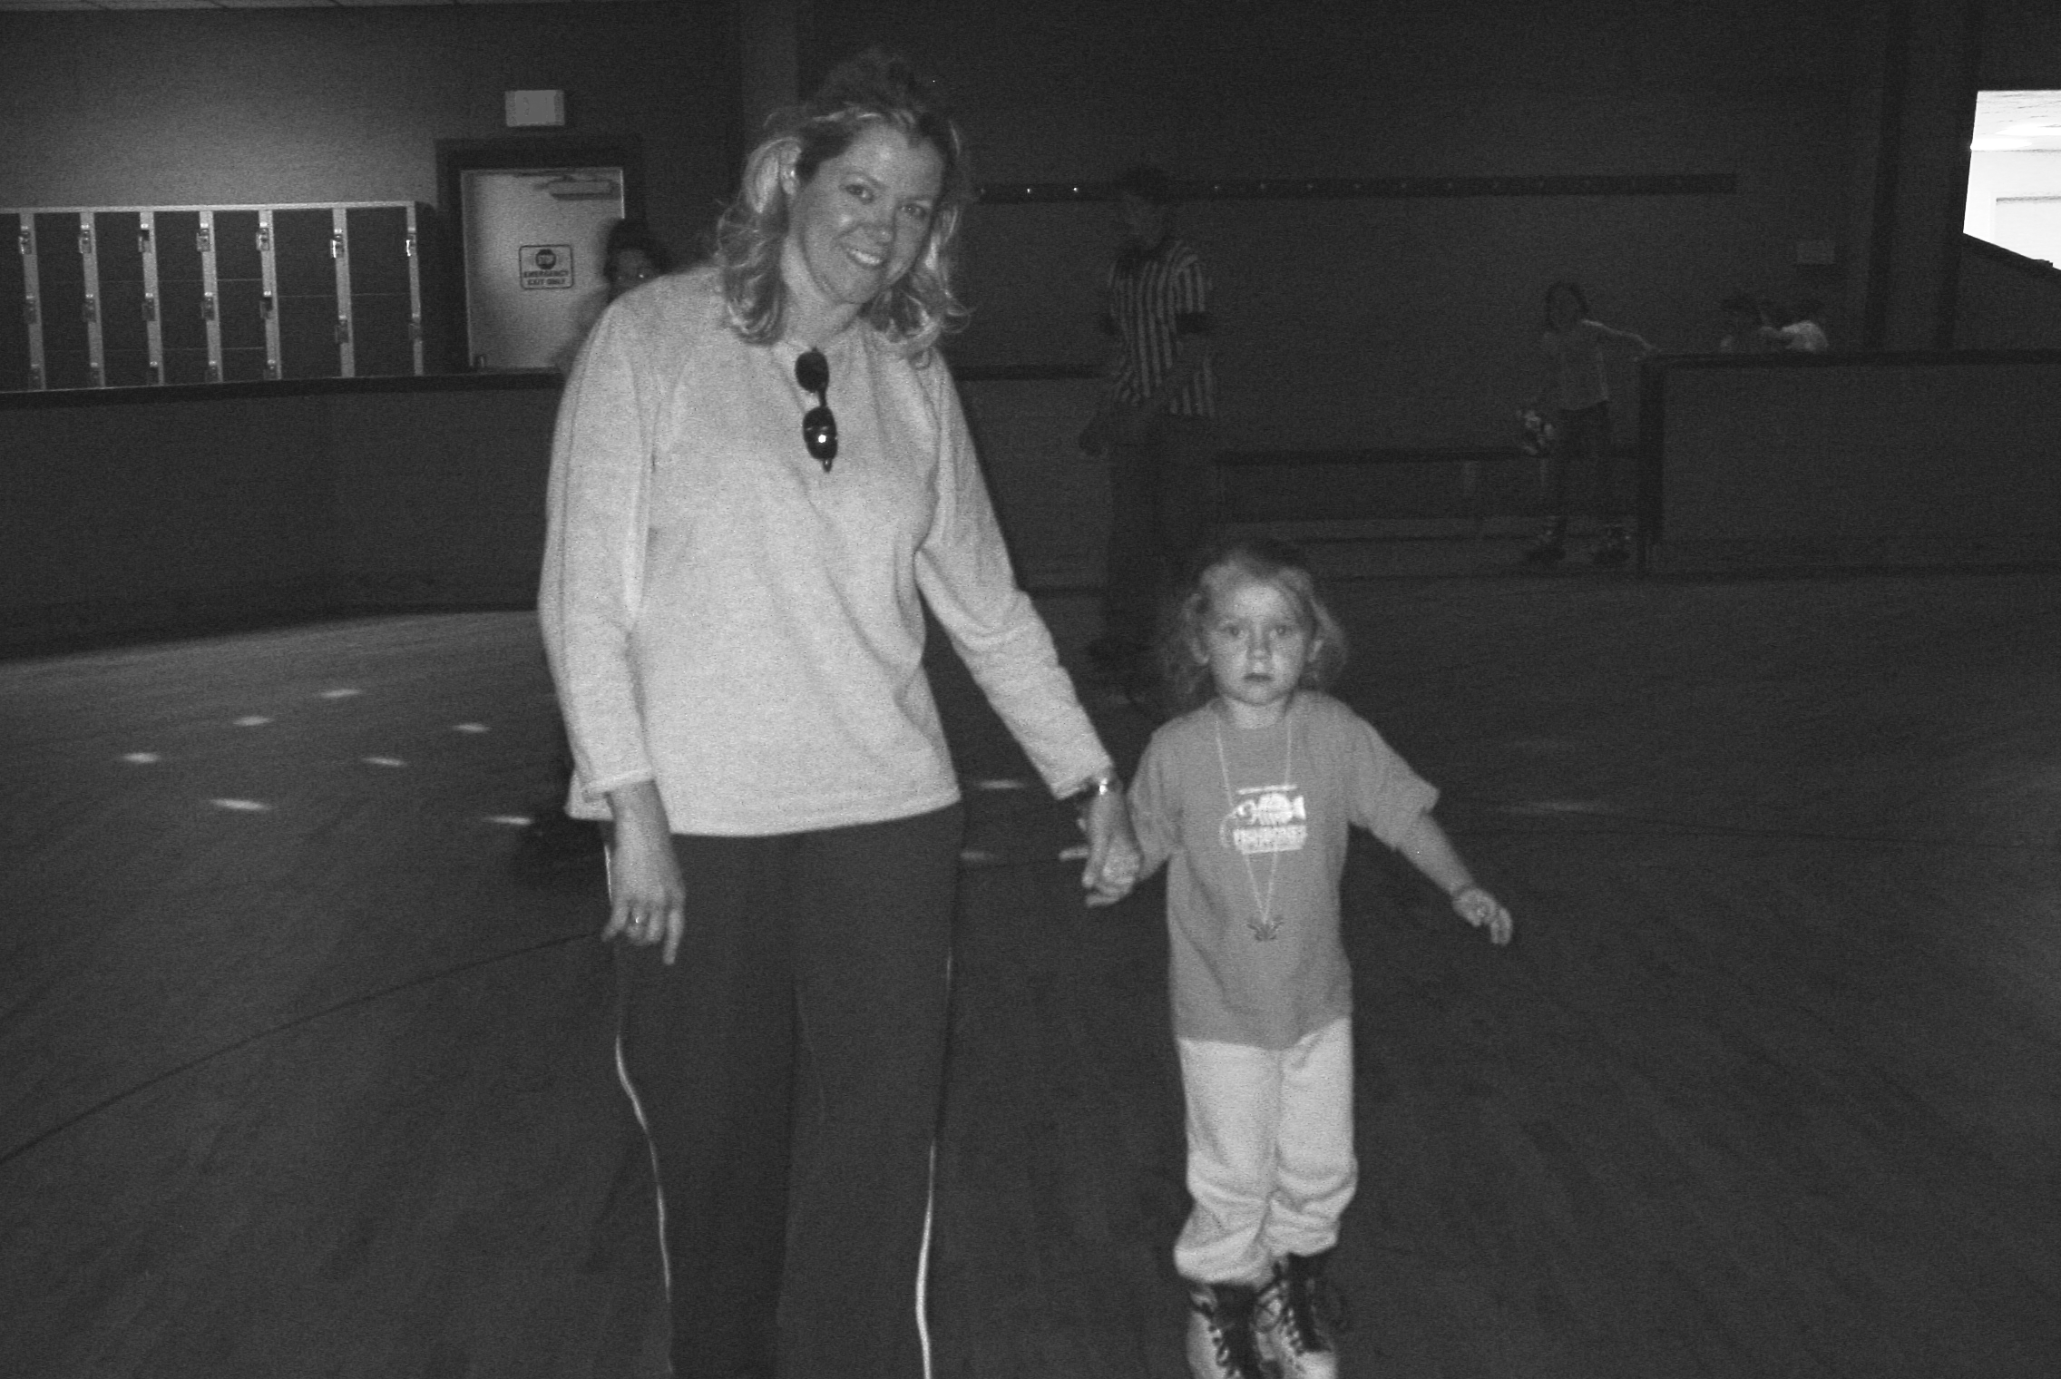
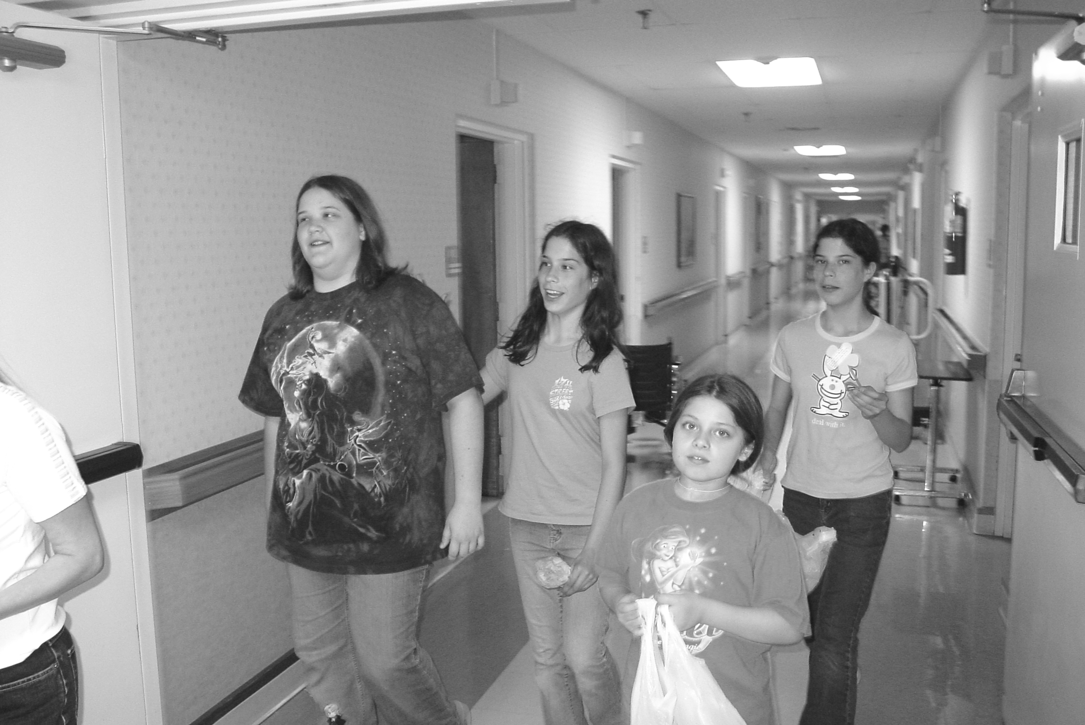

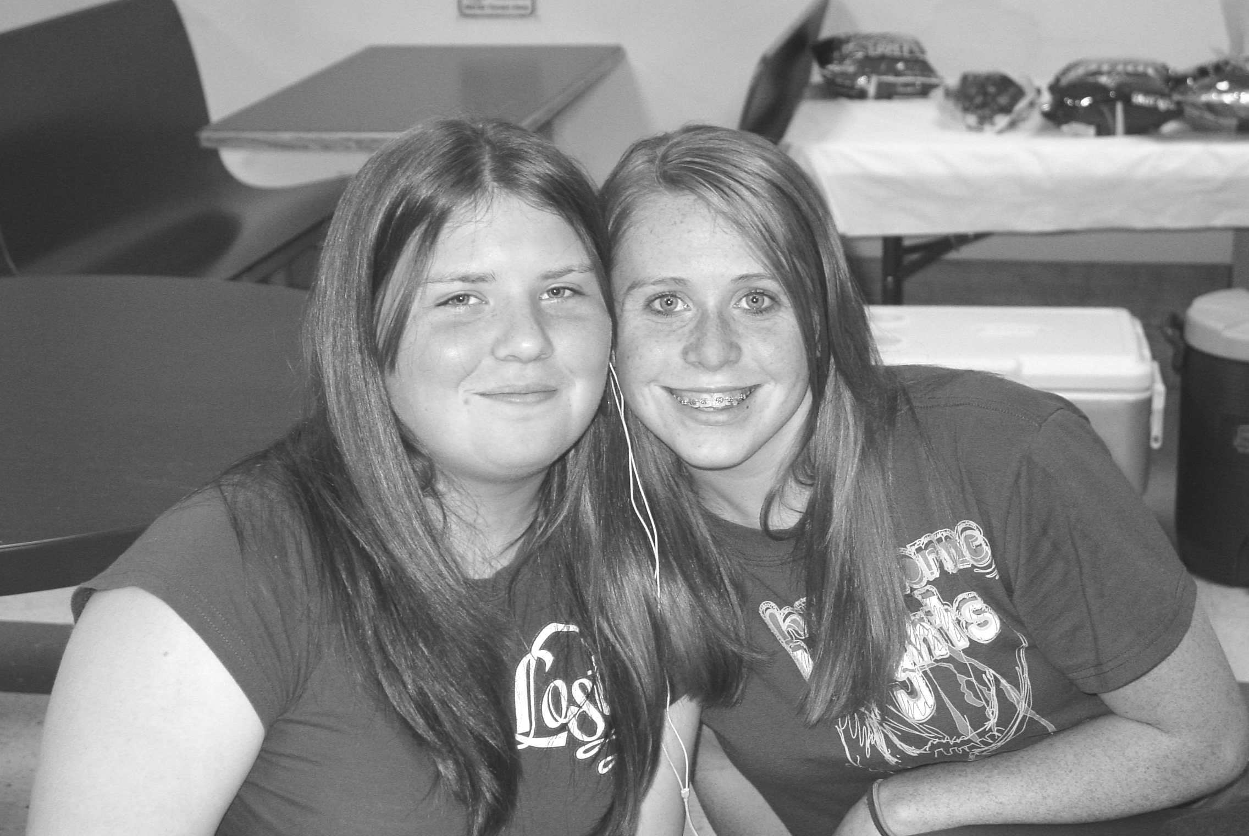
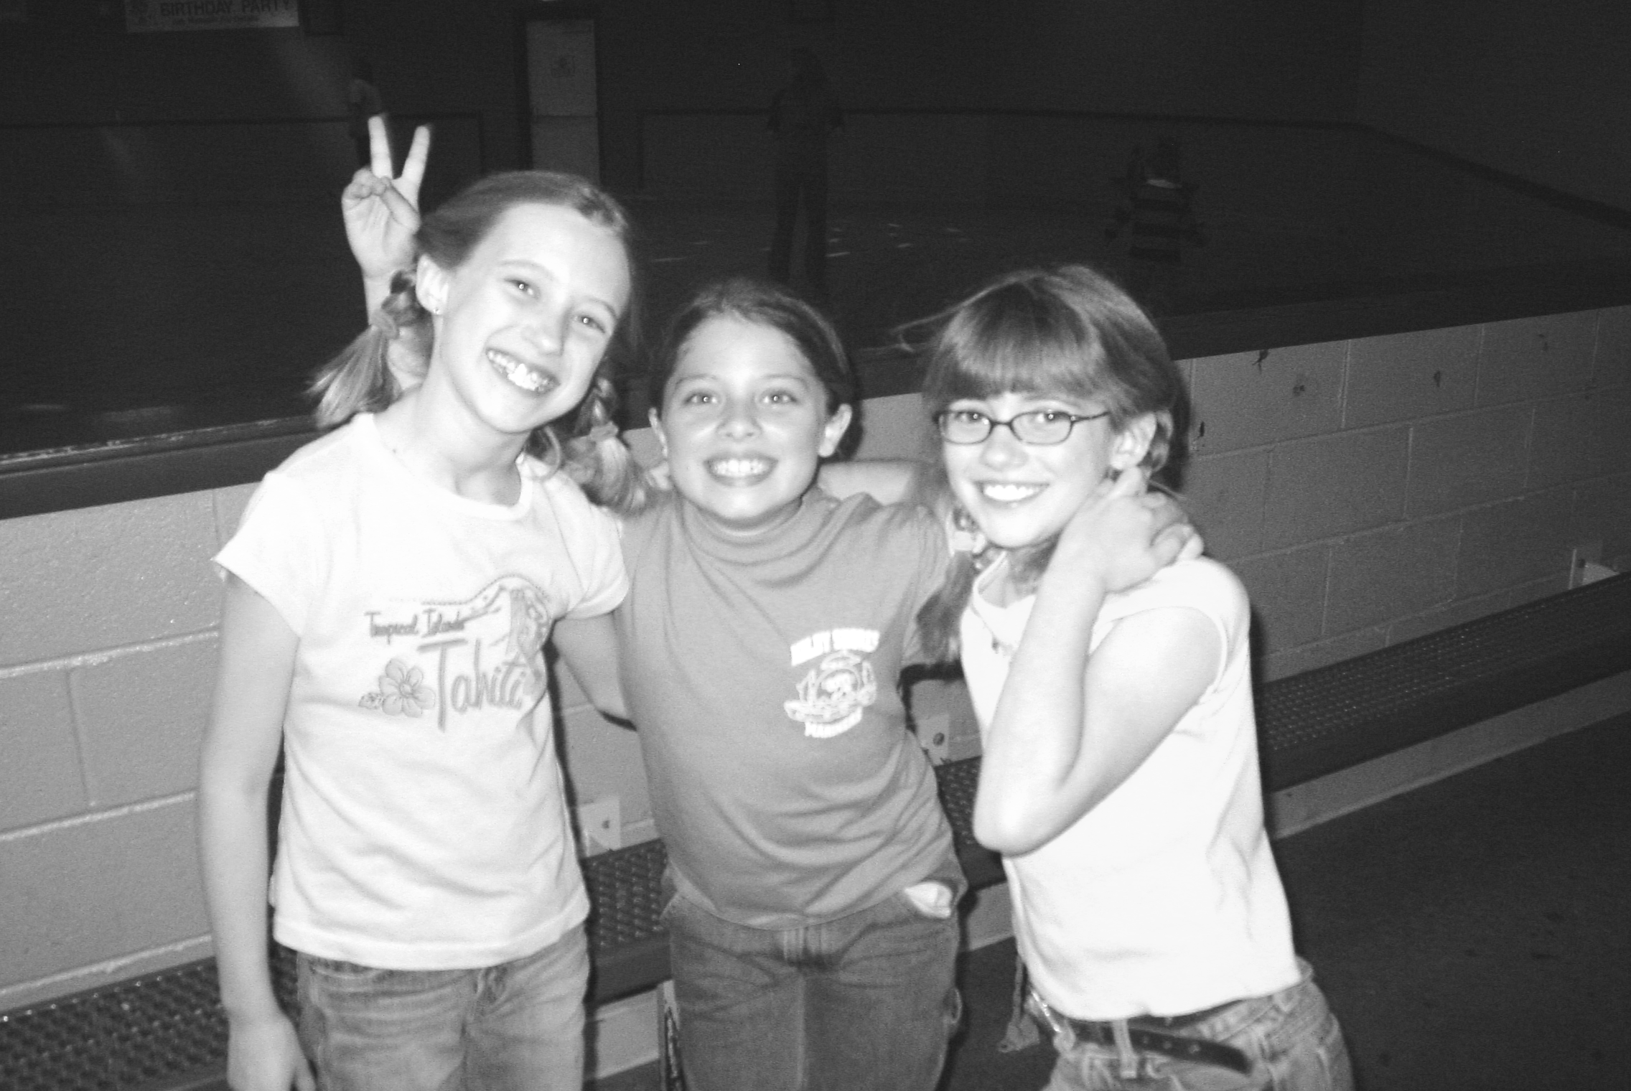
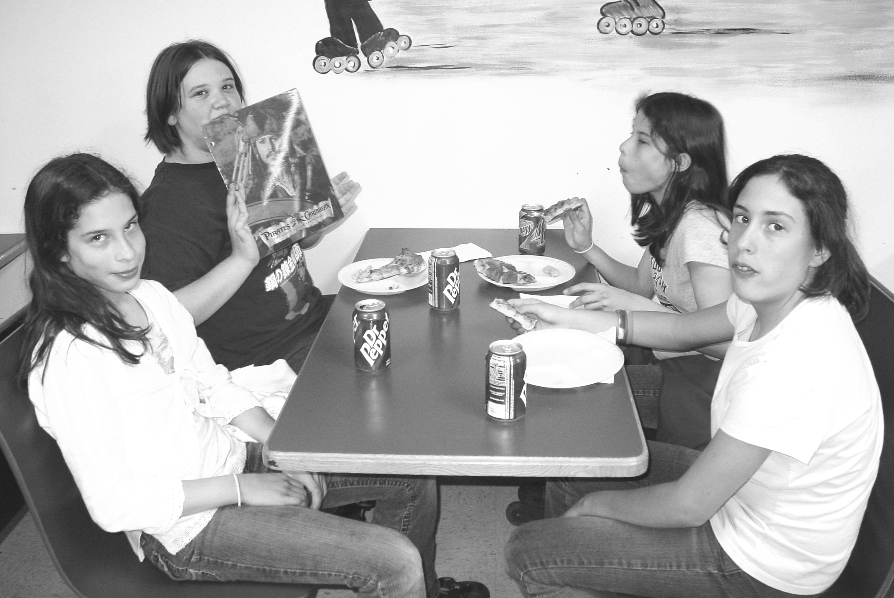
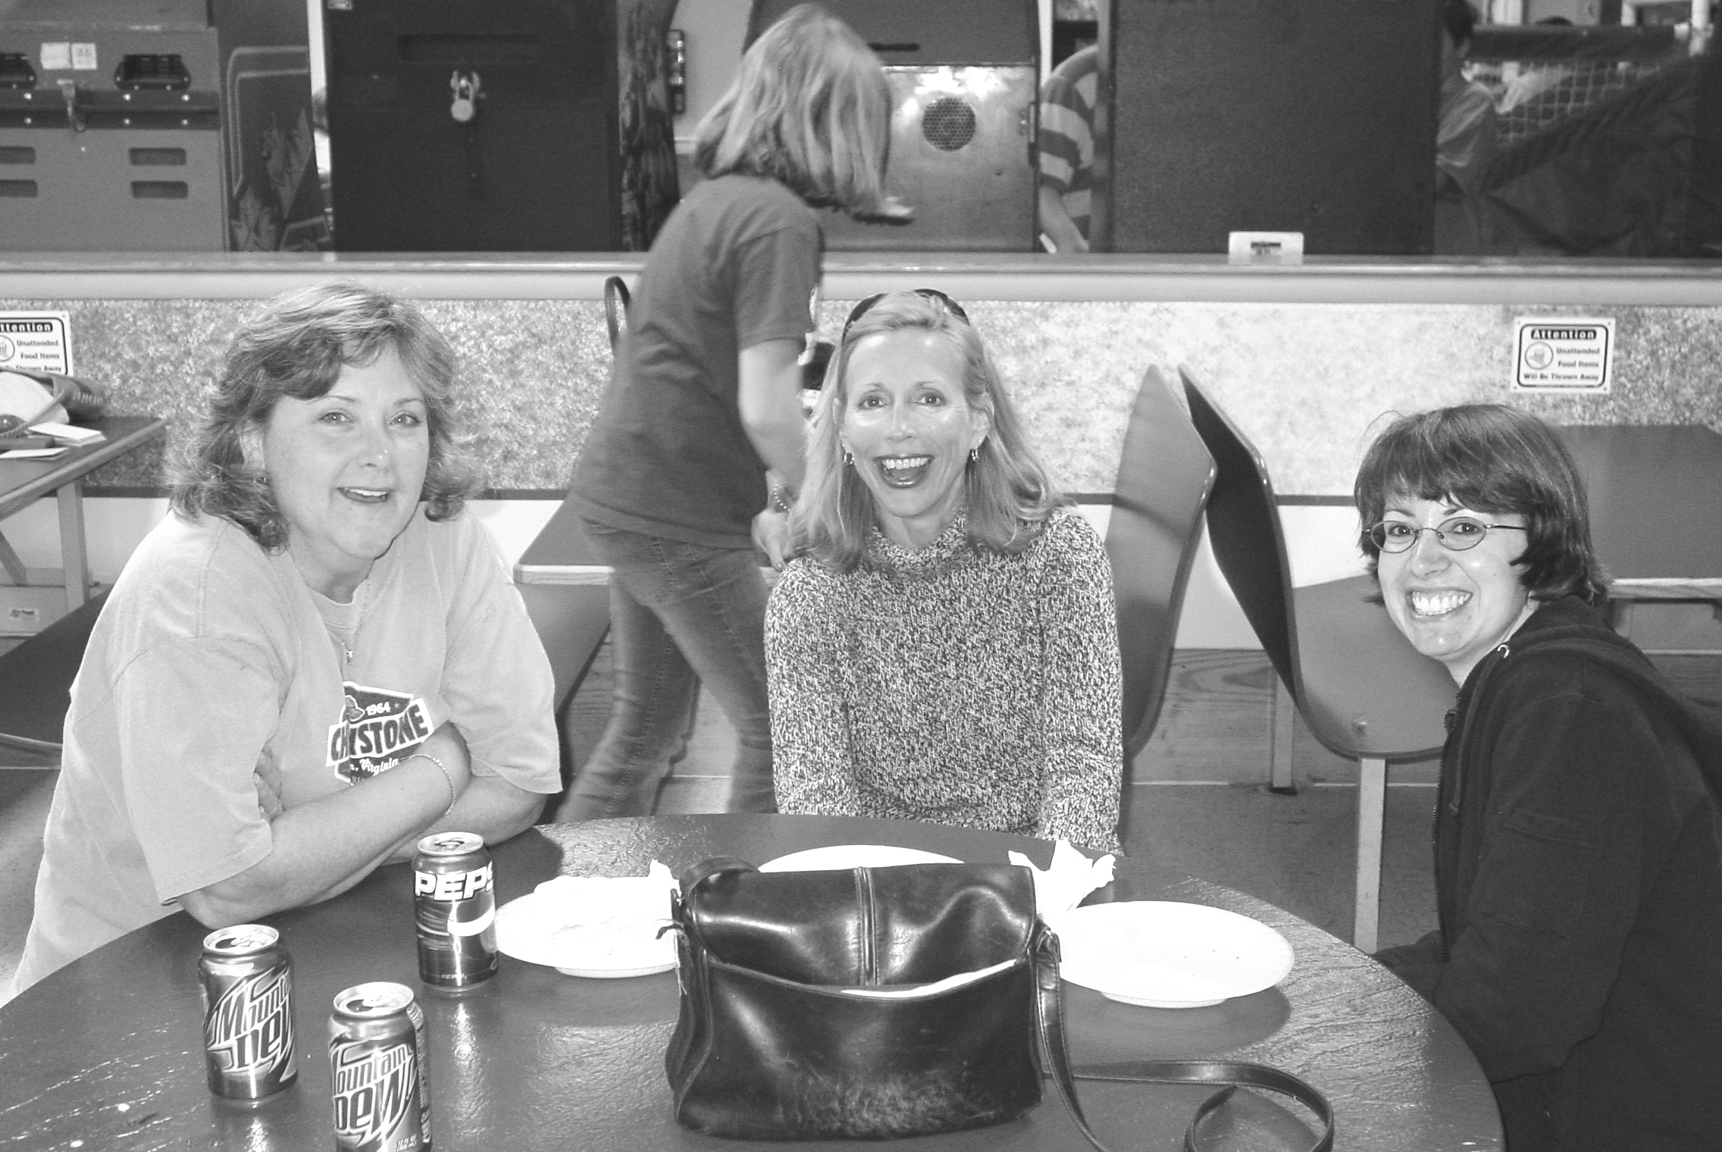
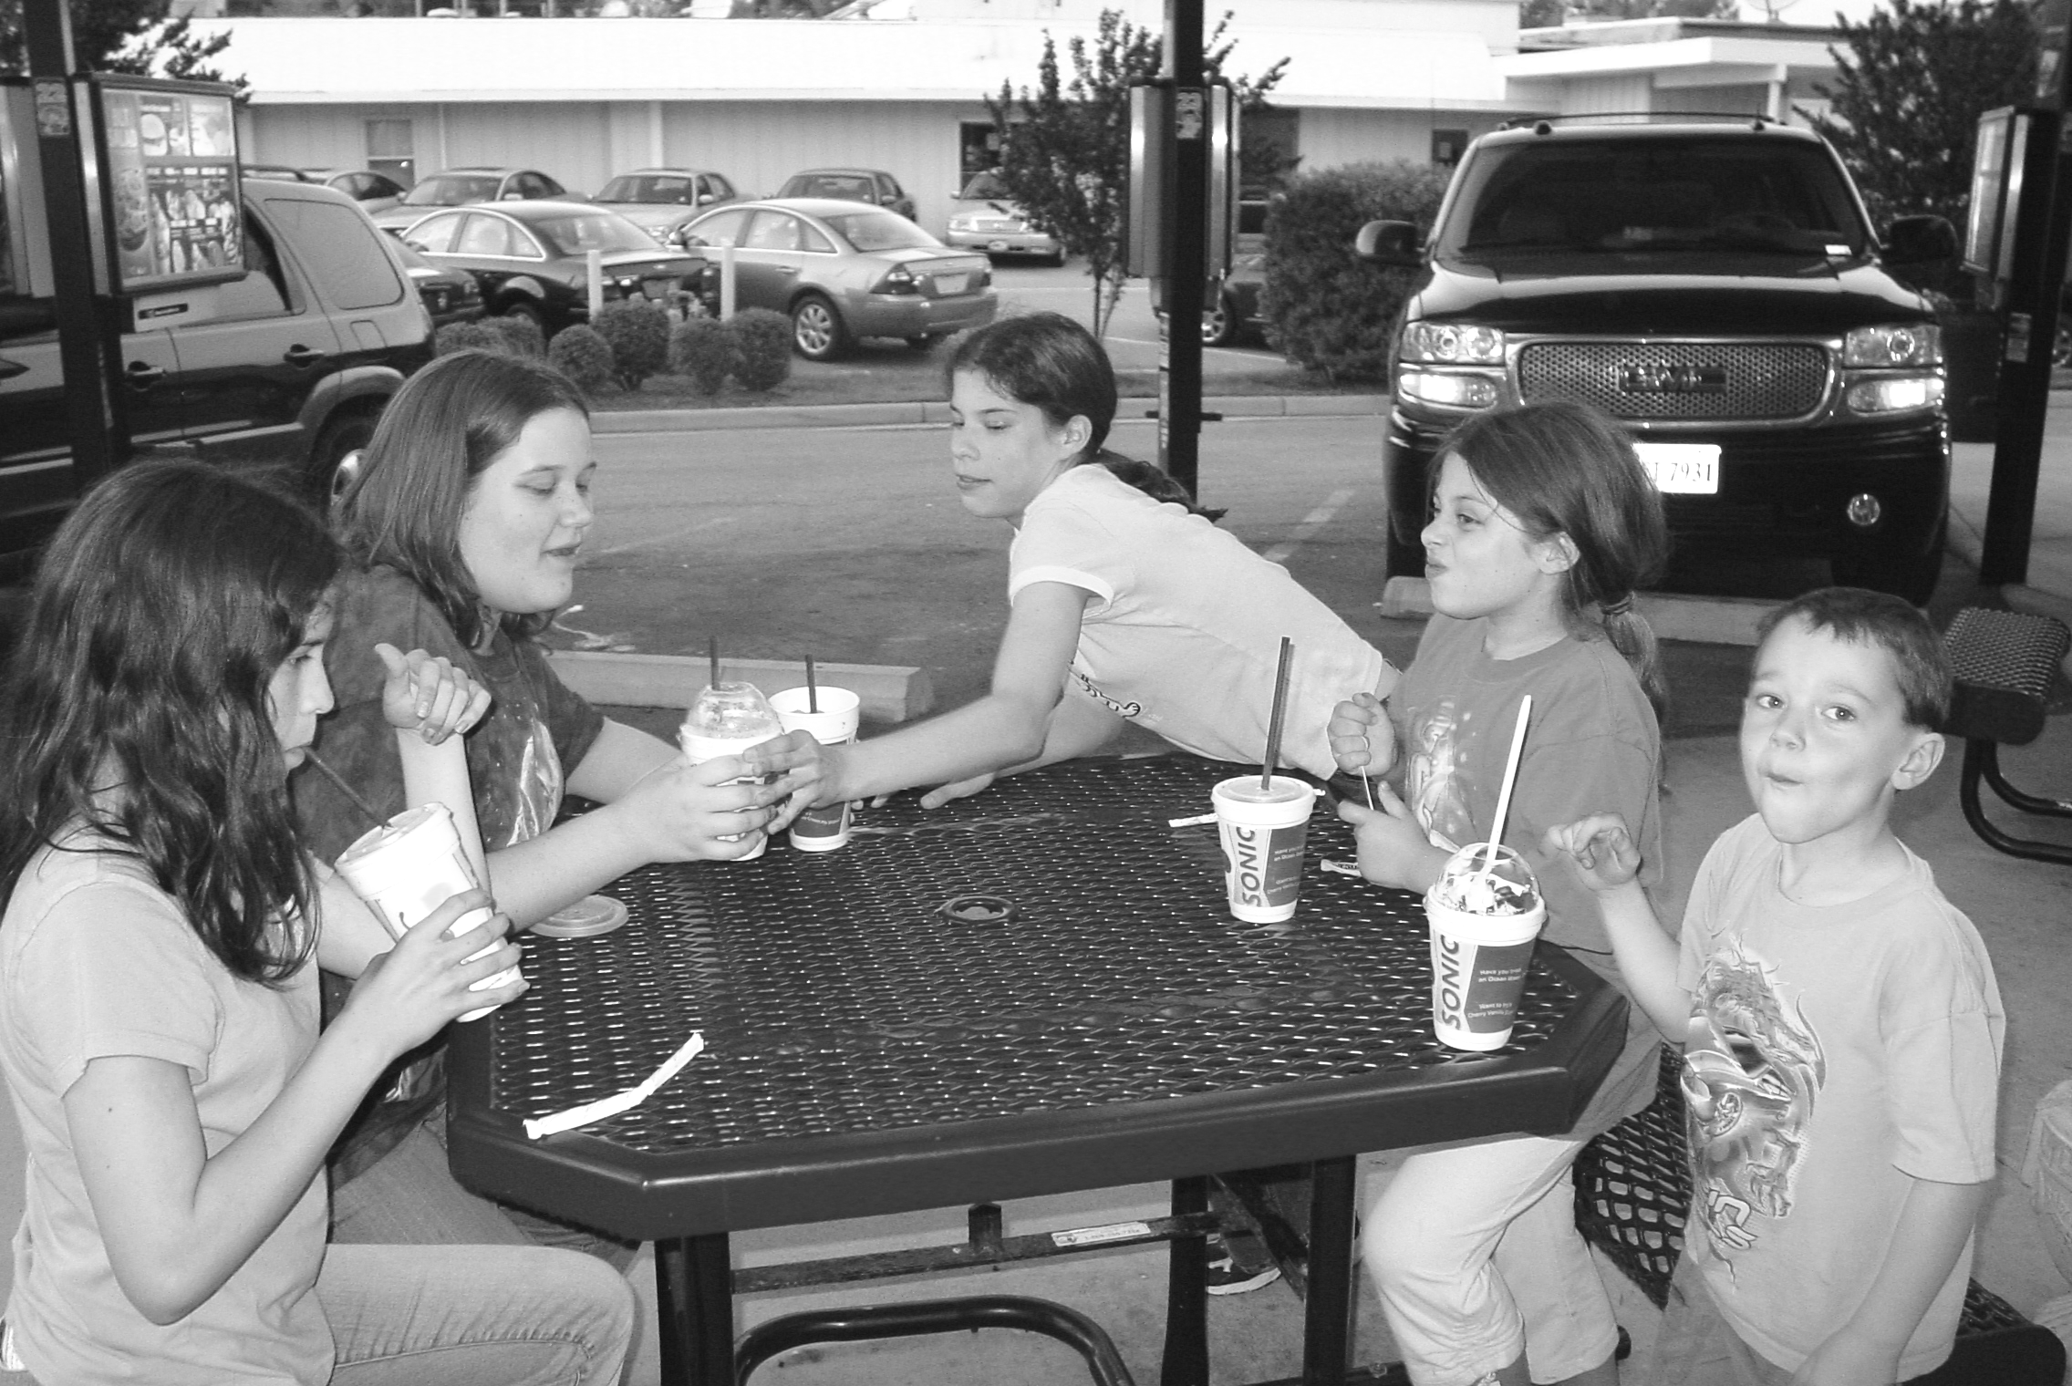




May 2006
Page 2
Youth Newsletter

The Youth Groups at Bethlehem Christian Church
Youth Group Cook-Out

Sunday, June 4, 2006 • 3:00pm-7:30pm
Bennett's Creek Park • Shelter #1

All food and drink provided

Softball* • Kickball • Volleyball • Badminton • Football
Frisbee • Horseshoes • Tennis* • Fishing* • Nature Walking

*Please bring your own softball glove, tennis racquet and balls, or fishing equipment.

There is also a playground with swings, slides, and other activities for younger children.

There is limited space under the shelter. You may wish to bring your own chairs or blankets.

Directions: Take Wilroy Rd. (Rte. 642) North. Continue approximately 2 miles to end of Wilroy Rd., then turn left at light onto Nansemond Pkwy. (Rte. 337) Continue approximately 5 miles, passing Nansemond River High School and Driver, then turn left at light onto Shoulders Hill Rd. (Rte. 626) Continue approximately 2 miles. Turn left at sign for Bennett's Creek Boat Ramp and Park, approximately 1 mile before intersection with U.S. 17.

This is the final scheduled event of the 2005-2006 youth group season. Individual groups may have events planned during the summer months. Please check with your group’s leaders for details. The 2006-2007 youth group season will begin August 27—watch the youth group web site (www.bccyouth.org) for more information. Cook-Out will be re-scheduled in case of rain.

