Youth Newsletter
The Youth Groups at Bethlehem Christian Church

March 2008

YOUTH GROUP SCHEDULES

Alphas/Omegas Hungry to Help, Participate in 30 Hour Famine

“So when do we eat?” Parents of teenagers probably hear that question every day. For us, the answer usually depends on how long the line is at Burger King, how fast we can microwave a frozen dinner, or how quickly the pizza delivery guy can get to our house. However, for more than 850 million people around the world, mostly women and children, the answer is often “I don’t know.”

The facts are staggering. 29,000 children die every day due to hunger and hunger-related causes. That’s one child every three seconds. What’s more, over 1 billion children worldwide live on less than $1 a day.

For the fifth consecutive year, the youth at Bethlehem have chosen to make a difference—to be hungry, so that children in need all over the world can eat.

On Friday, February 22, twenty junior and senior high youth, along with three leaders, gathered in Graham Hall for the start of World Vision’s 30 Hour Famine.

Until 6:00pm the next day, the youth pledged not to eat or drink anything except for clear liquids, to challenge themselves personally and spiritually, and to gain a better understanding of what children living in poverty face on a daily basis.

A brief opening video and devotion helped the youth understand just how serious the problem of hunger is, and how we as Christians are called to help others in need.

Throughout the Famine, the group participated in the game of Tribe. Created by World Vision, Tribe engages famine participants in a number of “Survivor”-like challenges, simulating the real challenges children in poverty are faced with every day. Each tribal challenge is followed by a topical devotion and time of discussion.

This year, the focus was on learning about the plight of the orphans of Indonesia. These children are often separated from their families after floods and other natural disasters, and forced to fend for themselves. Homes, schools, and hospitals are destroyed, entire harvests of crops are lost, and fresh water supplies are often polluted. Each famine participant was given a new identity as an Indonesian orphan, and assigned to one of four different tribes looking to find hope after the floods.

After the first tribal challenge of the Famine, a question-and-answer game about an young Indonesian boy orphaned in the aftermath of an earthquake, the group went on its Fellowship Activity—a trip to Franklin for bowling. Several of the youth found it challenging to concentrate on bowling while others around them were enjoying pizza, nachos, and soft drinks.

The group returned to church around 11:00pm and, after a candle-light devotion, spread their blankets and sleeping bags to rest for the night.

(continued on Page 2, Famine)
(Famine, continued from Page 1)

The youth help light candles for their midnight devotion

The youth awoke the next morning around 8:00am, and Pastor John visited shortly afterwards, curious about how their Famine experience was going.

After showers and some free time, the group participated in its next Tribal Challenge, “Mosquito Menace”. Mosquitoes can carry many diseases, including malaria, which affects nearly 20 percent of all Indonesians. The devotion following the tribal challenge focused on 1 Peter 2:19-23, and how Christ understands suffering, because he suffered for us.

Between the tribal challenges, the youth watched movies, played video games, and read books to help pass the time.

Video games were a popular way to pass the time

Shortly after noon, the group participated in its third Tribal Challenge of the Famine, “Bamboo Architect”. The tribes were challenged to work together to build a large, sturdy temporary shelter using drinking straws and tape. Shelter is one of the biggest needs following a natural disaster. After the 2006 Indonesia earthquake, more than 1.5 million people lost their homes. The devotion for this tribal challenge was based on Matthew 6:19-21, and dealt with the topic of “storing up treasures”.

The Borneo tribe shows off its first-place shelter

At about 1:30pm on Saturday, the group participated in a special Tribal challenge—a Food Scavenger Hunt at Food Lion on Holland Road. Each tribe was given $20 and a scoring sheet, and were challenged to purchase as many items as they could with the amount given. Points were awarded for each item purchased, and bonus points were awarded for items that met certain criteria on their score sheets. After returning to church and determining the winners, the food items purchased were donated to Bethlehem’s Food Pantry. In total, over 100 items were donated to help needy families right here in our own community.

The youth with their purchases for the Food Pantry

After more free time, the group participated in its final tribal challenge of the Famine, a Concentration-style game that challenged the students to turn over cards and find matching Famine facts.

(continued on Page 3, Famine)
(Famine, continued from Page 2)

At 5:15pm, the group gathered for their closing Bible study. The youth read several Scripture passages, including Matthew 15:29-39, James 2:14-17, and 1 John 3:17-18, and discussed how those passages applied to our lives. The famine participants were challenged not to let the experience end, but in the days and months to follow, to continue the spirit of the 30 Hour Famine, and to dedicate themselves to showing a Christ-like compassion for others in need.

Finally, at 6:00pm, the hungry famine participants were treated to a dinner of steak or spaghetti and meat sauce, baked potato, and tossed salad, prepared by Johnny and Becke West.

Although the final totals are still being calculated, thanks to the support of the congregation, nearly $600 in pledges have already been collected to date. Donations can still be made through Sunday, March 9.

Special thanks to all who contributed to World Vision, and a great job to the youth who fasted so that others might eat.

ALL CLUBS

March 2 Regular Meeting, 5:30pm-7:15pm
March 9 Regular Meeting, 5:30pm-7:15pm
March 16 No Regular Meeting • Easter Egg Hunt
March 23 No Regular Meeting • Easter Sunday
March 30 Regular Meeting, 5:30pm-7:15pm
April 6 Regular Meeting, 5:30pm-7:15pm

For more information about your club's schedule, including any special events planned for your individual club, please contact your club's leaders.

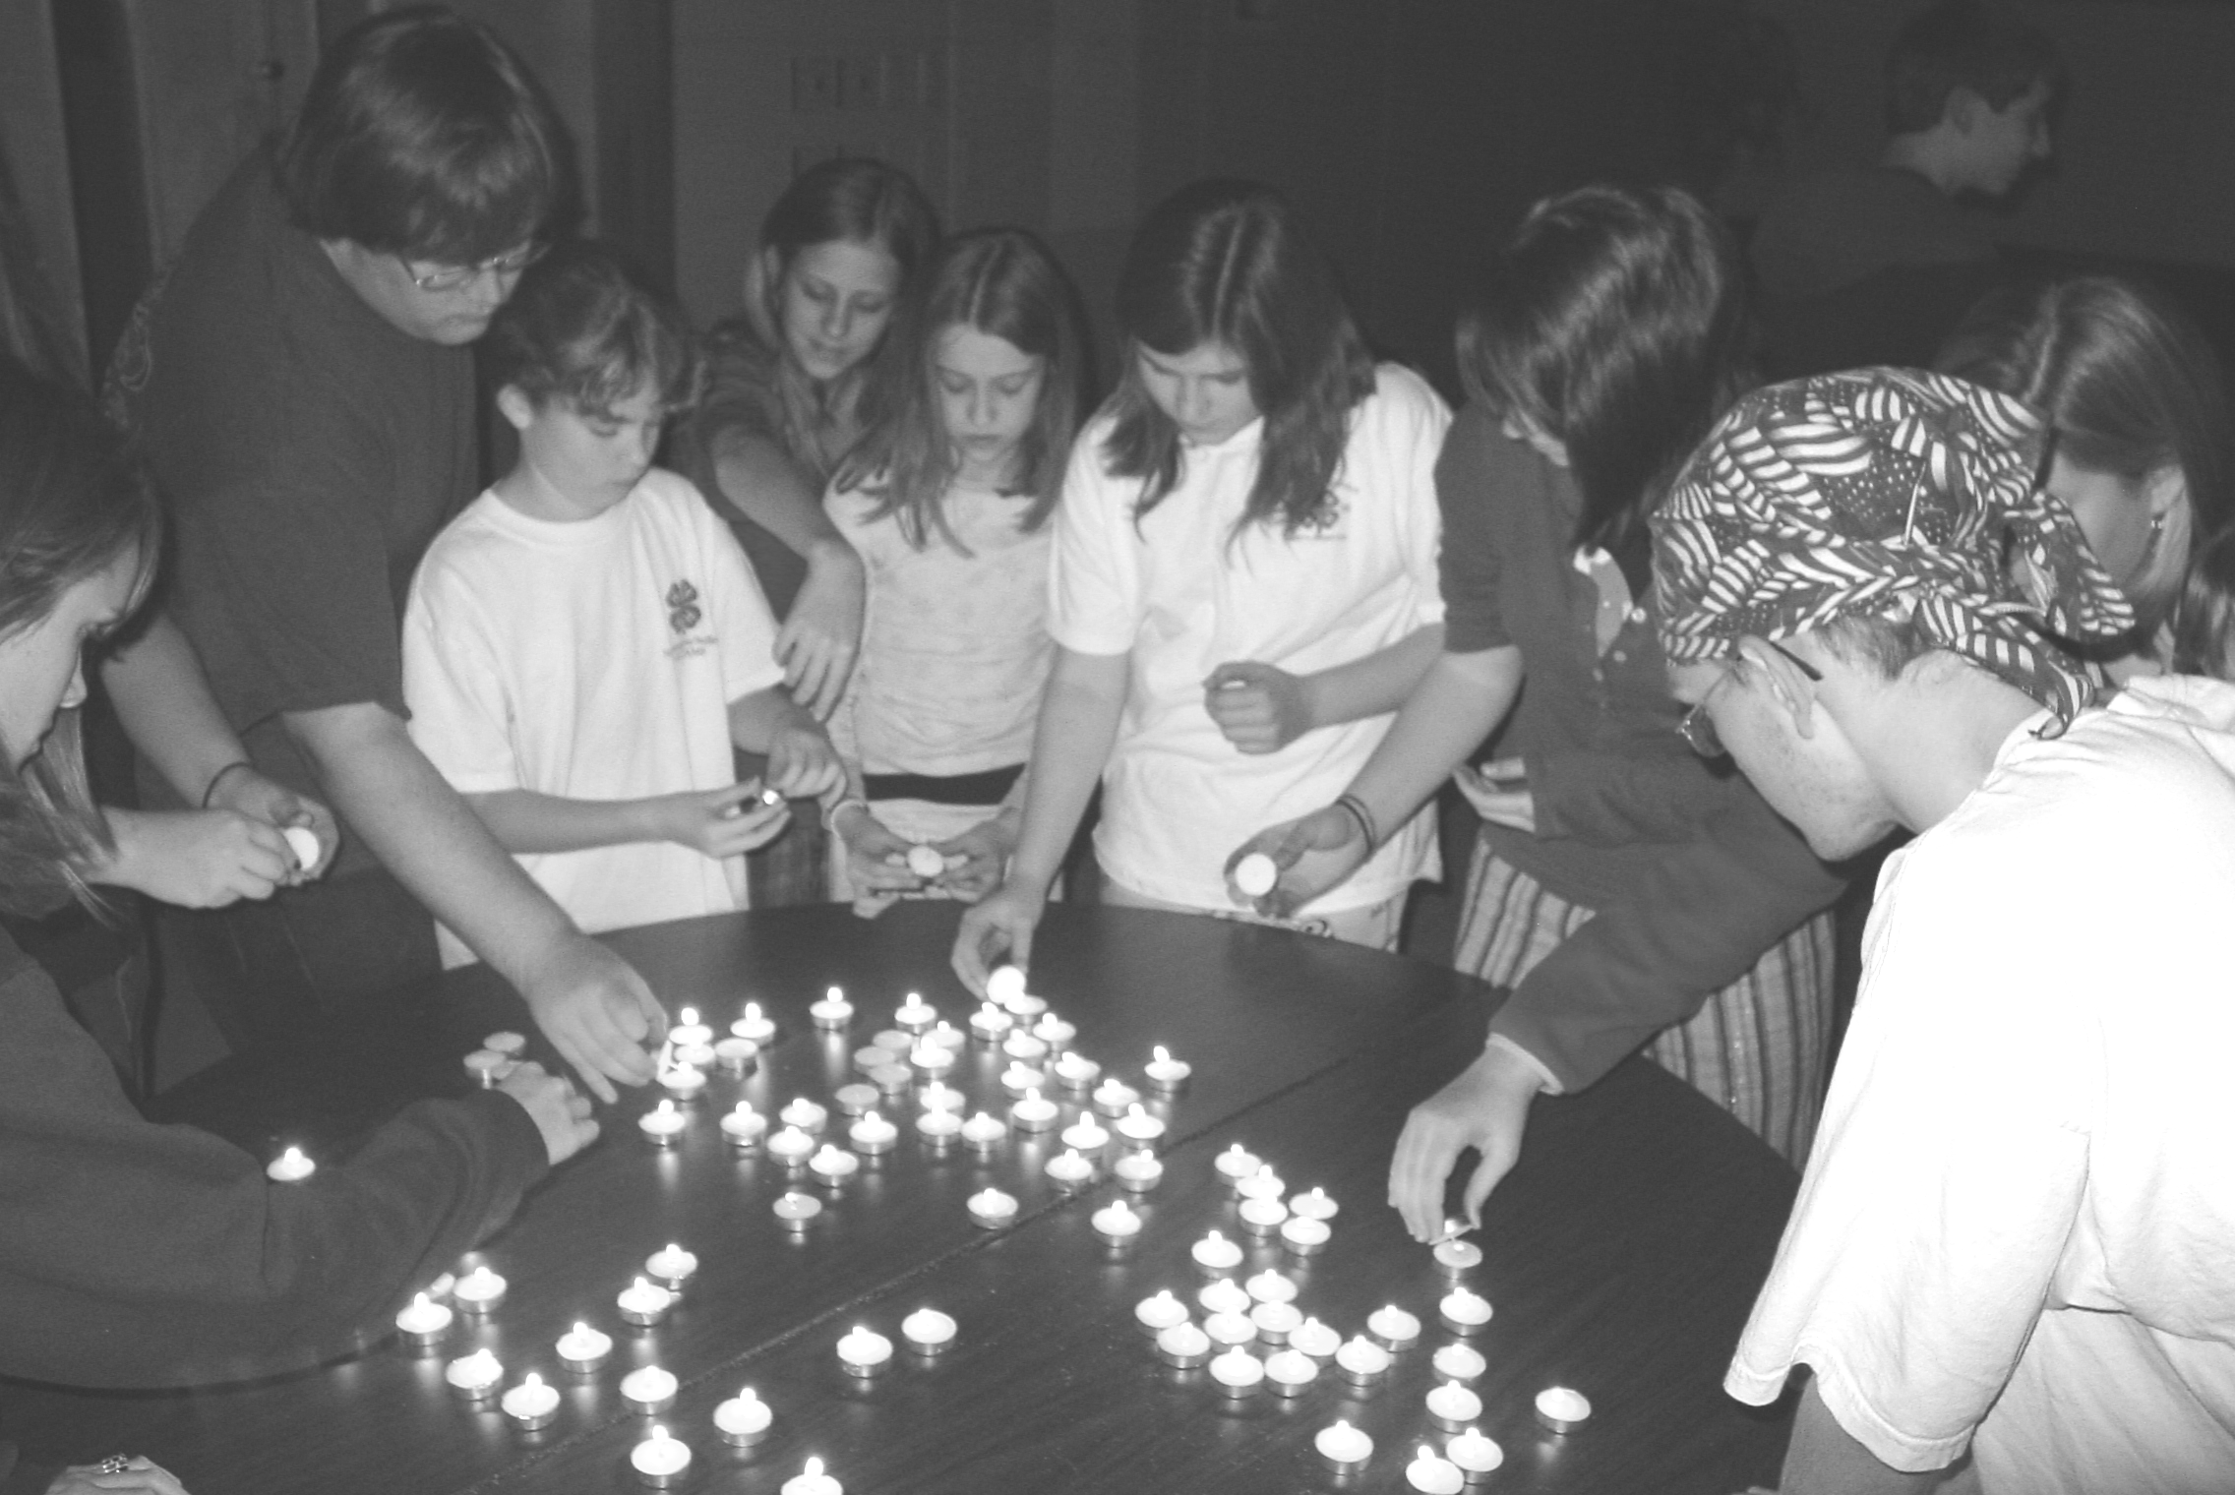
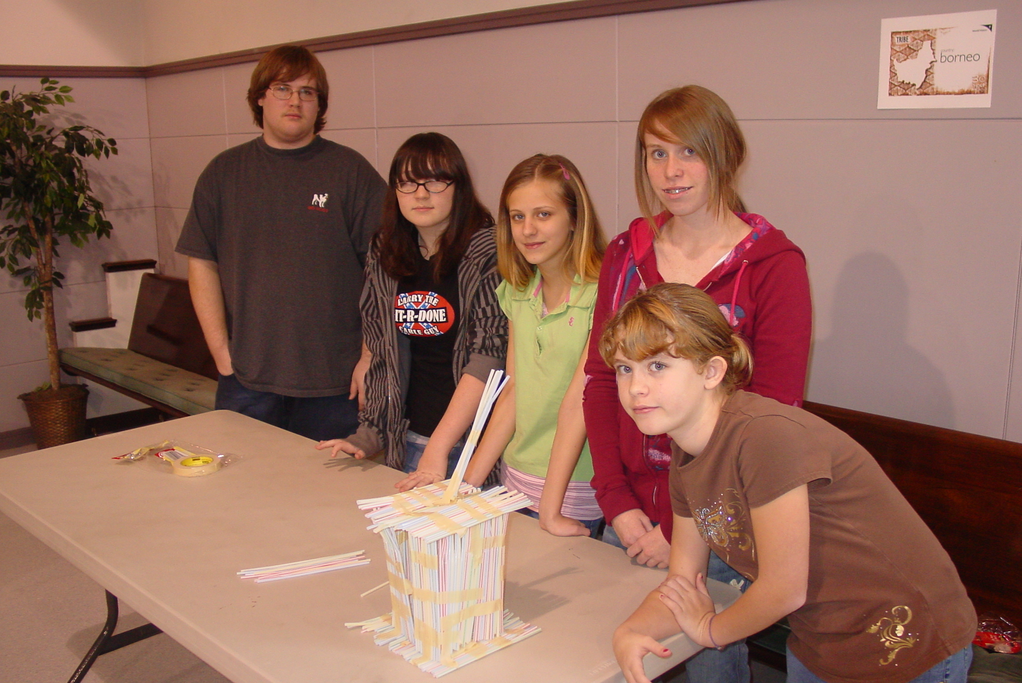
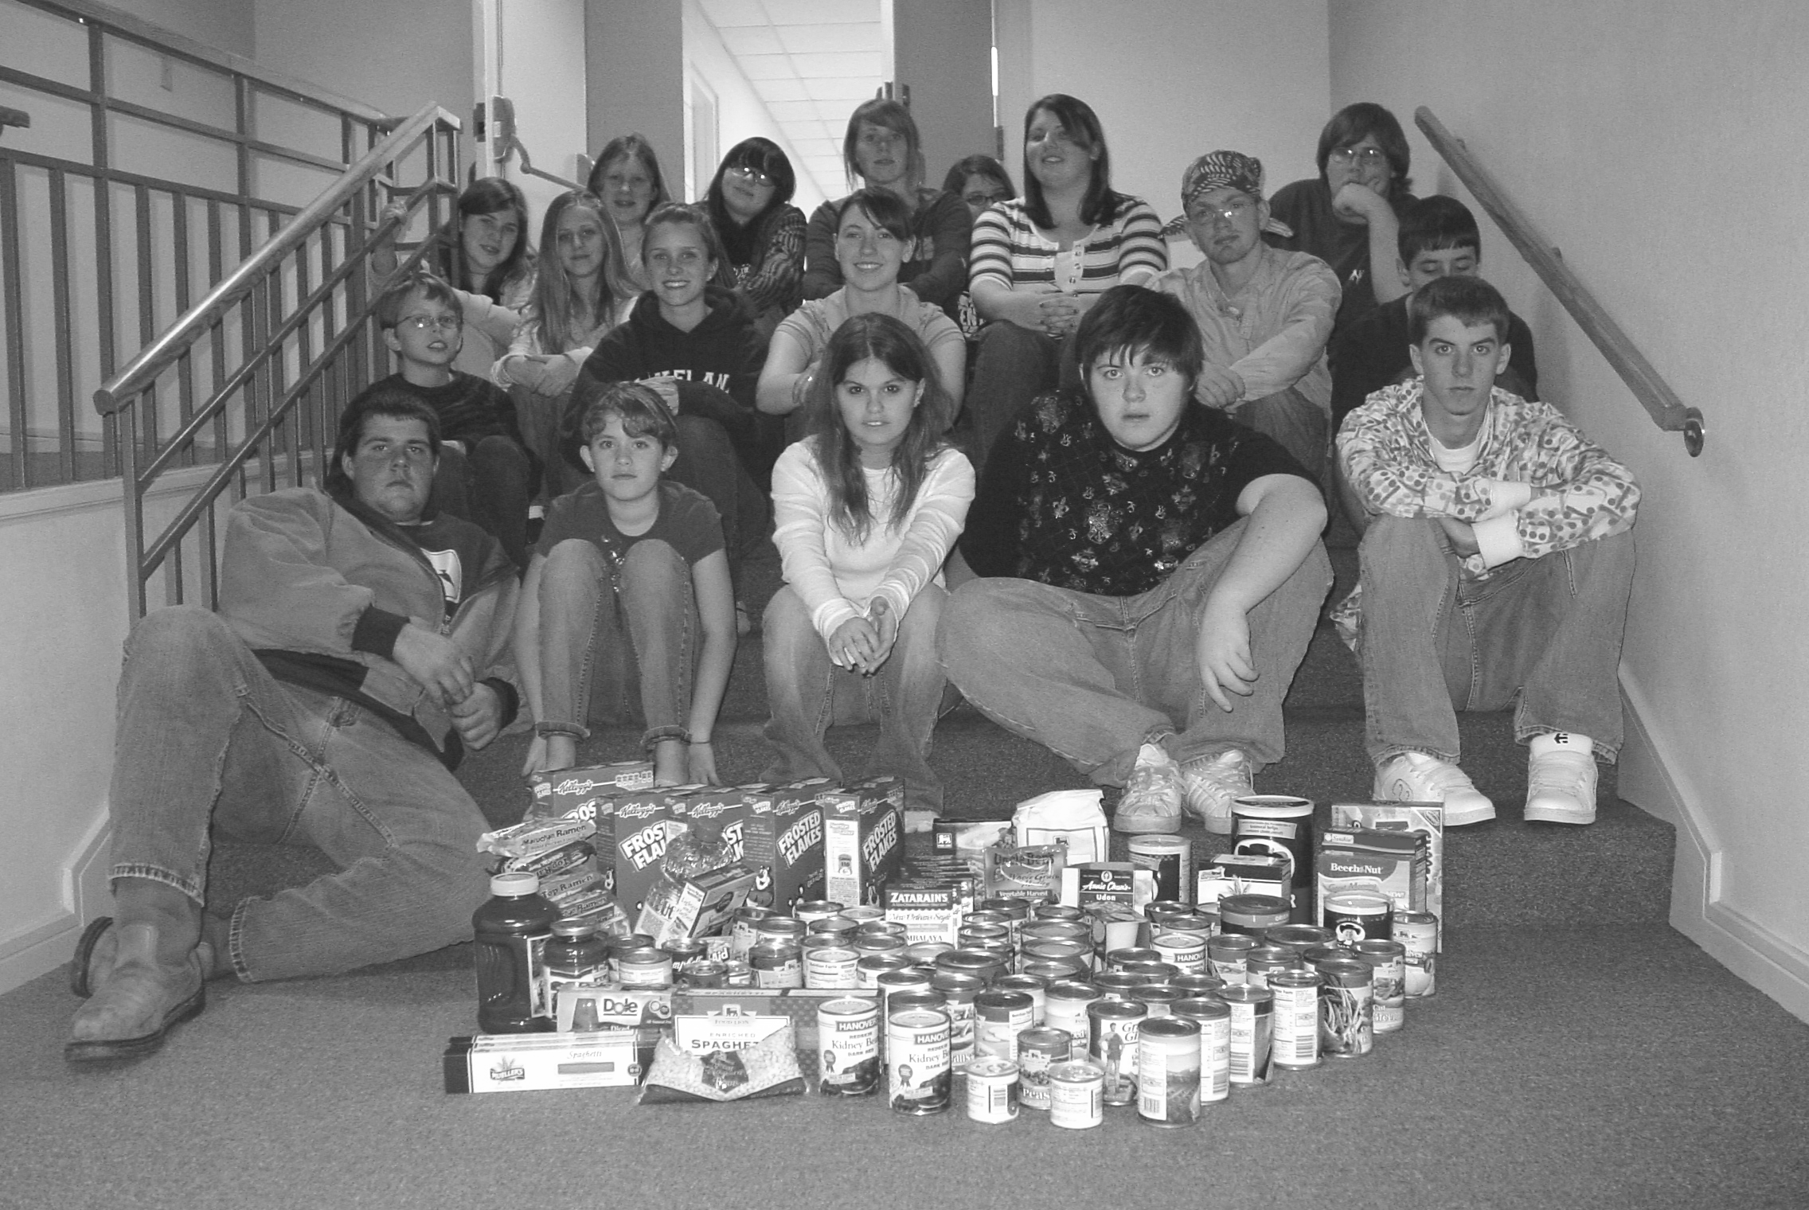
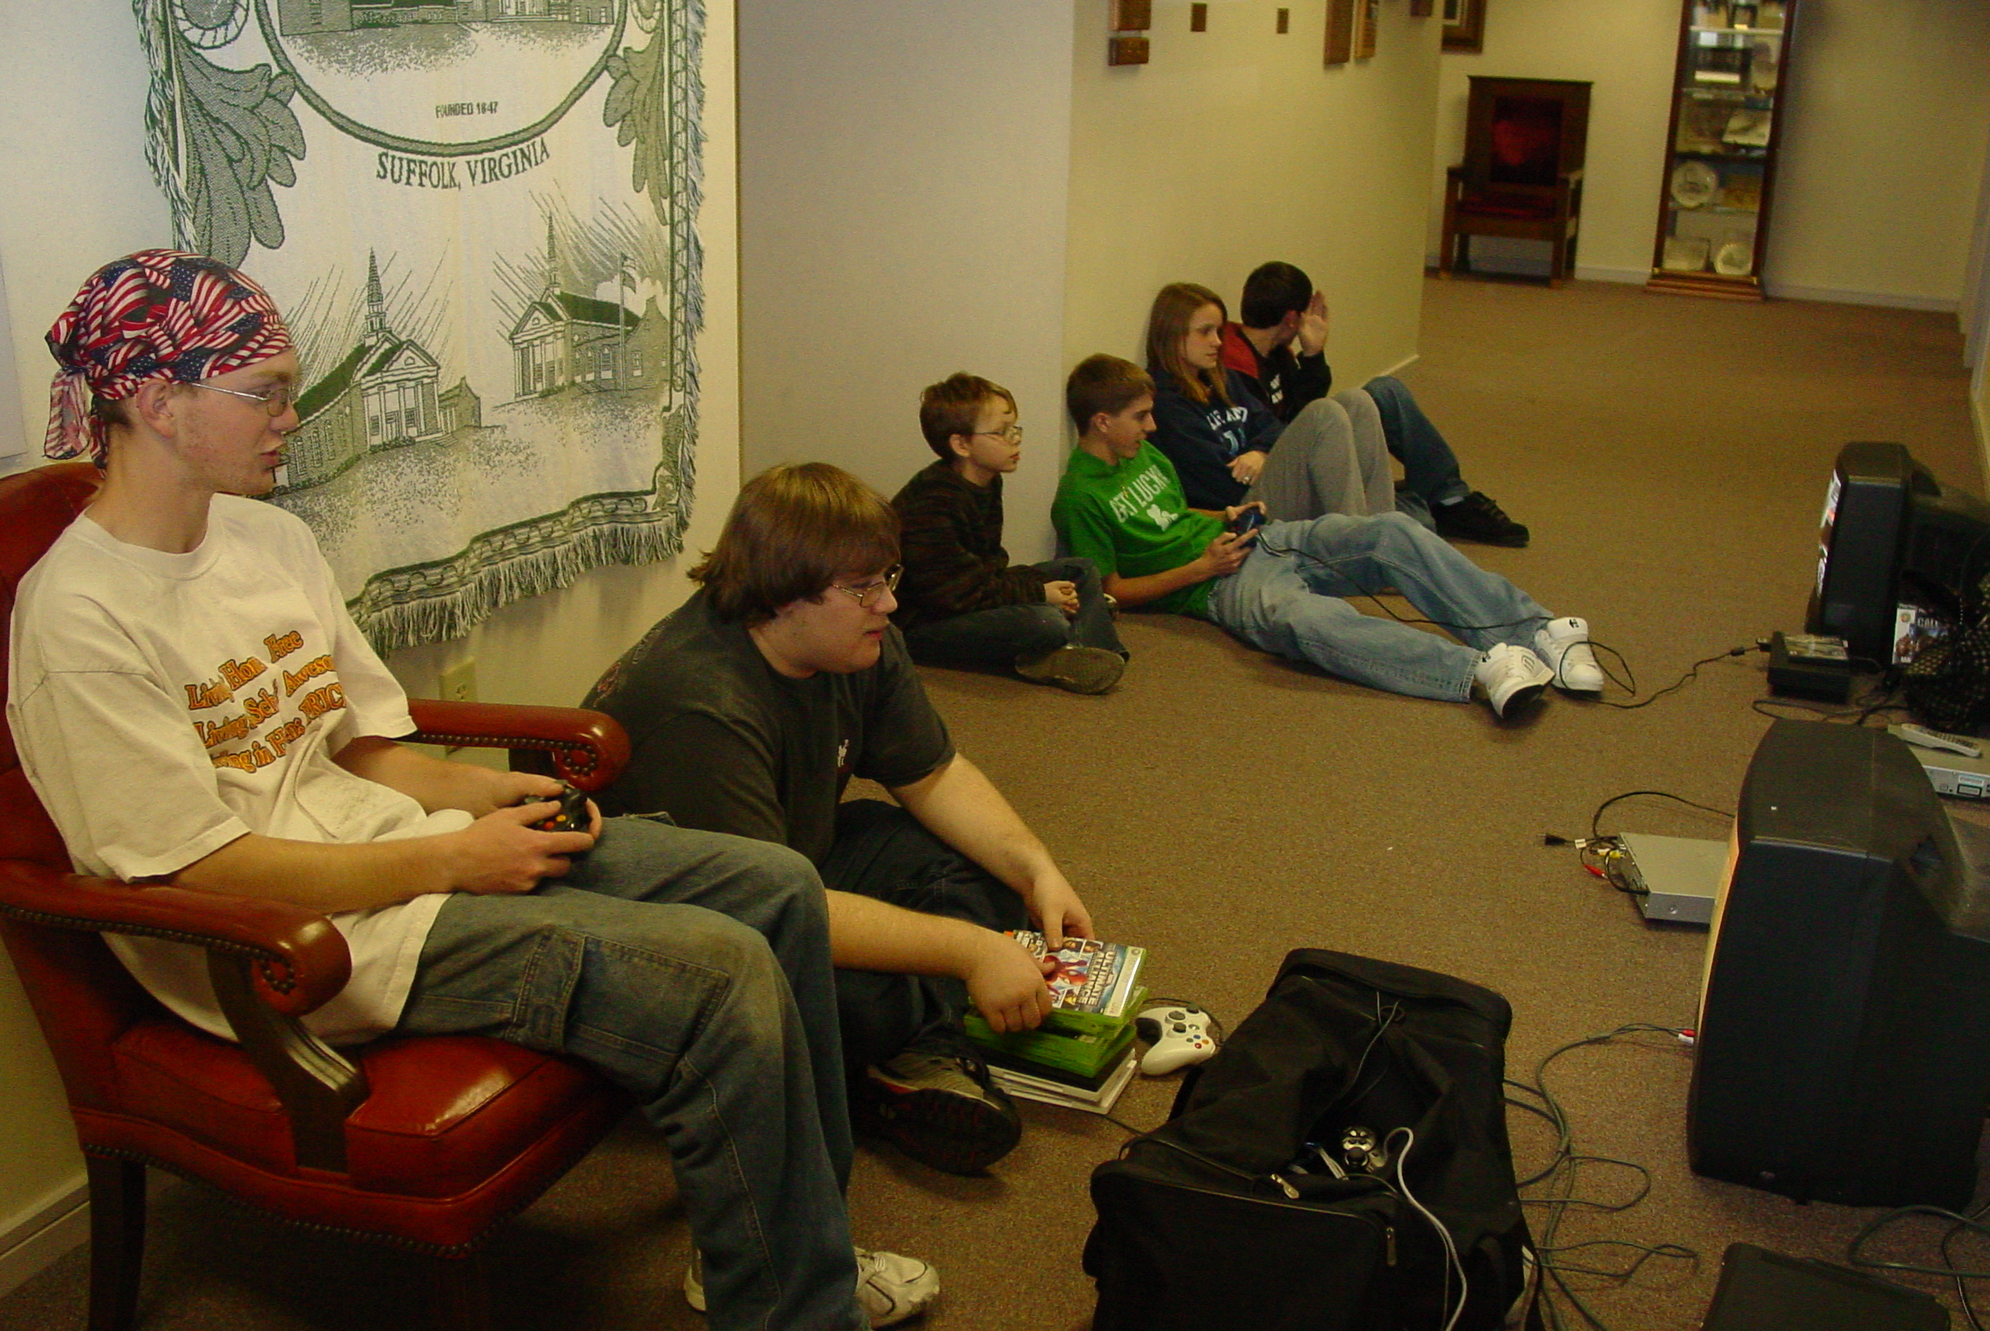
Youth Newsletter
March 2008
Page 2
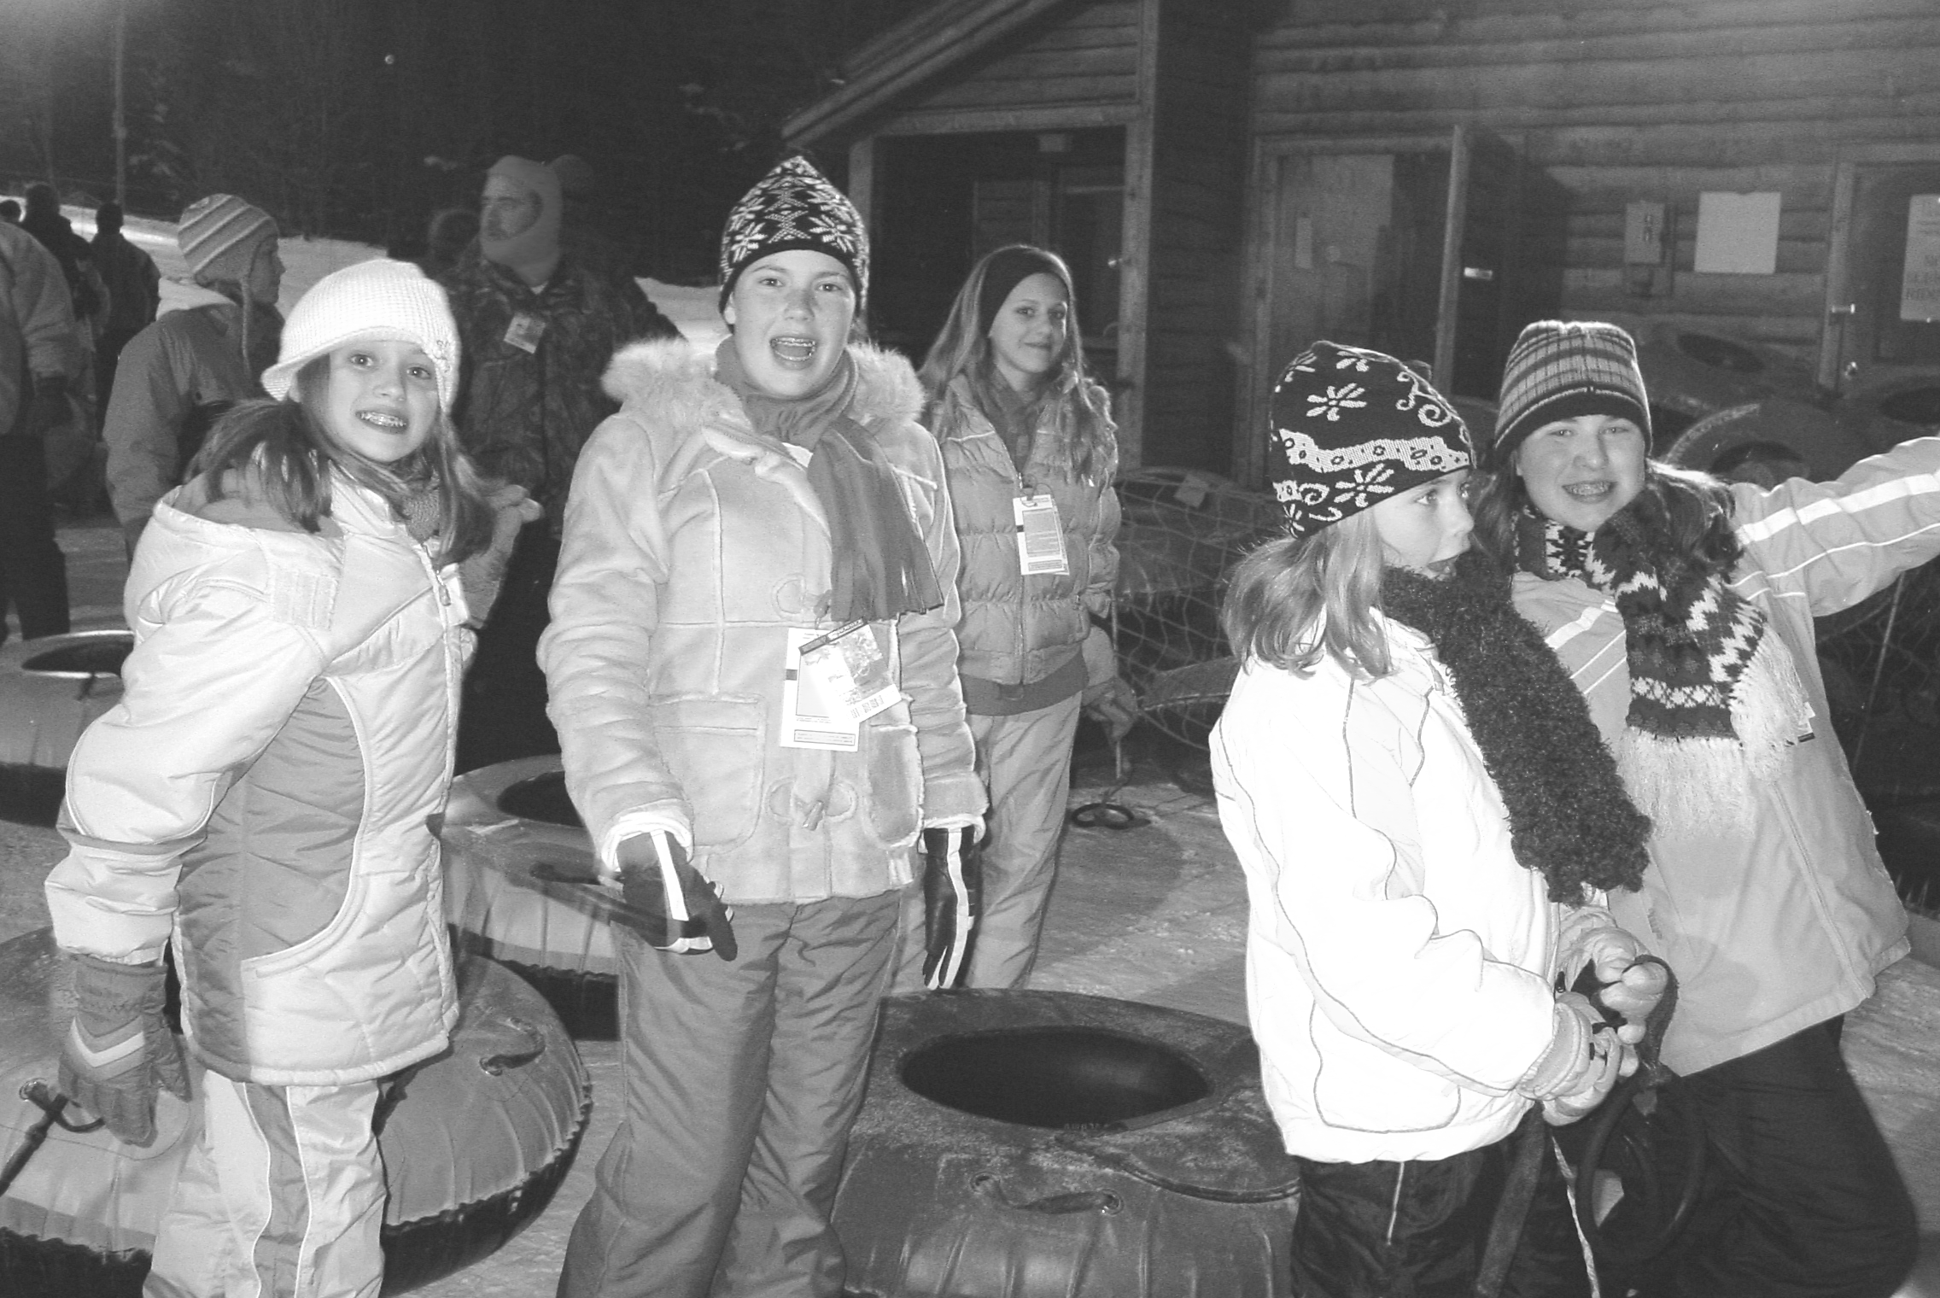
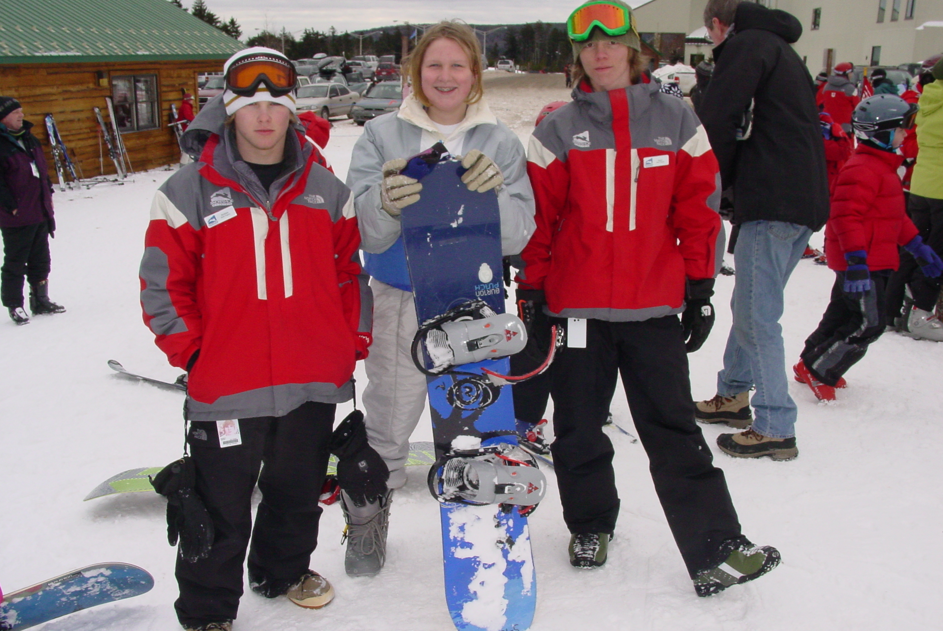
Youth Newsletter
March 2008
Page 3
Alphas, Omegas Travel to West Virginia for Annual Ski Trip

For the second consecutive year, the Alpha and Omega Youth traveled to Snowshoe Resort in West Virginia for their annual Ski Retreat.

The group left shortly after 2:00pm on Friday, January 25, and after a long drive through the mountains of West Virginia, arrived at the resort around 11:00pm. The group checked into their rooms at the Silver Creek resort area, and turned in for the night.

The next morning, after an early breakfast in their rooms, several of the youth got their rental gear and headed out for Ski School, while the rest of the group hit the slopes for an early morning ski session. “Attending Ski School really helped the first-time skiers and snowboarders get ‘up-to-speed’ quickly,” commented David Salerno, Bethlehem’s Youth Director and a chaperone on the trip. “Snowshoe’s Ski School program was excellent, and by the end of the first day, the kids were keeping right up with the more experienced skiers. It really helped them get the most out of their trip.”

Kate poses for a picture with her snowboarding instructors after class

After lunch in our rooms, many in the group returned to the slopes, while a few hit the Tubing Hill for a session of snow tubing. Each of our rooms at Silver Creek had a full kitchen, which allowed us to make our own meals and help hold down expenses for the kids. Plus, our resort was literally steps from the ski slopes and the Tubing Hill, making it easy to come and go as we pleased.

Around 5:00pm, everyone stopped for dinner—spaghetti with meat sauce and garlic bread prepared by Becke West. After dinner, some youth returned to the slopes for night skiing, but many in the group tried snow tubing.

Tori, Melissa, Dominique, Laura, and Taylor are ready for snow tubing

The group awoke on Sunday morning and headed off for the Protestant worship service at Saint Bernard’s Chapel.

(continued on Page 4, Ski Retreat)
(Ski Retreat, continued from Page 3)

The group after the service at Saint Bernard’s Chapel

Following the church service, the group returned to their rooms for an early lunch, then hit the slopes once again.

Melissa, Paula, Philip, Jake, Laura, and Kelsey pause in front of Silver Creek before starting another run downhill

About 4:00pm, many returned to the resort early to relax, play in the snow just outside our rooms, and check out the souvenirs at the gift shop. After dinner—Southwestern chili made by Paula Thornton—part of the group returned to the slopes for one last ski session, while the rest turned in their rental gear and enjoyed the resort’s indoor/outdoor pool.

The girls relax in the indoor pool at Silver Creek
The conditions at Snowshoe during our trip could not have been much better. The resort had received several feet of natural snowfall to date, with over six inches of fresh snow falling during the week prior to our arrival. The high temperatures throughout our stay were in the low 20s, with a beautiful light snowfall coming down much of the time we were there.

The view from our rooms at Silver Creek

The group woke up early Monday morning, packed their belongings, and left Snowshoe around 9:30am. The group returned to church a few hours earlier than scheduled, allowing the youth to enjoy dinner with their families before returning to school the next day.

“I feel that part of the reason for our Youth Fellowship Program here at Bethlehem is to provide the youth with genuine opportunities for Christian fellowship,” commented David. “This Ski Retreat was a great chance for the kids to get away from their daily routines, to grow closer together as a group, and to grow closer to God along the way.”

The group pauses for a picture before leaving Snowshoe

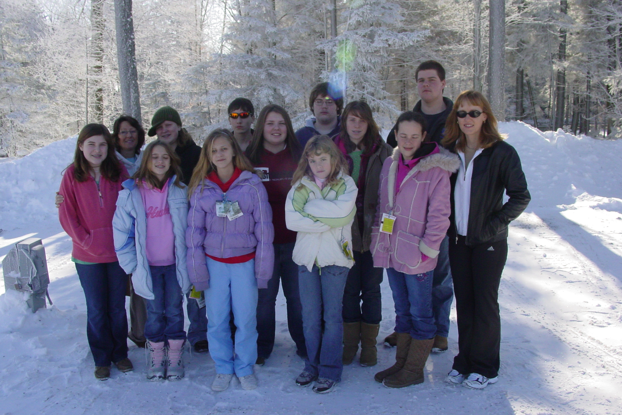
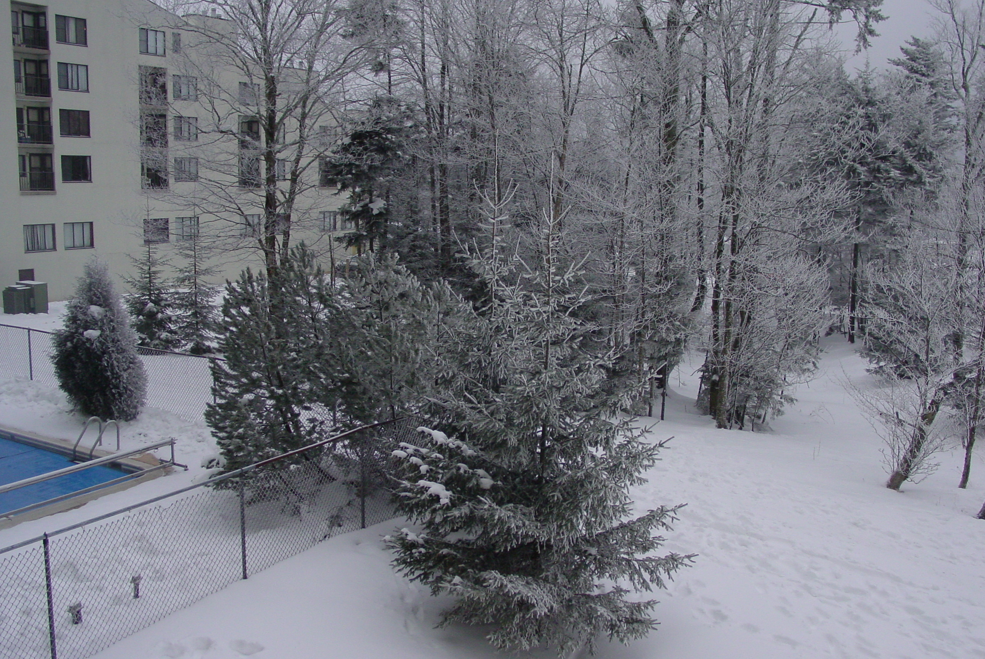
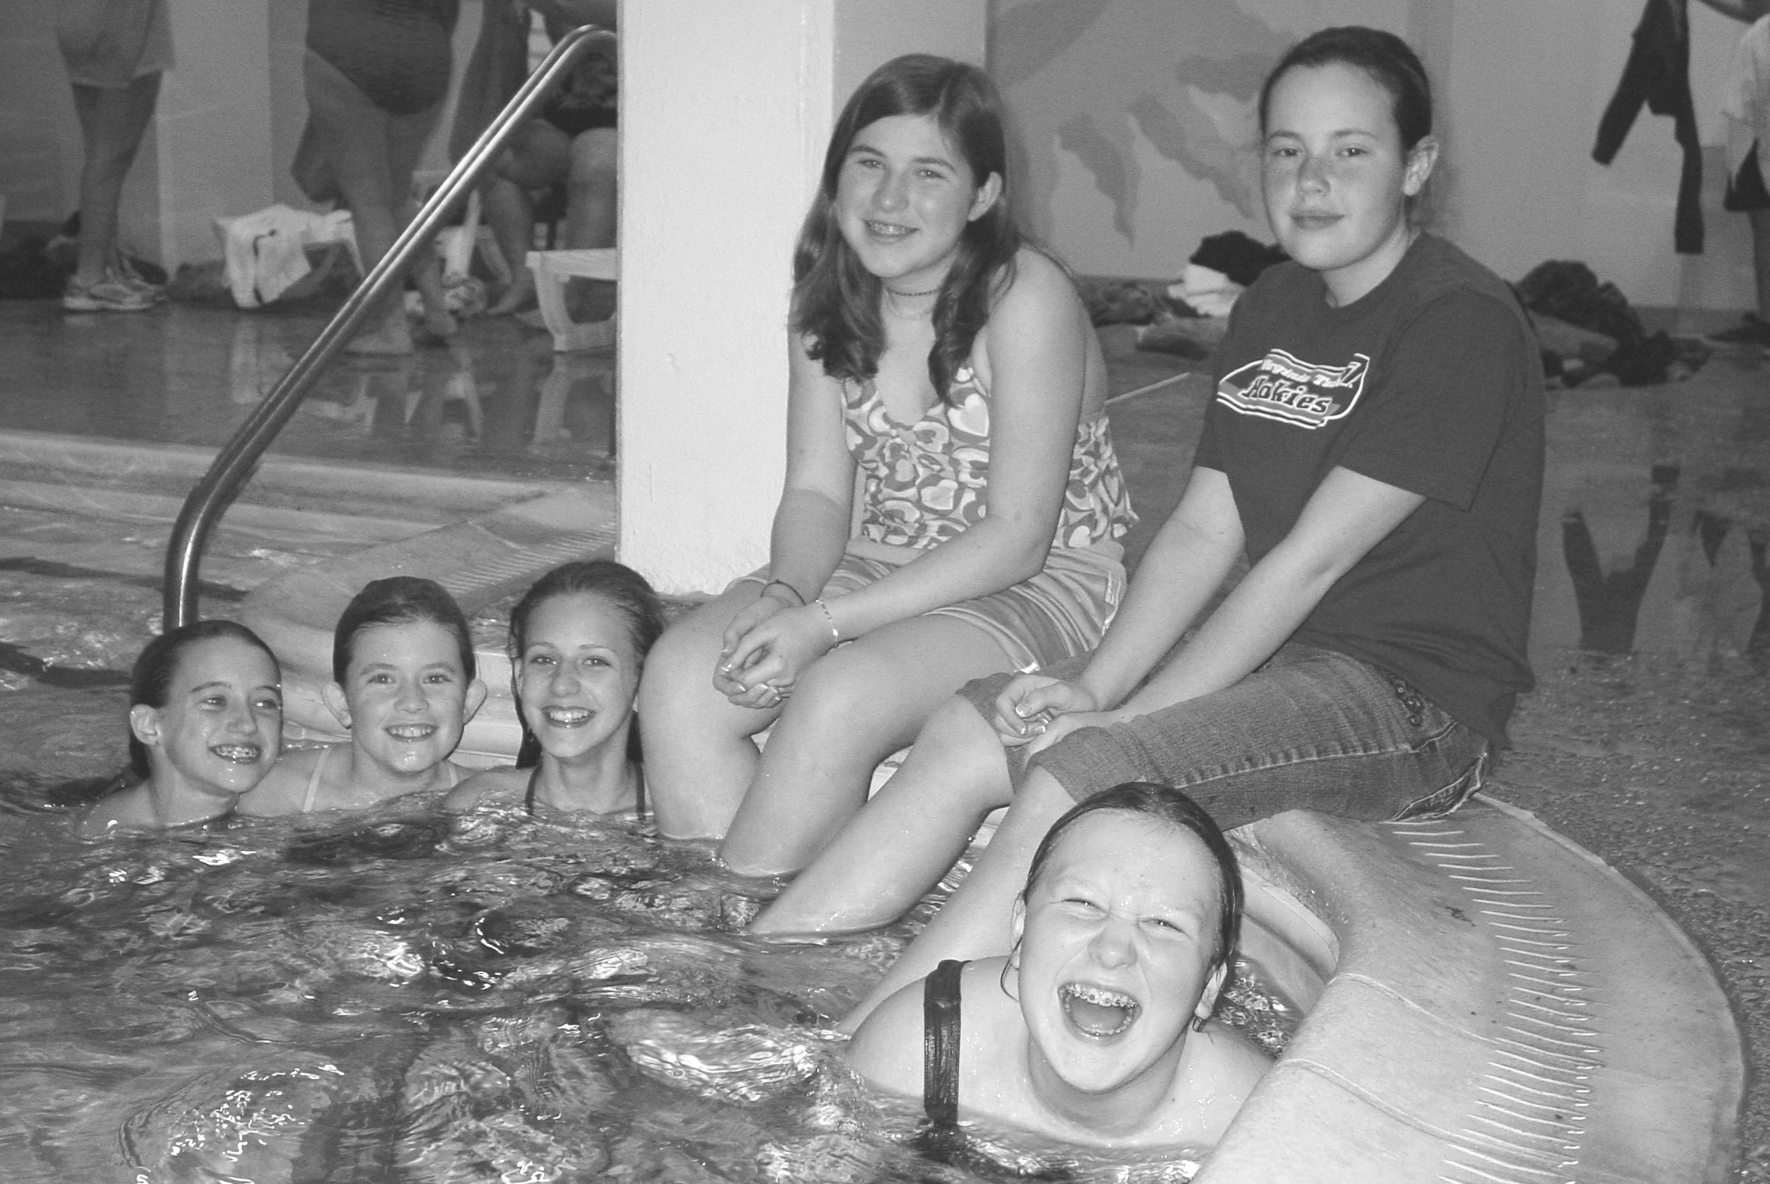
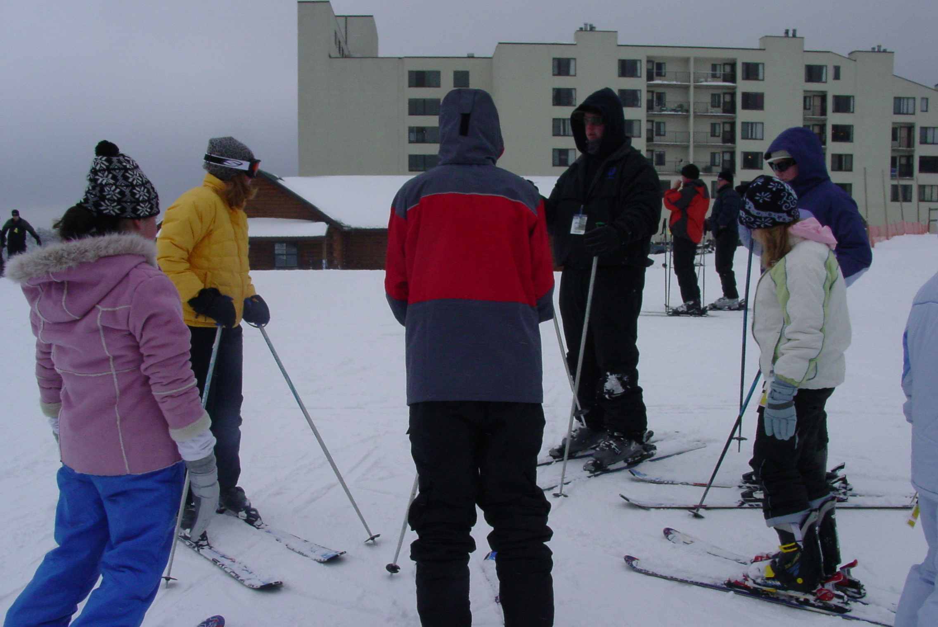
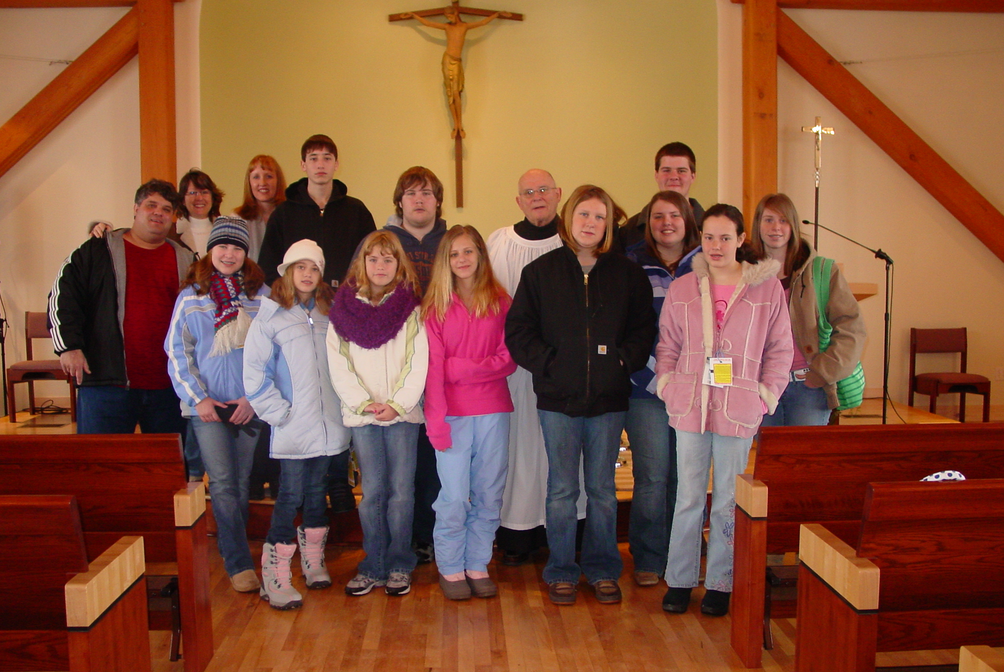
Youth Newsletter
March 2008
Page 4

Coming next month:
Pioneer Clubs News and Notes

