
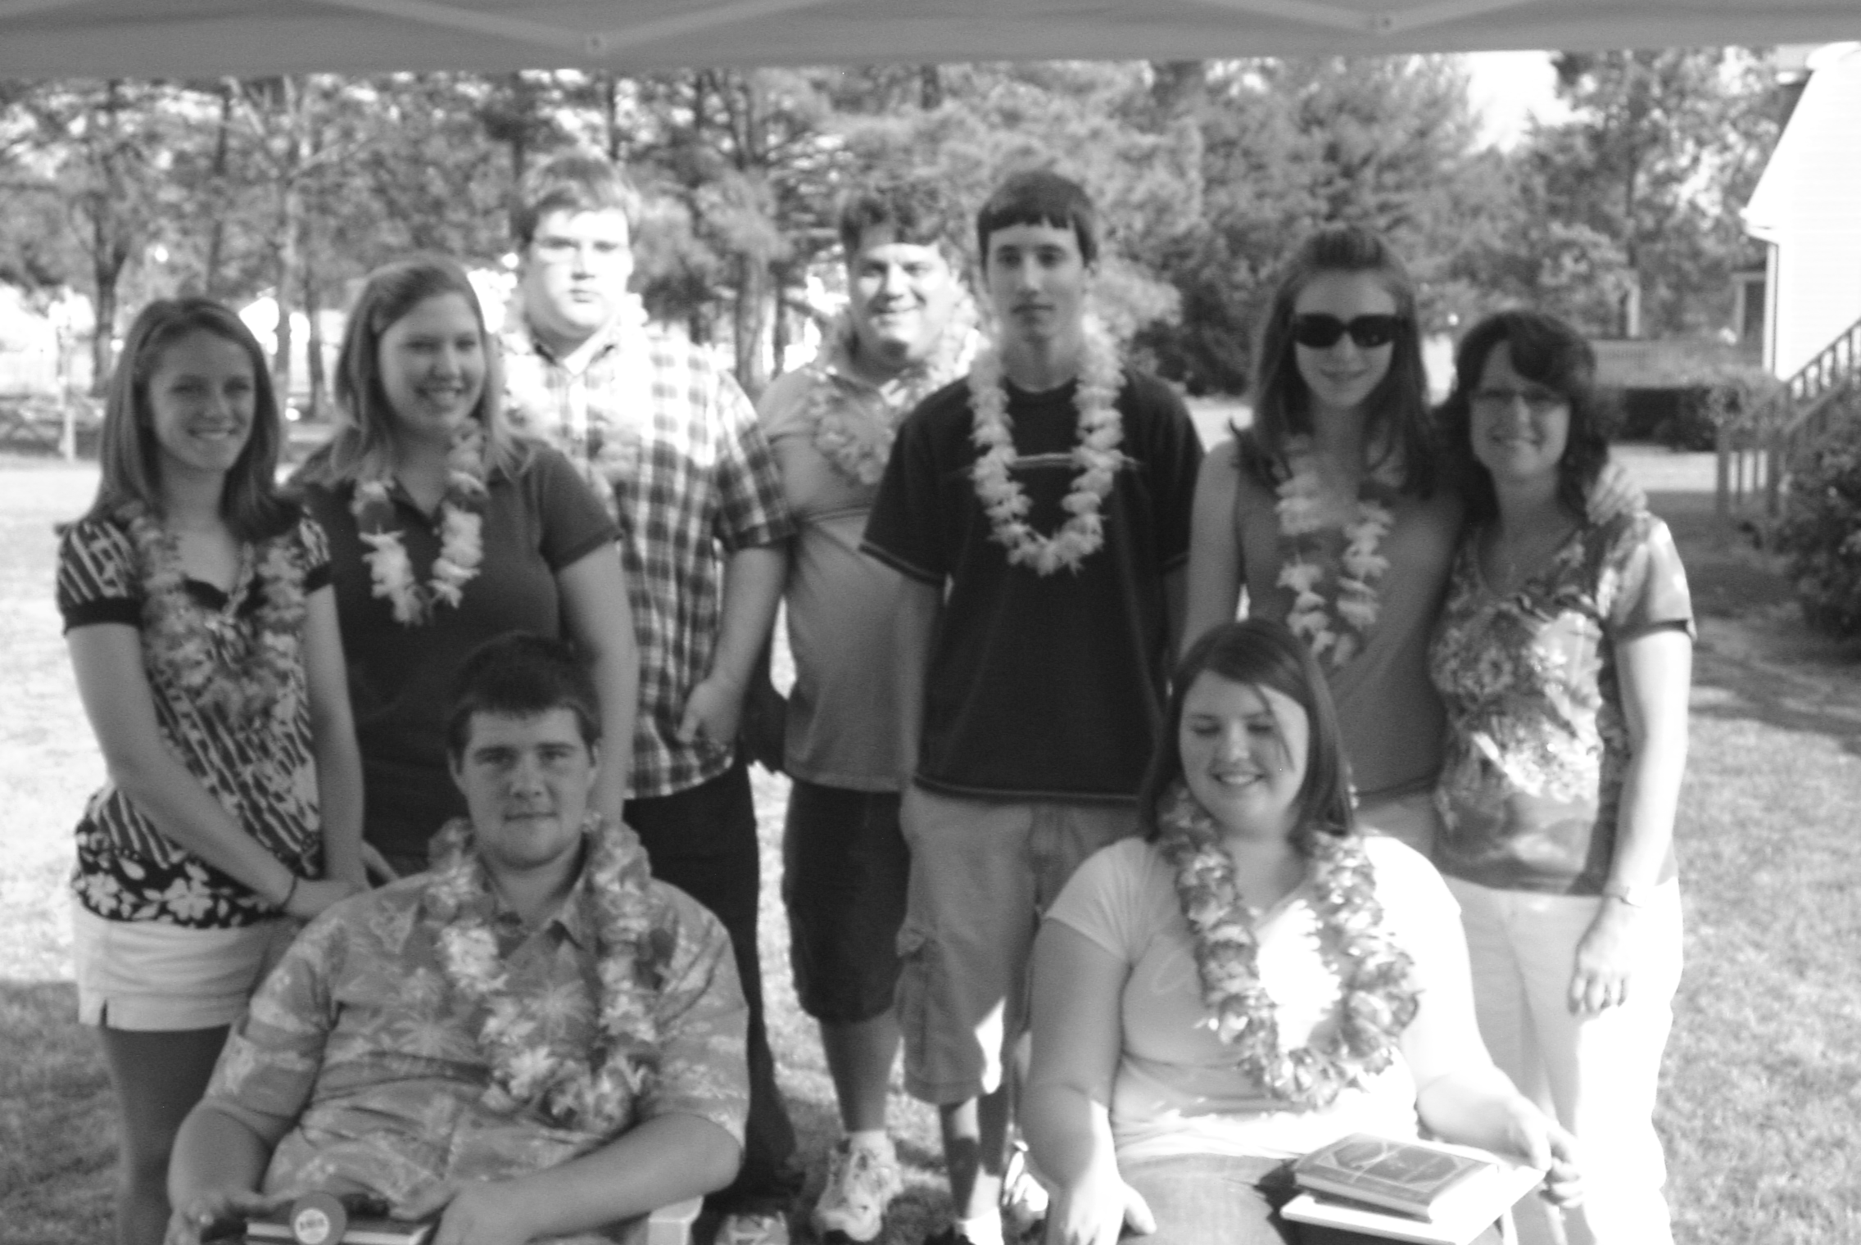
Youth Newsletter
YOUTH GROUP SCHEDULES

The Youth Groups at Bethlehem Christian Church

June 2008

ALL CLUBS

June 1 Youth Group Pool Party, 6:00pm-8:00pm
Suffolk Family YMCA
June 14 Camp Piankatank Open House, 1:00pm-4:00pm (rain date—June 15)
bus will leave church at 9:30am and return by 8:00pm, with stops for lunch and dinner
June 29-July 1 Camp Piankatank • Children’s Discover Camp (ages 7-9)
July 12 Alphas/Omegas Kings Dominion Kings Fest Trip, time & details TBA
July 20-25 Camp Piankatank • Extreme Escape Youth Camp (ages 13-17)
August 3-8 Camp Piankatank • Outdoor Outburst (ages 10-14)
September 7 Opening Activity, time & details TBA

Prior registration required for camp sessions. Contact David Salerno at (757) 539-1966 for more information.

NOTE: Bus transportation provided for camp sessions listed above. Parents are welcome to ride along to drop off and/or pick up their children. Bus will leave church at 2:00pm on the first day of camp, and return by 8:30pm, with a stop for dinner. Bus will leave church at 9:00am on the last day of camp, and will return by 3:30pm, with a stop for lunch. Please plan to be at church 30 minutes prior to scheduled departure times for check-in, packing, etc.

For more information about your club's schedule, including any special events planned for your individual club, please contact your club's leaders.

Youth Prepare to Close Out Youth Group Season

Although Regular Meetings on Sunday evenings ended in April, the Youth Groups at Bethlehem were busy into the month of May preparing to close out their year.

The Alpha Youth ended their year with a fishing trip on Sunday, April 27. The junior high youth went to the home of Jerry Thornton, Sr., where they fished in his backyard lake. Everyone in the group caught at least one fish, and many of the youth caught several. Special thanks to the Thorntons for hosting the youth!

C.J. and Laura show off their prize catch!

The Omegas closed out their year with their annual End-of-Year Luau at Becke West’s house on Sunday, May 4. Graduating seniors Kelsey Greene and Jacob Oliver were honored with gifts and a special message from Becke. Afterwards, the group enjoyed dinner and dessert together. Thanks to the West family for all their hard work!

The Omega Youth pause for a picture with their graduating seniors

In May, the youth sold Krispy Kreme donuts to help raise money for the church’s Relay for Life Team. Thanks to the support of the congregation, $245 was raised for the American Cancer Society.

The Youth Groups at Bethlehem will officially close out their year with a Pool Party at the Suffolk Family YMCA on Sunday, June 1, from 6:00pm to 8:00pm. However, several activities are planned for the summer months, including Summer Camp at Camp Piankatank, and a trip to Kings Dominion for Kings Fest in July.

Special thanks to everyone for their support of our Youth Fellowship Program here at Bethlehem this past year!



Youth Newsletter
June 2008
Page 2
Bible Reading Challenge

Use the Bible Reading Plan below to read the entire New Testament over the summer. It only takes about 20 minutes a day, and you can use the Bible translation you’re the most comfortable reading!

Those who complete the challenge will receive special recognition and an award at the Youth Group Cook-Out.
Summer Bible Reading Plan
Certification Card

I certify by my signature below that I have successfully completed the Summer Bible Reading Plan, and that I have completely read the entire New Testament.

Signature/Date Parent’s/Guardian’s Signature

NOTE: Please give this completed card to David Salerno no later than August 31 to insure that you receive your award at the Youth Group Cook-Out!

Sunday, June 15 Matthew 1-3
Matthew 4-6
Monday, June 16 Matthew 7-9
Tuesday, June 17 Matthew 10-12
Wednesday, June 18 Matthew 13-15
Thursday, June 19 Matthew 16-18
Friday, June 20 Matthew 19-21
Saturday, June 21 Matthew 22-24
Sunday, June 22 Matthew 25-28
Mark 1-3
Monday, June 23 Mark 4-6
Tuesday, June 24 Mark 7-9
Wednesday, June 25 Mark 10-12
Thursday, June 26 Mark 13-16
Friday, June 27 Luke 1-3
Saturday, June 28 Luke 4-6
Sunday, June 29 Luke 7-9
Luke 10-12
Monday, June 30 Luke 13-15
Tuesday, July 1 Luke 16-18
Wednesday, July 2 Luke 19-21
Thursday, July 3 Luke 22-24
Friday, July 4 John 1-3
Saturday, July 5 John 4-6
Sunday, July 6 John 7-9
John 10-12
Monday, July 7 John 13-15
Tuesday, July 8 John 16-18
Wednesday, July 9 John 19-21
Thursday, July 10 Acts 1-3
Friday, July 11 Acts 4-6
Saturday, July 12 Acts 7-9
Sunday, July 13 Acts 10-12
Acts 13-15
Monday, July 14 Acts 16-18
Tuesday, July 15 Acts 19-21
Wednesday, July 16 Acts 22-24
Thursday, July 17 Acts 25-28
Friday, July 18 Romans 1-3
Saturday, July 19 Romans 4-6
Sunday, July 20 Romans 7-9
Romans 10-12
Monday, July 21 Romans 13-16
Tuesday, July 22 1 Corinthians 1-3
Wednesday, July 23 1 Corinthians 4-6
Thursday, July 24 1 Corinthians 7-9
Friday, July 25 1 Corinthians 10-12
Saturday, July 26 1 Corinthians 13-16
Sunday, July 27 2 Corinthians 1-3
2 Corinthians 4-6
Monday, July 28 2 Corinthians 7-9
Tuesday, July 29 2 Corinthians 10-13
Wednesday, July 30 Galatians 1-3
Thursday, July 31 Galatians 4-6
Friday, August 1 Ephesians 1-3
Saturday, August 2 Ephesians 4-6
Sunday, August 3 Philippians 1-4
Colossians 1-4
Monday, August 4 1 Thessalonians 1-5
Tuesday, August 5 2 Thessalonians 1-3
Wednesday, August 6 1 Timothy 1-3
Thursday, August 7 1 Timothy 4-6
Friday, August 8 2 Timothy 1-4
Saturday, August 9 Titus 1-3
Sunday, August 10 Philemon
Hebrews 1-3
Monday, August 11 Hebrews 4-6
Tuesday, August 12 Hebrews 7-9
Wednesday, August 13 Hebrews 10-13
Thursday, August 14 James 1-3
Friday, August 15 James 4-5
Saturday, August 16 1 Peter 1-5
Sunday, August 17 2 Peter 1-3
1 John 1-3
Monday, August 18 1 John 4-5
Tuesday, August 19 2 John • 3 John •
Jude
Wednesday, August 20 Revelation 1-3
Thursday, August 21 Revelation 4-6
Friday, August 22 Revelation 7-9
Saturday, August 23 Revelation 10-12
Revelation 13-15
Sunday, August 24 Revelation 16-18
Revelation 19-22
Sunday, August 31 Deadline for
turning in
Certification Card
Sunday, September 7 Awards presented
at Youth Group
Cook-Out

adapted from the Comprehensive Bible Reading Plan (365 days) on biblegateway.com

