
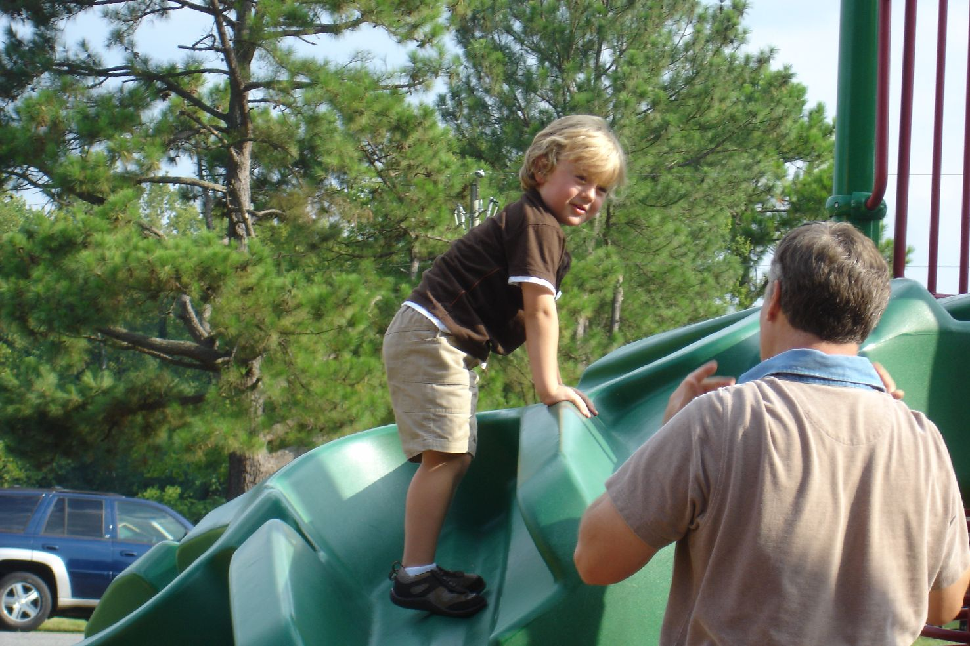
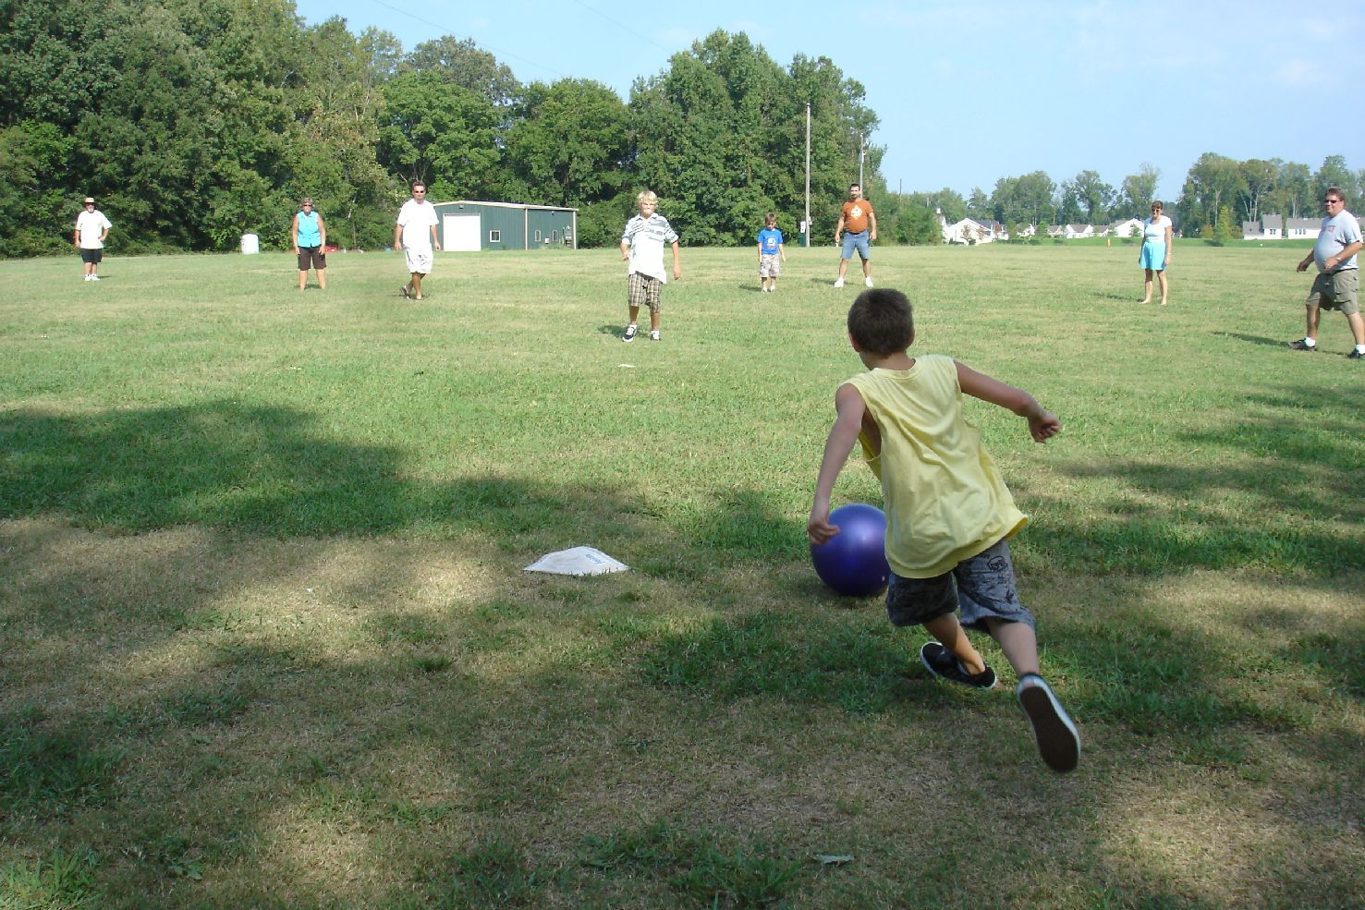
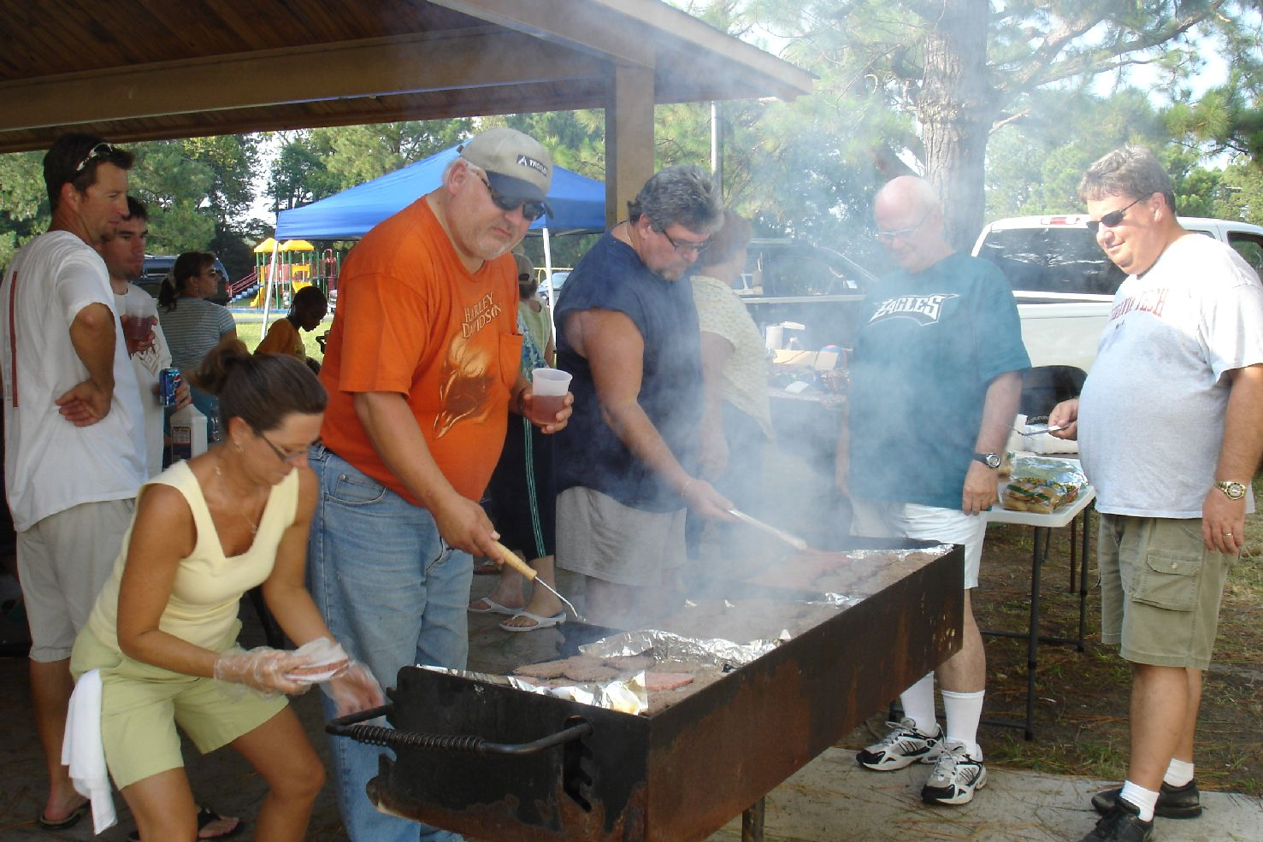
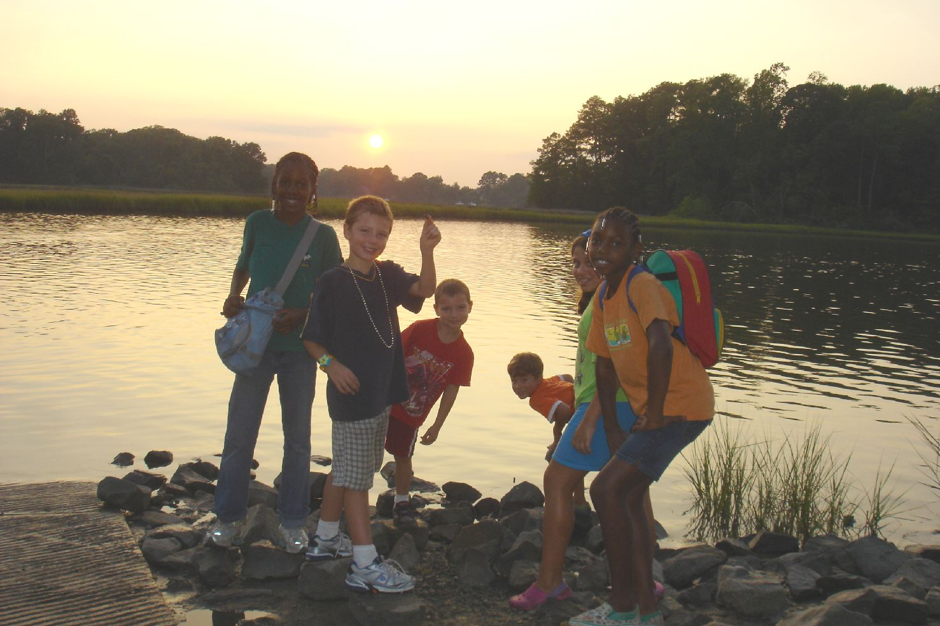
Youth Newsletter
The Youth Groups at Bethlehem Christian Church

October 2008

Over 60 Youth, Adults Attend Opening Cook-Out

On Sunday, September 7, the Youth Groups at Bethlehem kicked off the 2008-2009 youth group season with a cook-out at Bennett’s Creek Park.

The youth and their families started to arrive around 3:00pm on a perfect picnic afternoon.

The younger children enjoyed the playground, while several of the youth played tennis on the tennis courts. Shortly before dinner, the children and adults organized a game of kickball.

Clifton climbs on the playground

Tristan gets ready to kick one out of the park!

Around 5:00pm, the group stopped for dinner. The meal consisted of grilled hamburgers and hot dogs, baked beans, chips, drinks, and cookies.

Becke, Mark, Kenny, Al, and Robert have the grill under control

Shortly after dinner, several of the youth went nature walking, while others went to the pier to go crabbing and exploring.

Exploring by the river

(continued on Page 2, Cook-Out)
(Cook-Out, continued from Page 1)

The cook-out ended shortly before 7:00pm. Special thanks to all those who helped to make this cook-out happen.

Everyone gathers for a group photo
YOUTH GROUP SCHEDULES

ALL CLUBS

October 5 Regular Meeting, 5:30pm-7:15pm
October 12 Regular Meeting, 5:30pm-7:15pm
October 19 Regular Meeting, 5:30pm-7:15pm
October 26 Community Harvest Festival, 4:00pm-7:00pm
November 2 Youth Sunday, 8:30am-12:00noon

For more information about your club's schedule, including any special events planned for your individual club, please contact your club's leaders.
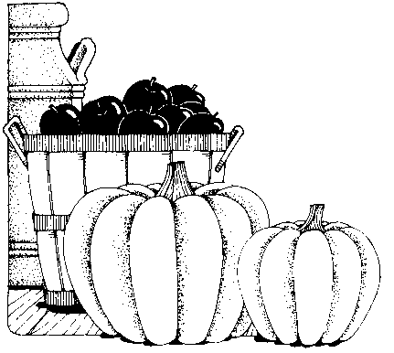





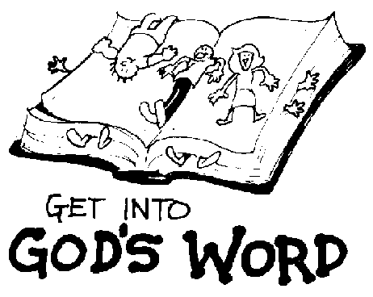
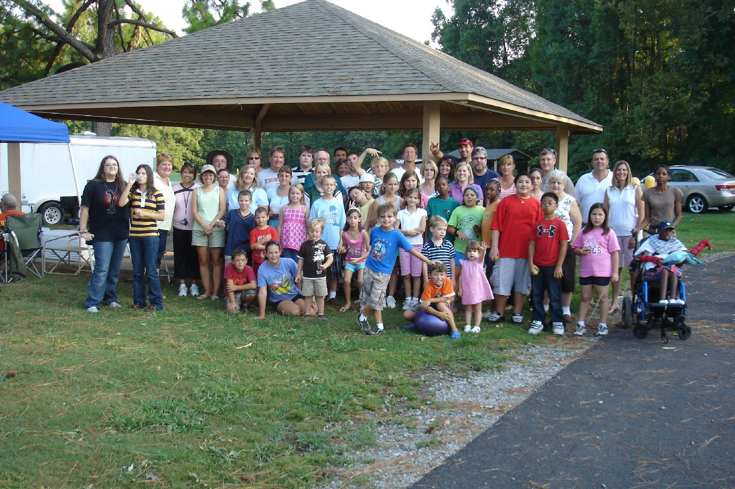

Youth Newsletter
October 2008
Page 2

6th Annual

Community Harvest Festival

Sunday, October 26 • 4:00pm-7:00pm

Moon Walk • Hay Ride • Games • Cake Walk • Crafts
Hot Dogs • Popcorn • Cotton Candy • Sno Cones • Candy • Prizes

Fun for the whole family!

Pioneer Clubs
News & Notes

The Scooters started the year with their first unit, “Jesus the Helper”. After their lesson, “Jesus Loves”, the children sang songs, listened to “Thy Word”, the Pioneer Clubs theme song, and played a game they created themselves.

The Voyagers began the new year learning the Pioneer Clubs Verse, Psalm 119:105. The children also helped the leaders make club rules. This year, the group will be working on the Growing in God’s Love series.

The Pathfinders began their series for the year—Discovering God’s Goodness—by working on earning the Understanding the Bible award. The children also created bookmarks and banners for their Design activity award.

Old Testament
Bible Reading Challenge

Read the entire Old Testament using the customized Bible Reading Plan (available online at www.bccyouth.org, click on Documents & Forms). It only takes about 15 minutes a day, and those who complete the challenge will receive a special award at the Youth Group Pool Party!
Sorry
for the delay!

We’re still getting our pictures and interviews together for our Summer Camp Report. Watch for it in next month’s Youth Newsletter!

