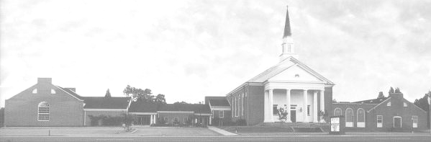

Youth Newsletter

YOUTH GROUP SCHEDULE
The Youth Groups at Bethlehem Christian Church

May 2009
Looking Back, Looking Ahead

As summer quickly approaches, we race into the home stretch of our youth group season. Our youth have been quite active this year and, in addition to their Regular Meetings, have done much both in church and in our community.

The first event of the youth group season was the Alpha Youth Group’s pool party on Sunday, August 17. The year officially started a few weeks later, on Sunday, September 7, with the Opening Cook-Out. Over sixty youth, parents, and leaders were in attendance. The Pioneer Clubs started off their year by learning their official Club Verse, Psalm 119:105.

In October, 27 junior and senior high students, recent graduates, and leaders attended Judgement House at First Baptist Church. And, on Sunday, October 26, over 150 children and parents attended our sixth annual Community Harvest Festival. The event featured games, food, prizes, a hay ride, a moon walk, and for the first year ever, a Pony Ride. Also in October, the Alpha youth visited Nansemond Pointe Nursing Home and gave small pumpkins to the residents, while the Voyagers went on a nature walk to earn their Exploring Nature activity award.

Throughout the youth group season, the Pioneers earned “Pioneer Bucks” for special achievements, such as bringing a friend to club, learning their memory verses, or earning a Bible or activity award. Once a month, children used their Pioneer Bucks to “buy” special rewards in the Pioneer Clubs General Store.

On Sunday, November 2, over 20 junior and senior high youth taught Sunday School and led the morning worship service on Youth Sunday. High school seniors Brooke Crumpler and Shane Culbertson brought the morning messages. On November 16, the children participated in Operation Christmas Child, filling 41 shoe boxes with toys, school supplies, and other items for needy children overseas. In total, the church sent 92 filled shoe boxes to children in need all over the world. Also in November, the Pathfinders and Omegas sent over 200 cards to Military Mail Call, and the Alpha youth visited Edith Powell.

In December, the Omega youth made nearly 100 pounds of fudge to sell and raise money for their annual Christmas mission project. Youth of all ages also participated in the Christmas Cantata, the Children’s Christmas Play, and the Living Nativity. The week before Christmas, the Pathfinders went on a night of traditional Christmas caroling in Bethlehem Court, while the Alphas visited the residents at Nansemond Pointe.

In January, the Alpha Youth Group traveled to the nursing home in Windsor to visit Pauline Modlin.

(continued on Page 2, Looking Back)
(Looking Back, continued from Page 1)

In February, children of all ages donated over 130 food items to the church’s Food Pantry during our annual Souper Bowl Sunday. The youth also helped serve during a fundraising dinner sponsored by the Missions Committee. On February 14, fourteen youth and leaders left for Snowshoe Mountain in West Virginia for their annual Ski Retreat. And, on February 26-27, nineteen junior and senior high students, recent graduates, and leaders participated in the World Vision 30 Hour Famine. The group went without food for 30 hours, to gain a greater understanding of what children in need all over the world go through on a daily basis, and to raise money for World Vision’s Christian relief efforts.

In March, the Voyagers and Alphas attended the Answers in Genesis conference at First Baptist Church. The younger children learned about dinosaurs and the Bible, while the older youth discussed making good choices in movies, music, and television.

And, in April, the junior high youth delivered Easter lilies to the residents at Nansemond Pointe Nursing Home. The junior and senior high youth also helped the Mission Committee serve their Fundraising Dinner for Relay for Life.

Although the youth have accomplished much this year, there are still several events left in the youth group season.

On Sunday, May 3, the Omega youth will honor their graduating seniors at their annual Luau. And, on May 15-16, youth of all ages will be participating in the Suffolk Rockin’ Relay for Life, to raise money for the American Cancer Society and to show our support for those who are battling cancer. Several groups are also planning to visit the nursing home. And, in June, the group will have its Closing Pool Party.

Throughout the year it has been our goal to help the youth put their faith into action, and to show God’s love to a world in need in both action and word. Thanks so much for your support of your youth group program here at Bethlehem!

May 3 Regular Meeting, 5:30pm-7:15pm
Omegas Graduation Luau, 3:00pm
Becke’s House, 333 Sussex Ct.
May 10 No Regular Meeting
Mother’s Day
May 15-16 Relay for Life
Nansemond-Suffolk Academy
May 17 Regular Meeting, 5:30pm-7:15pm
May 24 No Regular Meeting
Memorial Day Weekend
May 31 Regular Meeting, 5:30pm-7:15pm

For more information about your club’s schedule, including any special events planned for your individual club, please see your club’s leaders.

Youth Newsletter
May 2009
Page 2


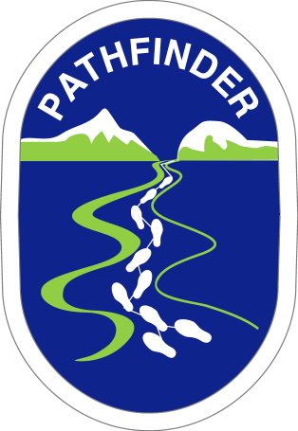
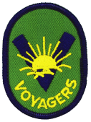


Pioneer Clubs
News & Notes

The Scooters finished their Growing unit in April. The children made mosaic containers to hold things they have learned about God. The Scooters started their Be a Friend unit, and made invitations to give to other children to invite them to Pioneer Clubs. The children also made animals out of thread spools.

This past month, the Voyagers worked on their Honoring My Family unit. The children made a puppet stage and puppets, and learned about the miracles God performed to help families.

In April, the Pathfinders worked to complete their God Creates unit. To earn their Our Environment activity award, the children learned about reducing waste and recycling junk, and made journals out of recycled materials.
The Youth Groups at Bethlehem Christian Church

SUFFOLK ROCKIN’
Relay for Life
May 15-16, 2009
Nansemond-Suffolk Academy
3373 Pruden Boulevard, Suffolk, Virginia

All youth and their families are encouraged to participate

Join our Relay for Life team today!

Sign up now at www.suffolkrockinrelay.org,
or by completing the Registration Form.

Please call David Salerno at (757) 334-1507 for more information.

Bethlehem Christian Church

FaithWalkers
“For we walk by faith, not by sight.” 2 Corinthians 5:7 (ESV)

