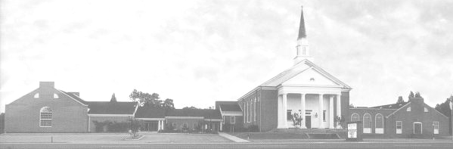

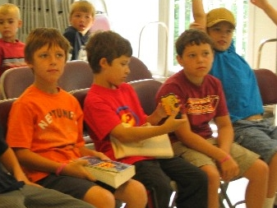
Youth Newsletter

UPCOMING EVENTS
The Youth Groups at Bethlehem Christian Church

October 2009
October 4 Regular Meeting, 5:30pm-7:15pm
October 11 Regular Meeting, 5:30pm-7:15pm
October 18 Regular Meeting, 5:30pm-7:15pm
October 25 7th Annual Community Harvest Festival, 4:00pm-7:00pm
November 1 Youth Sunday, 8:30am-12:00noon

For more information about your club’s schedule, including any special events planned for your individual club, please see your club’s leaders.

Thirteen Children, Youth Return to Summer Camp at Camp Piankatank

“Camp was awesome!” “I met lots of new friends.” “An overall awesome place!” “I had so much fun!” “My camp counselors were the best!”

These were just a few of the comments from thirteen children and youth who attended summer camp at Camp Piankatank in Hartfield, Virginia, including four who attended for the first time.

Located on a 90-acre site on the pristine Piankatank River north of Gloucester, Camp Piankatank is a Christian summer camp owned and operated by the Virginia Baptist Mission Board. The camp programs offered are very kid-friendly, high-energy, and spiritually-focused, with two interactive worship services every day and a resident Camp Pastor.

This is the second consecutive year that Bethlehem Christian Church has sponsored a Summer Camp Program for its youth. Fourteen children and youth attended Camp Piankatank last year, and thanks to largely positive reviews from the campers and their parents, the camp was chosen once again for our program in 2009.

Several fundraisers were held to help cover the fees for the campers. In addition, the Mission Committee made a generous donation to help cover camp fees.

Finally, on June 28, five boys ages 7-9 left church to attend Amazing Adventure Mini Camp. This special three-day camp session was designed for young campers to get a “taste” of the summer camp experience. Focused on traditional camp activities, the boys participated in rock wall climbing, arts and crafts, and a variety of outdoor games.

Chase, Benji, Stephen, and Bobby Rhea at the morning chapel service

Next, on July 19, three girls ages 13 and up attended Extreme Escape Youth Week. This six-day camp session was geared toward students who want to “escape” from their normal routines and have an awesome life-changing camp experience. The teens explored the challenge course, participated in waterfront activities such as canoeing and kayaking, and paddled across the river for an overnight island campout.

Lastly, on July 26, five youth ages 10-14 attended Amazing Adventure Camp. This action-packed camp session featured activities such as rock wall climbing, canoeing, sports, and the V-swing.

(continued on Page 2, Summer Camp)
(Summer Camp, continued from Page 1)

Madison, Ariel, Christina, Adrenia, and Arneze with their camp counselors

A typical day at camp started at 7:00am with exercises and devotions in the cabin, followed by breakfast in the dining hall. After breakfast, the campers spent time cleaning their cabins before heading off to morning worship service.

“Our cabin won ‘Cabin of the Day’ two times in a row for being the cleanest of them all!” boasted Amazing Adventure camper Christina Hilbert.

Then, usually about 10:00am, the morning camp activities began. These activities pertained to the general theme of the camp. “Canoeing was really fun,” commented Amazing Adventure camper Arneze Flood.

At about noon, the campers stopped for lunch in the camp’s dining hall, then headed back to their cabins for quiet time, where they could read their Bibles, pray, or just spend time reflecting on the lessons and activities of the day.

“You felt like you were at home,” reflected Amazing Adventure camper Ariel Salerno. “And the food was surprisingly good, too.”

At about 2:00pm, the campers started their afternoon activities. “We went to the pool, climbed the rock wall, and swung on the V-swing,” commented Amazing Adventure camper Adrenia Flood.

Dinner was typically about 6:00pm, followed by swimming time in the camp’s outdoor pool. All campers went to an evening worship service, and then returned to their cabins for devotions before calling it a night.

“Pastor Jack was a wonderful pastor,” commented Amazing Adventure camper Madison Davis. “The worship band was awesome!”

“It really was an ‘Amazing Adventure’!” said Christina.

“I learned more and more about God,” replied Madison. “I learned that there are struggles in life, and you need God to get through them.”


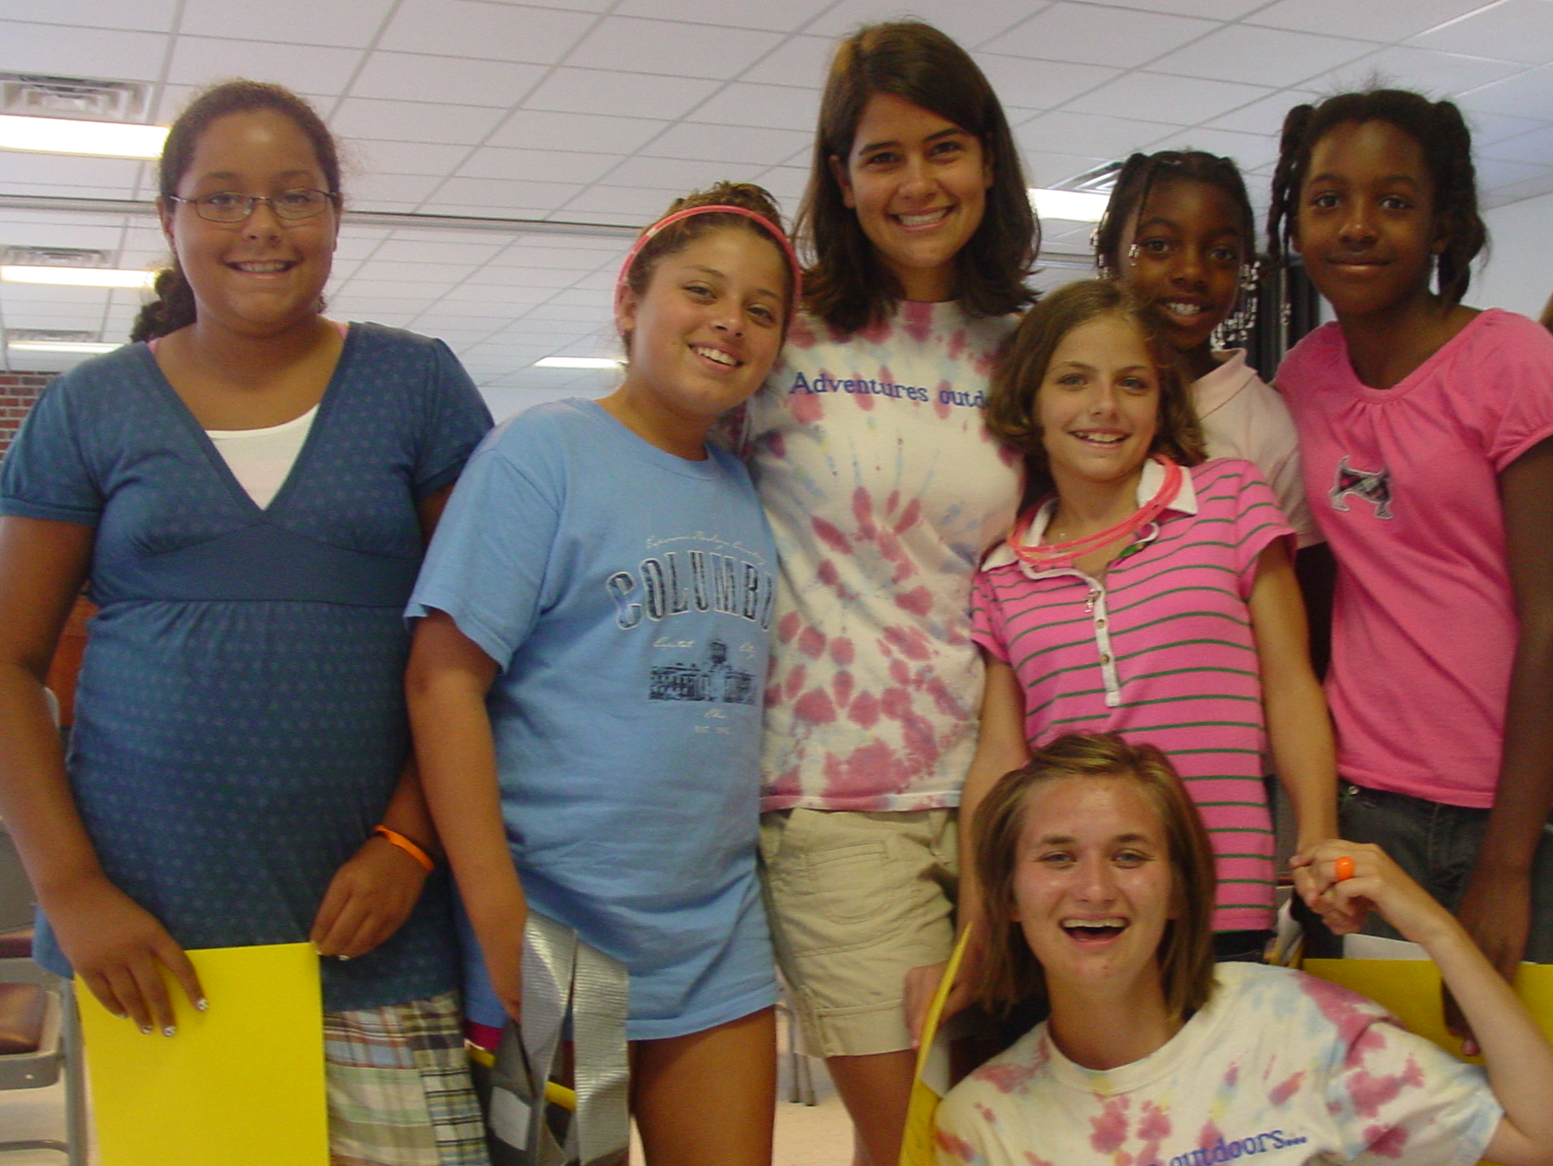
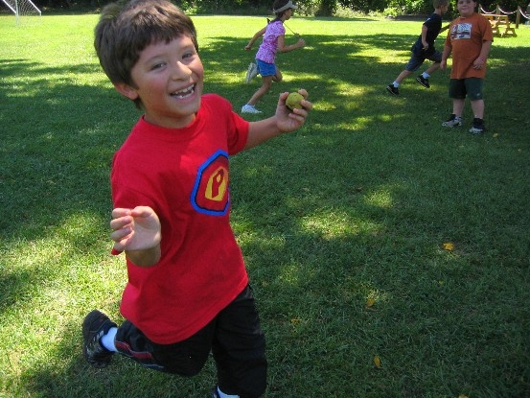
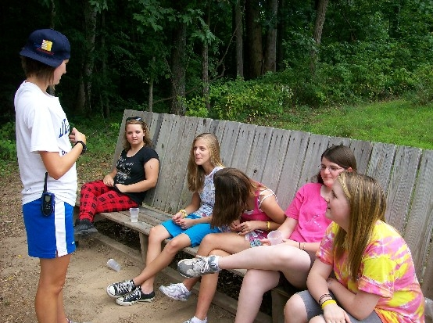
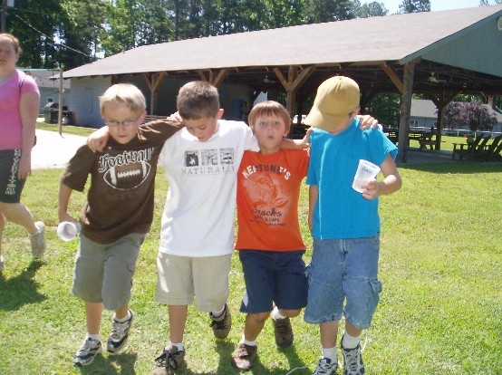
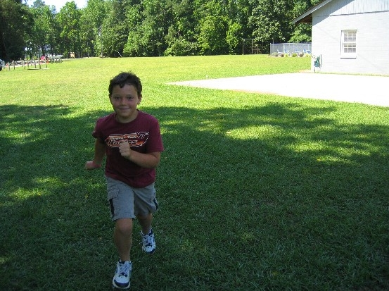
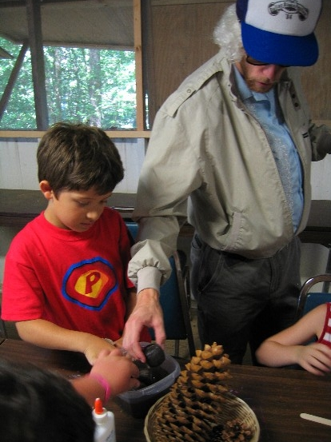
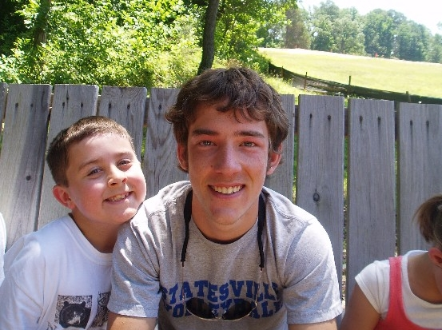
Youth Newsletter
October 2009
Page 2
7th Annual
Community Harvest Festival

Sunday, October 25
4:00pm-7:00pm

Moon Walk • Hay Ride • Games • Cake Walk • Crafts
Hot Dogs • Popcorn • Cotton Candy • Sno Cones
Candy • Prizes

Fun for the
whole family!
Summer
2009
Camp Piankatank

