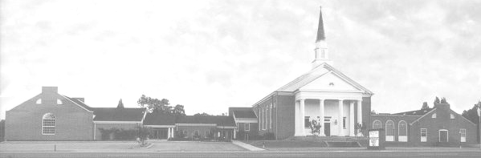

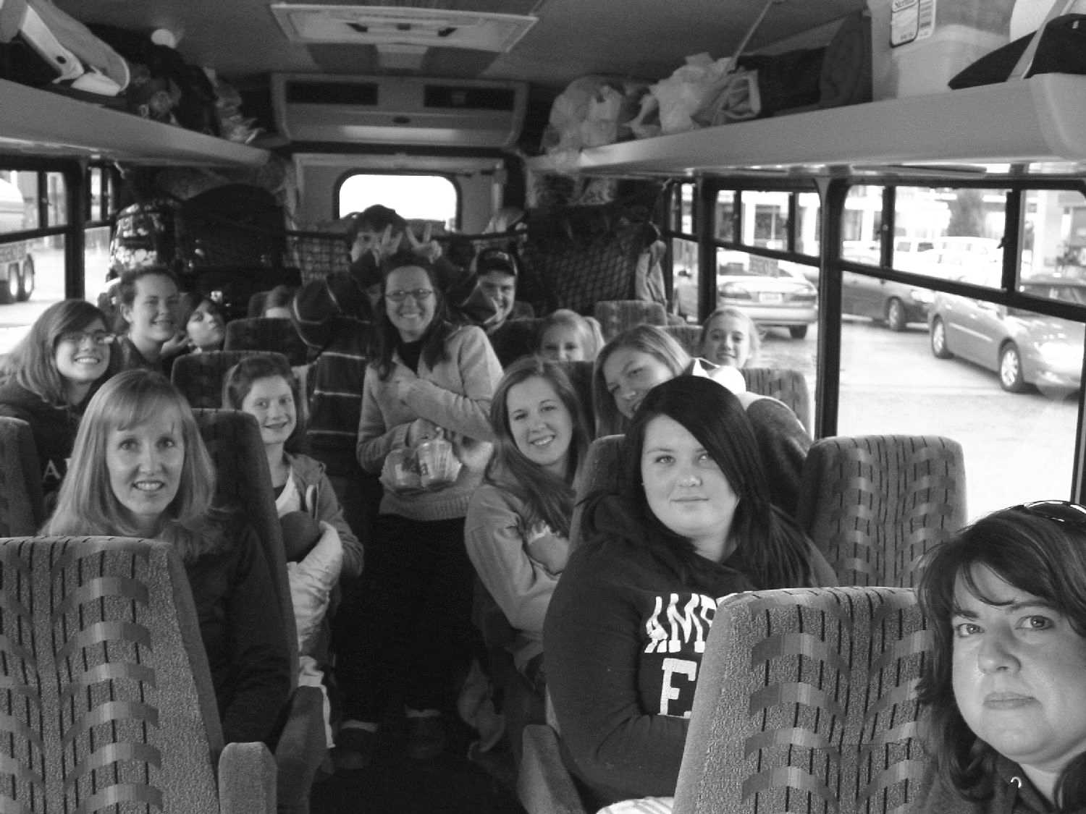
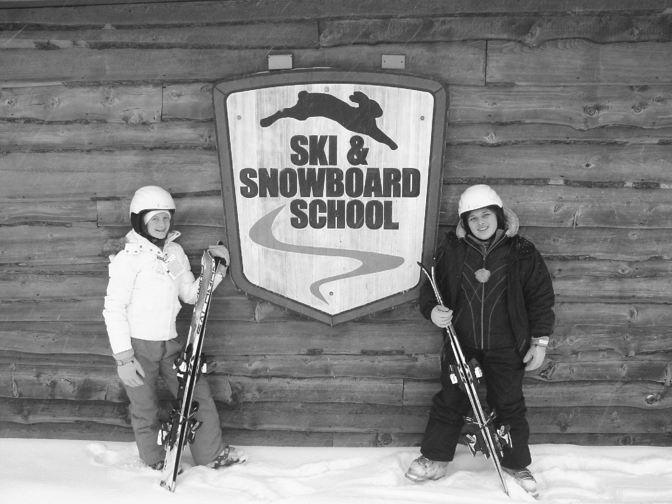
Youth Newsletter

UPCOMING EVENTS
The Youth Groups at Bethlehem Christian Church

March 2010
Alphas, Omegas Return to West Virginia for Annual Ski Trip

While Suffolk was receiving nearly a foot of snow last month, the Alpha and Omega Youth were away at Snowshoe Resort in West Virginia for their annual Ski Trip.

Sixteen youth, recent graduates, and chaperones left the church shortly before 2:00pm on Friday, January 29. After a bathroom stop in Richmond and a stop for dinner in Waynesboro, the group arrived at the resort around 10:00pm and checked into their rooms at the Silver Creek resort area.

Packed and ready to go to Snowshoe!

Each of the group’s rooms at Silver Creek had a full kitchen, and at least one queen bed and a queen pull-out sofa. Plus, the resort was literally steps from the ski slopes and the Tubing Hill, making it easy for the group to come and go as they pleased.

The next morning, after an early breakfast, two of the youth checked out their skis and headed out for Ski School, while the rest of the group hit the slopes for an early morning ski session.

“Attending Ski School really helped our first-time skiers get ‘up-to-speed’ quickly,” commented David Salerno, Bethlehem’s Youth Director and a chaperone on the trip. “Snowshoe’s Ski School program is excellent, and by the end of the first day, the younger kids were keeping right up with the more experienced skiers. It really helped them get the most out of their trip.”

Ginna and Ariel pose in front of the Ski School

After lunch in their rooms, most of the group returned to the slopes, while others took the bus to the Village Center for an afternoon of shopping and sightseeing.

Around 5:00pm, everyone stopped for dinner—spaghetti with meat sauce and garlic bread
(continued on Page 2, Ski Trip)
(Ski Trip, continued from Page 1)

prepared by Becke West. After dinner, most of the youth returned to the slopes for night skiing, then called it a night.

Pausing for a picture at the summit of the Silver Creek ski area

The group woke up early on Sunday morning and headed off for the Protestant worship service at Saint Bernard Chapel. Two of our youth were asked to read Scripture during the service.

The group poses in front of Saint Bernard Chapel before the service

Following the church service, the group split up for the afternoon—part of the group had an early lunch, then went snow tubing for the afternoon and evening tubing sessions, while the rest of the group skied at Silver Creek, had a late lunch, and then headed over to the Snowshoe slopes for the afternoon ski session.

It was a bright sunny Sunday afternoon at Silver Creek!

(continued on Page 3, Ski Trip)
(Ski Trip, continued from Page 2)

Pausing for a picture on the Tubing Hill during the evening tubing session

Between 5:00pm and 7:00pm, the group returned to the resort for dinner—Southwestern chili made by Paula Thornton. After dinner, several in the group returned to the slopes for one last night skiing session, while the rest enjoyed the resort’s indoor/outdoor heated pool, indoor and outdoor hot tubs, and sauna.

Laura, Ginna, Ginny, and Ginger have fun together in the indoor heated pool

The group woke up early Monday morning, packed their belongings, and left Snowshoe around 10:30am. After stopping for lunch and bathroom breaks, the group returned to church by 6:00pm, allowing the youth to enjoy dinner with their families before returning to school the next day.

The conditions at Snowshoe during the trip could not have been better. The drive up to West Virginia on Friday was perfectly clear, as the snow did not begin to fall until early Saturday morning. Light to moderate snow flurries fell throughout the day on Saturday, accumulating 6 to 8 inches of new snow on the mountain. On Sunday, the sun came out and the winds died down, making conditions excellent for skiing on the newly-fallen powder. And, by the time the group left the resort on Monday, the roads had been mostly cleared and were safe to travel.

The group pauses for a picture before leaving Snowshoe

“This year’s Ski Trip was a great time of fellowship, enabling us to grow closer together as a group, and to grow closer to God,” commented David. “Special thanks to Becke West, Paula Thornton, and Lisa Tarkington—this trip would not have been possible without them.”

March 7 Regular Meeting, 5:30pm-7:15pm
March 14 Regular Meeting, 5:30pm-7:15pm
March 21 Regular Meeting, 5:30pm-7:15pm
March 28 No Regular Meeting
Easter Egg Hunt
April 4 No Regular Meeting
Easter Sunday

For more information about your club’s schedule, including any special events planned for your individual club, please see your club’s leaders.

Youth Newsletter
March 2010
Page 2
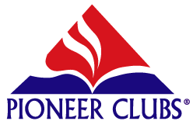
Pioneer Clubs
News & Notes

The Scooters have been meeting with the Pathfinders and working on their club activities together with the older children. This is a wonderful age group that is a delight to work with! If you would like to volunteer to be a leader for this club, please call David Salerno at (757) 334-1507.

In February, the Voyagers worked on the unit Belonging to God. They studied the book of 2 Kings, and discussed Elijah the prophet. The children also earned their Belonging to God and Club Helper awards. The Voyagers plan on visiting the nursing home and singing for the residents in the near future.

Last month, the Pathfinders worked on finishing their latest unit, Knowing God. The children also earned their Tumbling and Creative Messages activity awards.



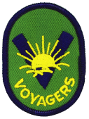
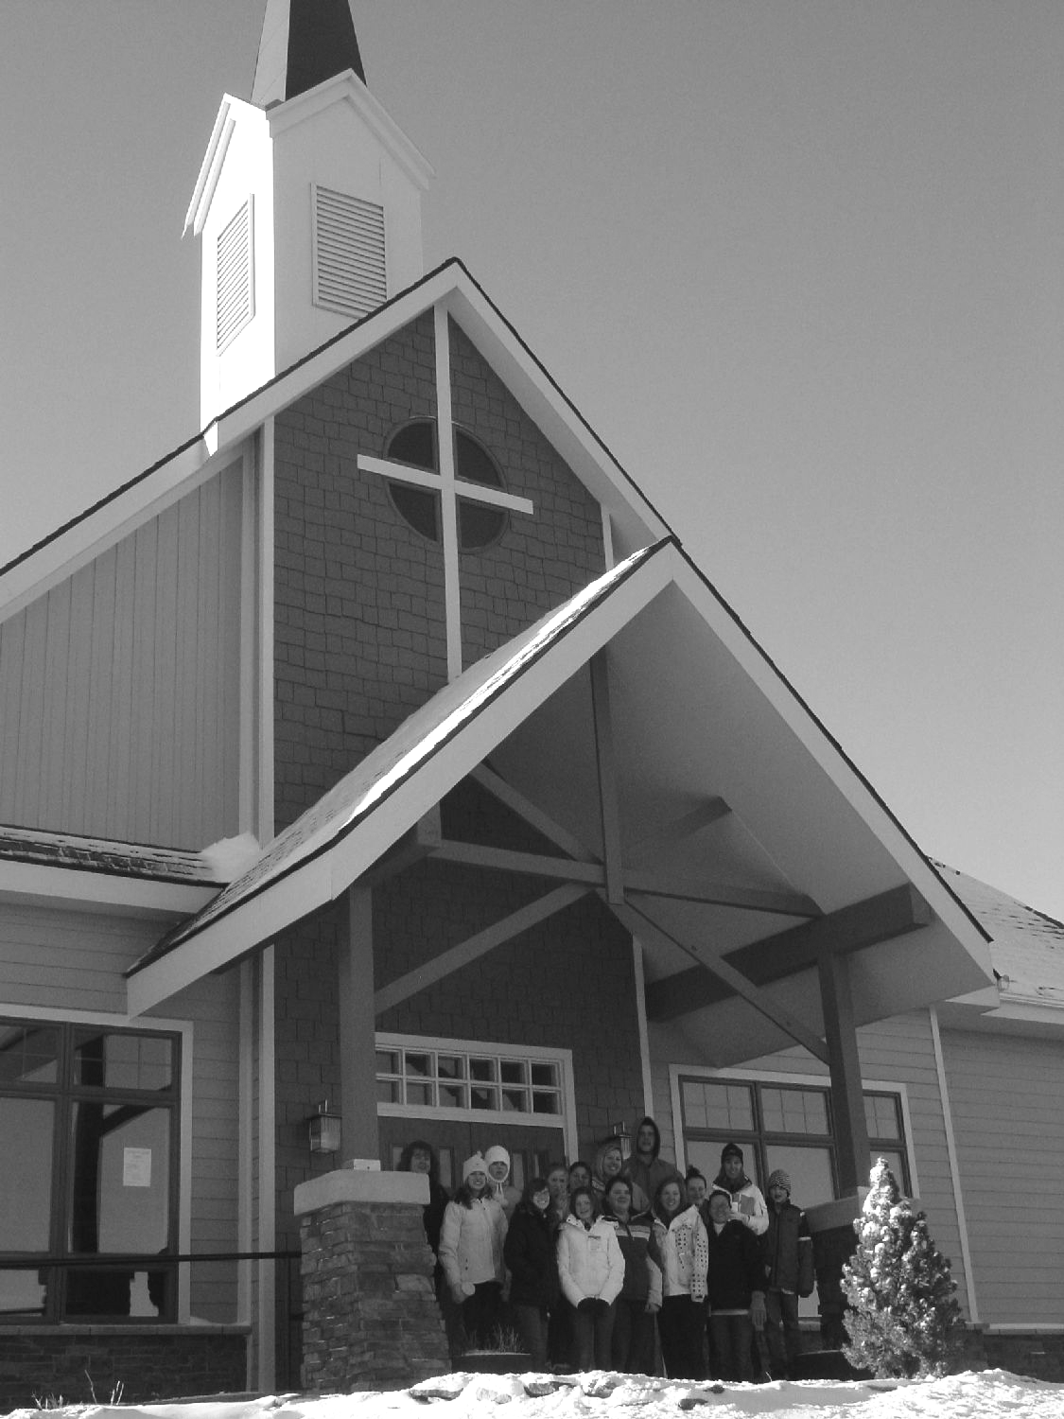
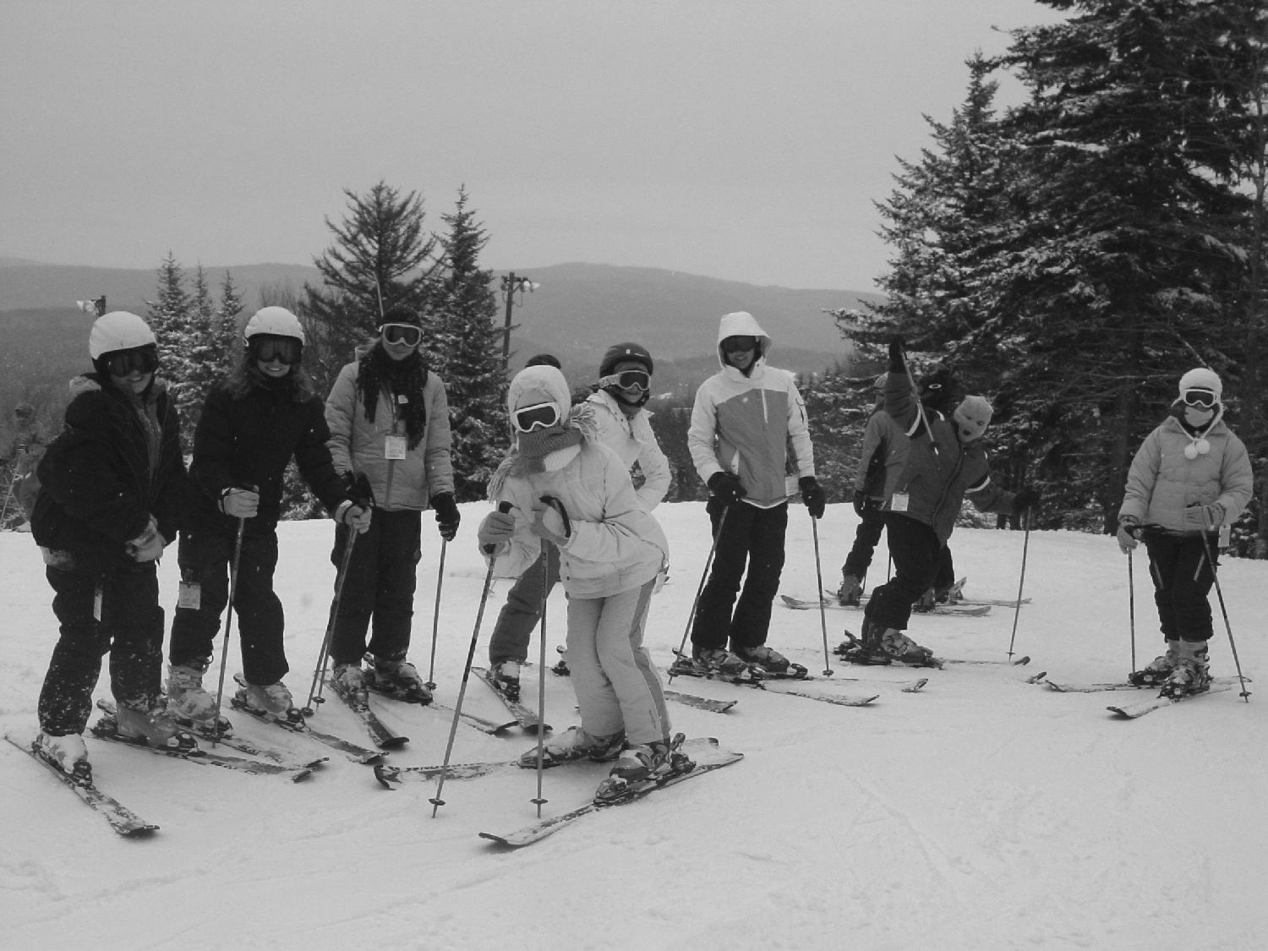
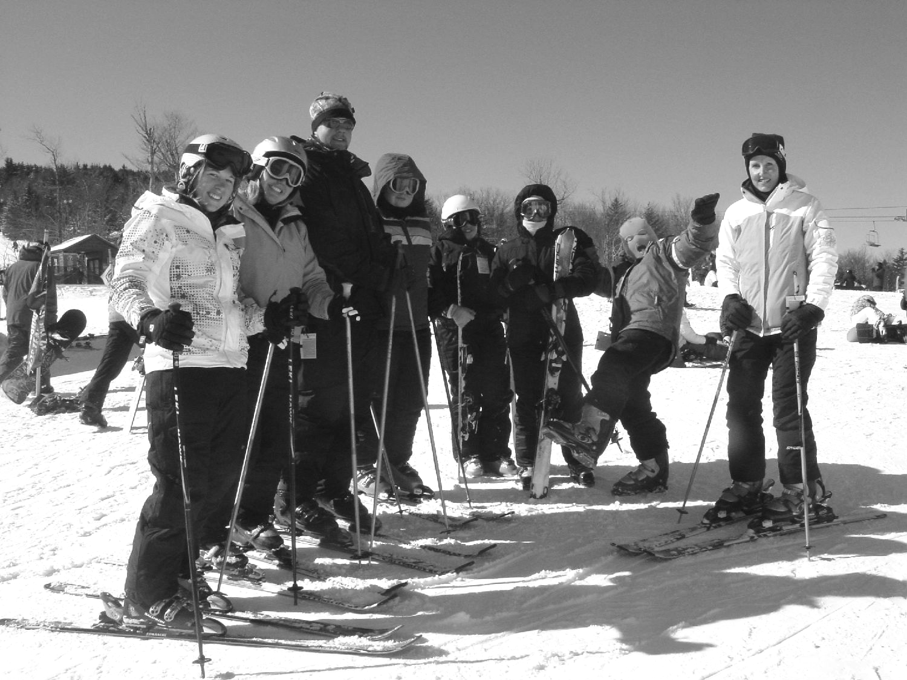

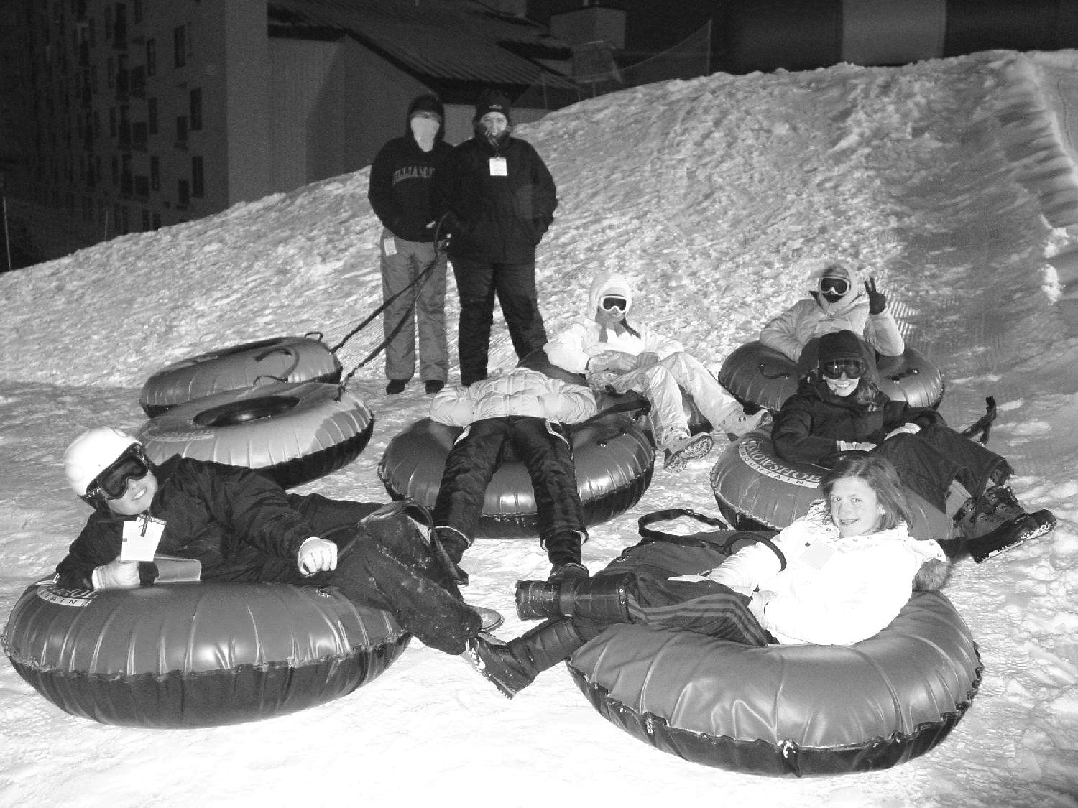
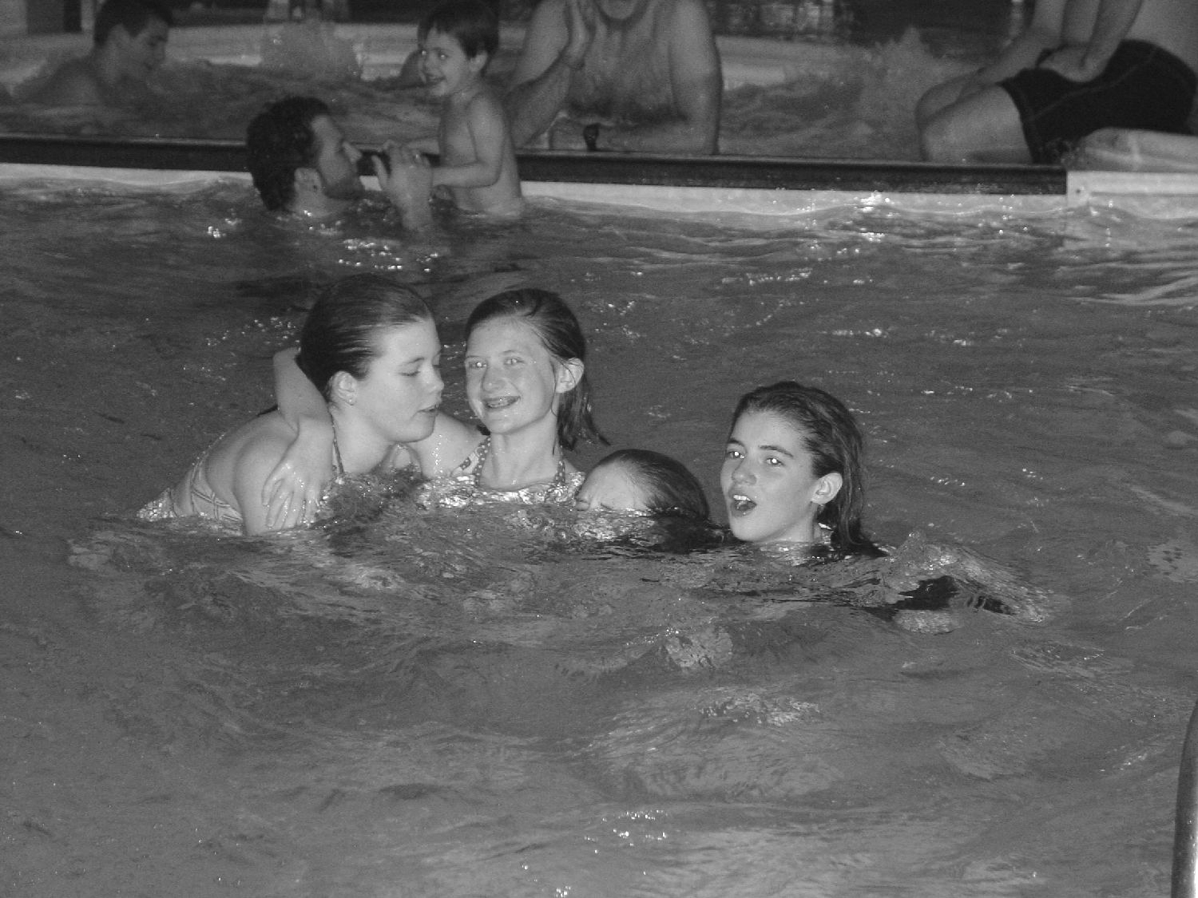
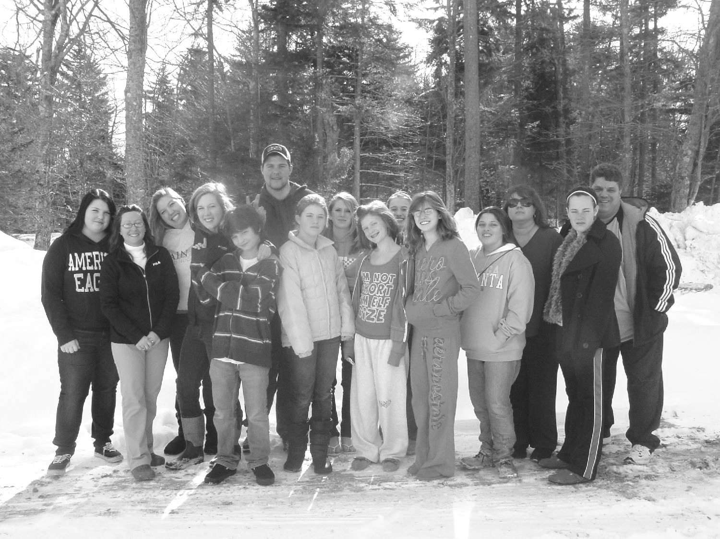
Youth Newsletter
March 2010

Page 3
Youth Donate to Food Pantry on “Souper Bowl” Sunday

On Sunday, February 7, the youth of Bethlehem Christian Church celebrated “Souper Bowl” Sunday by bringing in non-perishable food items for Bethlehem’s Food Pantry.

This year, several bags filled with different canned and boxed goods were donated by the children. Thanks to all the youth and parents who helped support this worthy cause.

For more pictures of the Youth Group Ski Trip, or any of our other youth activities, please visit the Youth Group Web site at www.bccyouth.org!

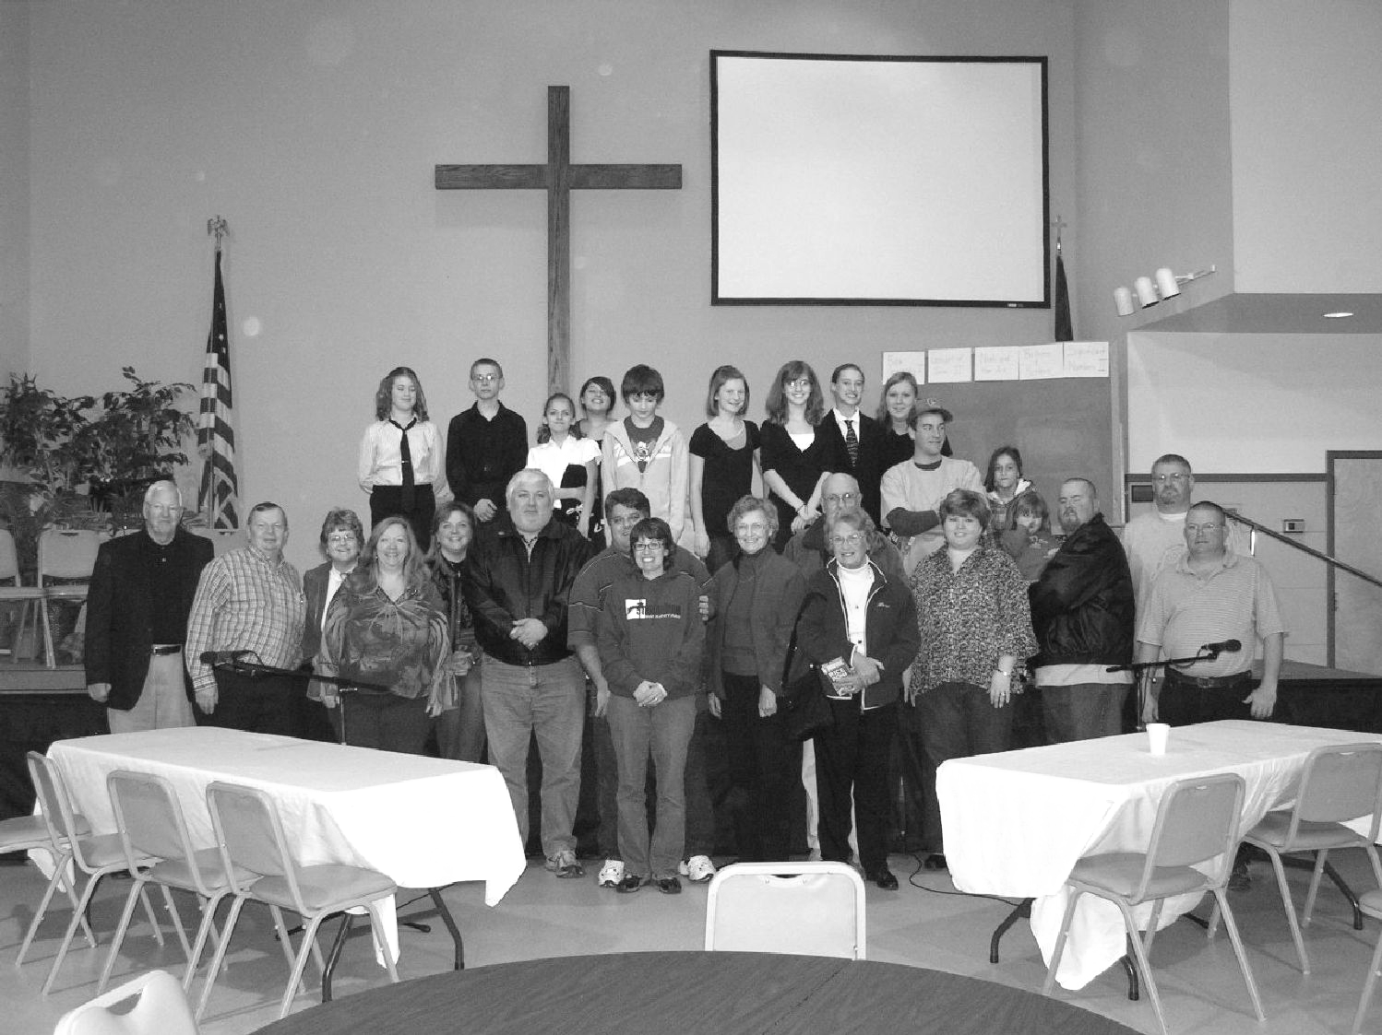
Youth Newsletter
March 2010
Page 4

2010

Camp Piankatank • Hartfield, VA

www.camppiankatank.org

July 7-9 Amazing Adventure Mini-Camp (ages 7-9)
July 18-23 Extreme Escape Youth Week (ages 13-17)
July 25-30 Amazing Adventure Camp (ages 10-14)

Register today to insure your space!
Alphas Sponsor Bible Jeopardy! Family Game Night

On Saturday, January 16, the junior high youth held their first-ever Bible Jeopardy! Family Game Night.

For several weeks before the event, the youth brainstormed questions from the Bible and practiced their Jeopardy! hosting skills. Each of the four adult Sunday School classes were invited to form a team and test their Bible knowledge.

The Bible Jeopardy! game began at 7:00pm with ten Alphas, 16 contestants, and around 30 “studio audience members” cheering on their favorite teams.

The youth used a computerized, programmable game system to set up and play the game. Game play was identical to the television game show, with the familiar Jeopardy! game board projected on the overhead screen in Graham Hall. Categories included topics such as The Gospel of John, Significant Numbers, and Bible Geography.

Laura Thornton and Tori Tarkington were the emcees for the evening, while Kate Jones served as the judge. Ginger Tarkington and Ginna Grady were the official scorekeepers, while the rest of the Alpha youth provided “sound effects”, helped with refreshments, and more.

In the first round, the ACTS Class competed against the Joyce Ann Harrell Class. Although the ACTS Class moved out to an early lead, the Joyce Ann Harrell Class emerged as the winners in a challenging low-scoring game.

In the next round, the COFFEE Class was pitted against the Taylor/Brittle Class. While the COFFEE Class surged ahead by two thousand points early on, the Taylor/Brittle Class took the lead in the second half of the game and held on for the win in a fast-paced high-scoring match.

Between rounds, the junior highers served refreshments, and presented funny sketches of the classic Oscar Meyer and Meow Mix commercials.
In the final round, the two winning teams competed to see who could answer the most Bible-related questions correctly. Although the Joyce Ann Harrell Class was highly competitive, the Taylor/Brittle Class ended up as the winners in a contest that came down to the final few questions.

Everyone who came out had a great time testing their Bible knowledge and watching the game. The winning team was treated to a dinner served by the Alpha youth on February 21, while the remaining teams received “consolation prizes” of Rice-A-Roni, the San Francisco treat.

Special thanks to the Alpha youth for sponsoring this time of fun and fellowship for our church, and to everyone who helped make it happen.

The Alpha youth pose with the Jeopardy! contestants after Family Game Night

