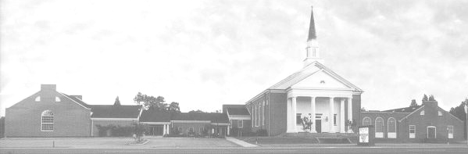

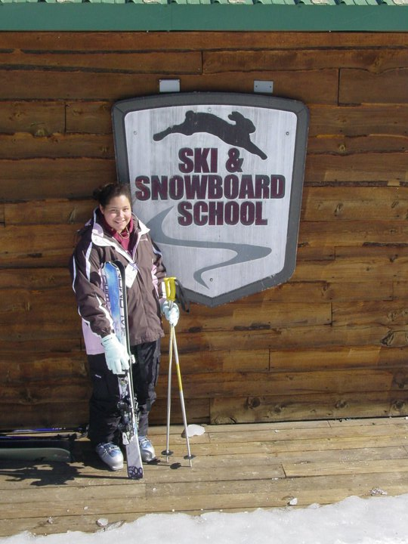
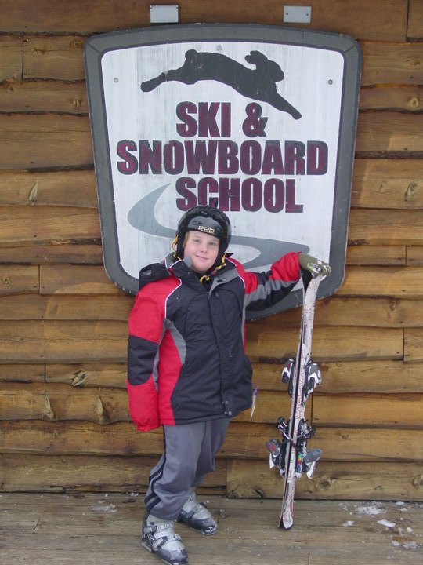
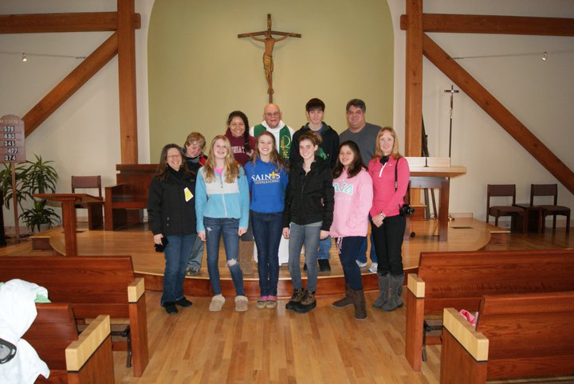
Youth Newsletter
UPCOMING EVENTS

The Youth Fellowship at Bethlehem Christian Church

March 2011
March 13 Regular Meeting, 4:30pm-5:45pm
Bible Jeopardy Dinner and Game Night, 5:30pm-8:00pm
March 19 Family Road Trip to Massanutten, 4:30am-9:30pm
March 20 Alphas/Omegas Winter Jam 2011 Trip, 3:30pm-11:00pm
March 27 Regular Meeting, 4:30pm-5:45pm
April 8 Soul Surfer Movie Trip, time TBA

For more information about your club’s schedule, including any special events planned for your individual club, please see your club’s leaders.

Alphas, Omegas Return to Snowshoe Resort for Annual Ski Trip

While temperatures hovered near the 70s here at home, the Alpha and Omega Youth headed off for their annual Ski Trip at Snowshoe Resort in West Virginia.

Ten youth and chaperones left the church shortly after 1:00pm on Friday, February 18. After a bathroom stop in Richmond, a stop for dinner in Waynesboro, and a final stop in Monterey, the group arrived at the resort around 9:30pm and checked into their rooms at the Silver Creek.

“The accommodations at Silver Creek are perfect for a group,” commented David Salerno, Bethlehem’s Youth Director. “The rooms are literally steps away from the ski rental area, the ski slopes, the Ski School, and the Tubing Hill, making it easy for us to plan our day. Plus, each room has a full kitchen, allowing us to prepare our own meals, save money, and spend more time together as a group.”

The next morning, after an early breakfast, two of the youth checked out their skis and headed for Ski School, while the rest of the group hit the slopes for an early morning ski session.

Madison and Dustin pose in front of the Ski School

Around 1:00pm, the youth went to their rooms for lunch, then returned to the slopes for an afternoon of skiing and snowboarding.

Early that evening, everyone returned to the room for a dinner of spaghetti with meat sauce and garlic bread, then spent time relaxing in the indoor/outdoor heated pool, hot tub, and sauna.

The group woke up early on Sunday morning and headed off for the Protestant worship service at Saint Bernard Chapel. Two of our youth were asked to read Scripture during the service. Before and after the church service, the group explored the Village Center area, and shopped at several of the stores there.

The group poses in front of Saint Bernard Chapel after the service

(continued on Page 2, Ski Trip)
(Ski Trip, continued from Page 1)

The group returned to Silver Creek around 12:00noon for an afternoon of fun on the slopes. Several of the youth also went snow tubing at the Tubing Hill later that afternoon. Then, finally, after the sun went down, everyone hit the slopes one last time for night skiing.

The group pauses for a picture at the top of Silver Creek

Ariel, Dustin, Ginger, and Madison stop for a picture on the Tubing Hill

After turning in their skis, the group returned to the room for dinner—homemade made-to-order personal pizzas—then started packing for the trip home.

The group woke up early Monday morning, packed the bus, and left Snowshoe around 10:00am. After stopping for lunch and a bathroom break, the group returned to church around 5:30pm, tired but full of exciting memories of their weekend adventure.

“This year’s Ski Trip was a great time of fellowship, enabling us to grow closer together as a group, and to grow closer to God,” commented David. “Special thanks to Becke West and Paula Thornton for all they did to make this trip happen.”



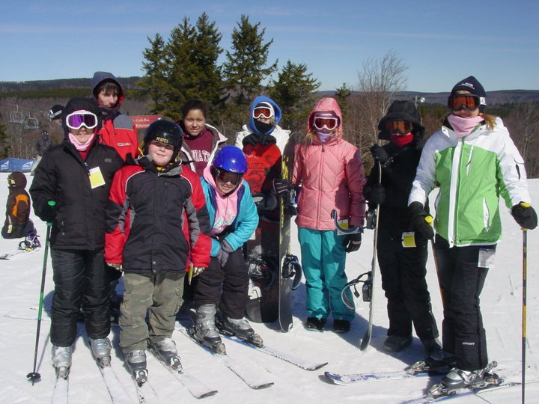
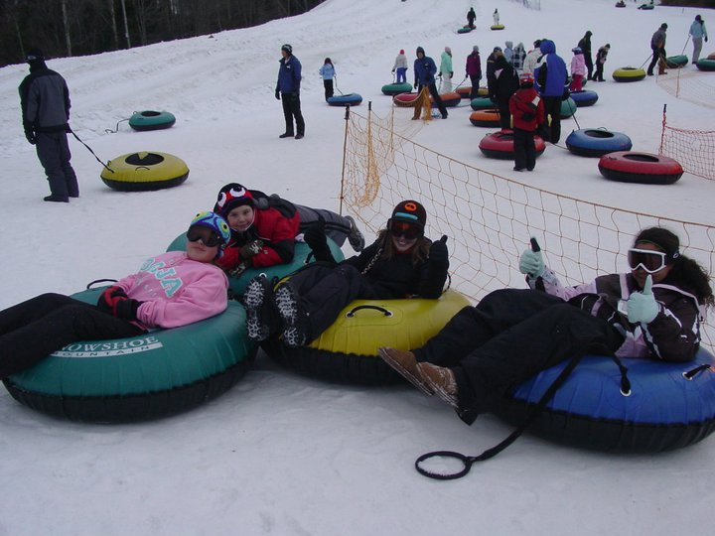

Youth Newsletter
March 2011
Page 2
It’s not
too late!

This past weekend, our youth participated in the World Vision 30 Hour Famine, to help raise money for needy children all over the world.

If you have already made your pledge, thank you!

If not, it’s never too late to make a difference in the life of a hungry child. Just $1 a day will help feed and care for a child in poverty through World Vision.

Please see any Famine participant or youth leader to make your pledge today. Thank you!
Bible
Jeopardy!
Family Dinner & Game Night

Sunday, March 13
Graham Hall

Bible Jeopardy begins at 6:30pm
Dinner served at 5:30pm
Sign-up sheets for dinner in Sunday School classrooms and back hallway.
Contestants needed! See Paula Thornton to sign up to play Bible Jeopardy!
Sunday, March 20
bus leaves church at 3:30pm – see David Salerno for info

